Website Development Notes

WDD 1 Web Fundamentals

Remember that each element needs to have a css rule for that element. Review elements if needed.

# Naming Convention Rules

* Use all **lowercase** syntax.

Platforms and systems handle case sensitivity differently. Case sensitivity is an important concept to understand when managing files and folders.

Example: products.html

* Do **NOT** use **spaces** in names. Use dashes instead.

Spaces are interpreted obtusely by user agents, therefore, do not use them. The Hypertext Transfer Protocol (HTTP) ignores spaces, except in file names. In file names, it replaces a space with a symbol—"%20." This makes URL's look confusing and can also lend itself to confusion in the mind of site visitors. So avoid using spaces. Instead, if you have to create a visual space, use hyphens/dashes.

Example: design-document.html

* Do **NOT** use **special characters**.

Special characters often mean specific things to computers, so just avoid using them completely in the naming of files and folders.

Special character examples (avoid these): <,>, \, /, #, ?, !

* Use as short and as meaningful (**semantic**) of names as possible.

Short, meaningful names save you, other developers, and site visitors from having to remember long complicated names for files and folders. When meaningful, they also help predict the purpose or nature of the file or folder contents when working with those files or folders.

Example: winter-scene-sm.png vs. image13-v123523brokenbranchlifeimagery w200x200.png

* In this class, the **standard folder names** for asset sub-folders are:
  + **styles** - Folders with this name contain our CSS files.
  + **images** - Folders with this name contain our images.

# An Introduction to HTML

HTML stands for **Hypertext Markup Language** and is one of the three core technologies of the web, HTML, CSS, and JavaScript. HTML defines the structure of a document. Hypertext refers to the way we can place hypertext links in our document that allows our users to move from one page to another. Markup is a set of symbols or codes for displaying content on the Internet. Web browsers use HTML markup and content to render pages.

"HTML (Hypertext Markup Language) is the most basic building block of the Web. It defines the meaning and structure of web content. Other technologies besides HTML are generally used to describe a web page's appearance/presentation (CSS) or functionality/behavior (JavaScript)." - MDN (Mozilla Developer Network Reference)

* Watch: 🎦 [Web Development Basics](https://www.youtube.com/embed/HTsJbDw13tI) - (4:32 mins, 📄 [Transcript](https://byui-wdd.github.io/wdd130/text/webdev_basics.pdf))
* Watch: 🎦 [What is HTML?](https://www.youtube.com/embed/jxYtjiuPfLQ) - (3:25 mins, 📄 [Transcript](https://byui-wdd.github.io/wdd130/text/what_is_html.pdf) )
* Watch: 🎦 [HTML Elements and Attributes](https://youtu.be/GpZmiD8WlFo) - (5:52 mins, 📄 [Transcript](https://byui-wdd.github.io/wdd130/text/beg_html_elements.pdf))

The following HTML elements are **required** for every HTML document created in this course.  
What is the purpose of each of the following HTML elements?

* <!DOCTYPE html>

Answer

"It is a required preamble. In the mists of time, when HTML was young (around 1991/92), doctypes were meant to act as links to a set of rules that the HTML page had to follow to be considered good HTML, which could mean automatic error checking and other useful things. However, these days, they don't do much and are basically just needed to make sure your document behaves correctly. That's all you need to know for now." - MDN

☑️ This is a required, development checklist item for all HTML documents produced in this course.

* <html lang="en-US"> ... </html>

Answer

"This element wraps all the content on the entire page and is sometimes known as the root element. It also includes the lang attribute, setting the primary language of the document." - MDN

☑️ This is a required, development checklist item and must include the lang attribute.

* <head> ... </head>

Answer

"The **head** HTML element contains machine-readable information (metadata) about the document, like its character support, viewport sizing, title, scripts, and style sheets." - MDN

☑️ This is a required, development checklist item.

* <meta charset="utf-8">

Answer

Located within the <head> element. "This attribute declares the document's character encoding. If the attribute is present, its value must be an ASCII case-insensitive match for the string "utf-8", because UTF-8 is the only valid encoding for HTML5 documents. <meta> elements which declare a character encoding must be located entirely within the first 1024 bytes of the document." - MDN

☑️ This is a required, development checklist item.

* <meta name="viewport" content="width=device-width, initial-scale=1.0">

Answer

Located within the <head> element. "This viewport element ensures the page renders at the width of viewport, preventing mobile browsers from rendering pages wider than the viewport and then shrinking them down." - MDN

☑️ This is a required, development checklist item.

* <title>...</title>

Answer

Located within the <head> element. "This sets the title of your page, which is the title that appears in the browser tab of the page. It is also used to describe the page when you bookmark/favorite it." - MDN

The content of the title should closely match the content of the heading 1 <h1> element in the document <body>.

☑️ This is a required, development checklist item and must be relevant to the document.

* <body> ... </body>

Answer

"The <body> HTML element represents the content of an HTML document. There can be only one body element in a document. It contains all the content that you want to show to web users when they visit your page, whether that's text, images, videos, games, playable audio tracks, or whatever else." - MDN

☑️ This is a required, development checklist item.

What is the basic anatomy of an HTML document that is required for all pages in this course? Answer

<!DOCTYPE html>

<html lang="en-US">

<head>

<meta charset="utf-8">

<meta name="viewport" content="width=device-width">

<title>Relevant Document Title</title>

</head>

<body>

</body>

</html>

• Using the following example HTML snippet of code, technically **name** the numbered parts:

<p>A paragraph containing a hyperlink to <a href="https://www.byui.edu">BYU-Idaho</a>.</p>

1. <p>
2. </p>
3. href
4. A paragraph containing a hyperlink to [BYU-Idaho](https://www.byui.edu).
5. The entire snippet.

Answers

1. **opening or start tag**
2. **closing or end tag**
3. **attribute** - The value of this **href** attribute, *https://www.byui.edu*, specifies the anchor <a> tag's destination, which destination in this case is an absolute reference, and means **hypertext reference**.
4. **content** or the text node of the paragraph element.
5. An HTML paragraph **Element**

• Some elements have no content and no closing tag. They are called _______ or self-closing tags.   
An example element of this type is an image <img> element. Answer [Void elements](https://developer.mozilla.org/en-US/docs/Glossary/Void_element)  
Example:

<img src="images/sample.png" alt="A sample image">

⚕️ In this class, we follow contemporary recommendations and do **NOT** include a closing forward slash / in the void element's closing tag.

# Working with Web Images

**Overview**

The multimedia web uses images. You will work with many different image formats and some of those image types are better suited for the web. This activity explores the images for the web and how to optimize images to be smaller, supporting smaller page weights thus download time.

"The older formats like PNG, JPEG, GIF have poor performance compared to newer formats like WebP and AVIF, but enjoy broader "historical" browser support. The newer image formats are seeing increasing popularity as browsers without support become increasingly irrelevant (i.e. have virtually zero market share)." - MDN

**Prepare**

* Watch: 🎦 [Image File Types (JPG, PNG, SVG, GIF) - Web Design Tutorial](https://youtu.be/Zx0CacsiDZ4)
* Watch: 🎦 [Image Optimization for Web Pages](https://youtu.be/85X16eLvNYY)

**Basic Steps of Image Optimization**

Often the original photos that we work with are very large in terms of dimensions AND file size. Large photos need to be scaled down and optimized to a size that is actually needed on the page. This size is determined by the design and layout of the page. Software can be used to crop, reduce, and optimize the images. These are the basic steps supported by most photo editing packages:

1. **Crop** the original image to the critical content keeping in mind design principles, like the [rule of thirds](https://www.slrlounge.com/glossary/rule-of-thirds-definition), and the site or section purpose.
2. **Resize** the image to the maximum size that you actually need in the design of your site. That image will then be saved in smaller formats, possibly with slightly different design to match the design and layout in smaller views, meaning, smart phone, tablet.
3. **Reduce the quality** of the image to an acceptable level, thus reducing its file size.

Optimizing images is an easy way to improve page performance without requiring a significant time investment. More techniques for handling responsive images will be covered in future courses.

**Activity Instructions**

All images in this class must be optimized in this course in order to reduce overall page weight.

## Optimize an Image

1. In your browser, navigate to the online application, [Squoosh.app](https://squoosh.app/).
2. Select on the button in the middle of the page and select an image from your computer.
3. In the **Edit** panel on the right, toggle **Resize** and change the width to ~200 pixels.
4. Under **Compress**, change the file type to **WebP**.
5. Under **Compress**, change the **Quality** to ~70%.
6. Note the overall change in file size displayed in those panels.
7. Click the download button (bottom right) to save the image to your computer.

**⚕️Help: "My image does not show up either locally or when I push to GitHub"**

Whenever an image does not show up, it is usually due to a naming or path issue. Here are some things to check:

* Check that the image file actually **exists** in the images folder on your site.
* Check that file **name** and make sure the reference matches the filename, including the exact case used (Upper and lower).
* Check the file **path** to make sure you are not pointing to the wrong folder or location.

**Relative Path Example:**   
This example references an image named "**myimage.png**" in a sub-folder named "**images**."

<img src="images/myimage.png" alt="Xavier Rodriguez" width="100" height="200">

**Absolute Path Example:**   
Absolute source references use external resources and start with a protocol.

<img src="https://resource.thesite.com/images/breakfast.svg" alt="Typical breakfast items">

To display the copyright symbol, use the HTML entity &copy; or use a built-in emoji.

Built-in Emoji Menu

**Windows/Linux**: Hold the windows key and press period (.)  
macOS: Hold down the following three keys at the same time: Command+Control+Spacebar or press the fn key.

# HTML Semantic Elements

## HTML <section> Element

The <section> element defines a section in a document.

According to W3C's HTML documentation: "A section is a thematic grouping of content, typically with a heading."

Examples of where a <section> element can be used:

* Chapters
* Introduction
* News items
* Contact information

A web page could normally be split into sections for introduction, content, and contact information.

## HTML <article> Element

The <article> element specifies independent, self-contained content.

An article should make sense on its own, and it should be possible to distribute it independently from the rest of the web site.

Examples of where the <article> element can be used:

* Forum posts
* Blog posts
* User comments
* Product cards
* Newspaper articles

## Nesting <article> in <section> or Vice Versa?

The <article> element specifies independent, self-contained content.

The <section> element defines section in a document.

Can we use the definitions to decide how to nest those elements? No, we cannot!

So, you will find HTML pages with <section> elements containing <article> elements, and <article> elements containing <section> elements.

## HTML <header> Element

The <header> element represents a container for introductory content or a set of navigational links.

A <header> element typically contains:

* one or more heading elements (<h1> - <h6>)
* logo or icon
* authorship information

**Note:** You can have several <header> elements in one HTML document. However, <header> cannot be placed within a <footer>, <address> or another <header> element.

## HTML <footer> Element

The <footer> element defines a footer for a document or section.

A <footer> element typically contains:

* authorship information
* copyright information
* contact information
* sitemap
* back to top links
* related documents

You can have several <footer> elements in one document.

## HTML <nav> Element

The <nav> element defines a set of navigation links.

Notice that NOT all links of a document should be inside a <nav> element. The <nav> element is intended only for major blocks of navigation links.

Browsers, such as screen readers for disabled users, can use this element to determine whether to omit the initial rendering of this content.

## HTML <aside> Element

The <aside> element defines some content aside from the content it is placed in (like a sidebar).

The <aside> content should be indirectly related to the surrounding content.

## HTML <figure> and <figcaption> Elements

The <figure> tag specifies self-contained content, like illustrations, diagrams, photos, code listings, etc.

The <figcaption> tag defines a caption for a <figure> element. The <figcaption> element can be placed as the first or as the last child of a <figure> element.

The <img> element defines the actual image/illustration.

## Why Semantic Elements?

According to the W3C: "A semantic Web allows data to be shared and reused across applications, enterprises, and communities."

## Semantic Elements in HTML

Below is a list of some of the semantic elements in HTML.

|  |  |
| --- | --- |
| **Tag** | **Description** |
| [<article>](https://www.w3schools.com/tags/tag_article.asp) | Defines independent, self-contained content |
| [<aside>](https://www.w3schools.com/tags/tag_aside.asp) | Defines content aside from the page content |
| [<details>](https://www.w3schools.com/tags/tag_details.asp) | Defines additional details that the user can view or hide |
| [<figcaption>](https://www.w3schools.com/tags/tag_figcaption.asp) | Defines a caption for a <figure> element |
| [<figure>](https://www.w3schools.com/tags/tag_figure.asp) | Specifies self-contained content, like illustrations, diagrams, photos, code listings, etc. |
| [<footer>](https://www.w3schools.com/tags/tag_footer.asp) | Defines a footer for a document or section |
| [<header>](https://www.w3schools.com/tags/tag_header.asp) | Specifies a header for a document or section |
| [<main>](https://www.w3schools.com/tags/tag_main.asp) | Specifies the main content of a document |
| [<mark>](https://www.w3schools.com/tags/tag_mark.asp) | Defines marked/highlighted text |
| [<nav>](https://www.w3schools.com/tags/tag_nav.asp) | Defines navigation links |
| [<section>](https://www.w3schools.com/tags/tag_section.asp) | Defines a section in a document |
| [<summary>](https://www.w3schools.com/tags/tag_summary.asp) | Defines a visible heading for a <details> element |
| [<time>](https://www.w3schools.com/tags/tag_time.asp) | Defines a date/time |

# <h1>–<h6>: The HTML Section Heading elements

# Definitions

## Callback

When we pass a function into another function we call it a 'callback'.

## Rules for Construction

While coding it is best to label items for what they are. For example: labeling a “container” that contains an image as “image-container” or “profile-container” will help with compiling a webpage that keeps it organized and easy to read. It will also help with page layout.

## Elements

An **element** is a part of a webpage. In [XML](https://developer.mozilla.org/en-US/docs/Glossary/XML) and [HTML](https://developer.mozilla.org/en-US/docs/Glossary/HTML), an element may contain a data item or a chunk of text or an image, or perhaps nothing. A typical element includes an opening tag with some [attributes](https://developer.mozilla.org/en-US/docs/Glossary/Attribute), enclosed text content, and a closing tag.

List of Tags for Elements: [HTML elements reference](https://developer.mozilla.org/en-US/docs/Web/HTML/Element)

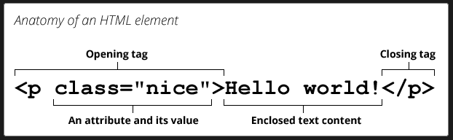

Elements and [tags](https://developer.mozilla.org/en-US/docs/Glossary/Tag) are *not* the same things. Tags begin or end an element in source code, whereas elements are part of the [DOM](https://developer.mozilla.org/en-US/docs/Glossary/DOM), (Document Object Model) the document model for displaying the page in the [browser](https://developer.mozilla.org/en-US/docs/Glossary/Browser).

## Attributes

An **attribute** extends an [HTML](https://developer.mozilla.org/en-US/docs/Glossary/HTML) or [XML](https://developer.mozilla.org/en-US/docs/Glossary/XML) [element](https://developer.mozilla.org/en-US/docs/Glossary/Element), changing its behavior or providing metadata.

An attribute always has the form name="value" (the attribute's identifier followed by its associated value). You may see attributes without an equals sign or a value. That is a shorthand for providing the empty string in HTML. However, this is not valid in XML: XML requires all attributes to have an explicit value.

A number of HTML attributes are [boolean attributes](https://developer.mozilla.org/en-US/docs/Glossary/Boolean/HTML). These attributes' values are only controlled by the presence or absence of the attribute. See [boolean attributes](https://developer.mozilla.org/en-US/docs/Glossary/Boolean/HTML) for more information.

List of Attributes and their associated Elements: [HTML attribute reference](https://developer.mozilla.org/en-US/docs/Web/HTML/Attributes)

The **<h1>** to **<h6>** [HTML](https://developer.mozilla.org/en-US/docs/Web/HTML) elements represent six levels of section headings. <h1> is the highest section level and <h6> is the lowest. By default, all heading elements create a [block-level](https://developer.mozilla.org/en-US/docs/Glossary/Block-level_content) box in the layout, starting on a new line and taking up the full width available in their containing block.

[Avoid using multiple <h1> elements on one page](https://developer.mozilla.org/en-US/docs/Web/HTML/Element/Heading_Elements#avoid_using_multiple_h1_elements_on_one_page)

While using multiple <h1> elements on one page is allowed by the HTML standard (as long as they are not [nested](https://developer.mozilla.org/en-US/docs/Web/HTML/Element/Heading_Elements#nesting)), this is not considered a best practice. A page should generally have a single <h1> element that describes the content of the page (similar to the document's [<title>](https://developer.mozilla.org/en-US/docs/Web/HTML/Element/title) element)

## Tags

In [HTML](https://developer.mozilla.org/en-US/docs/Glossary/HTML), a **tag** is used for creating an [element](https://developer.mozilla.org/en-US/docs/Glossary/Element).

### List of tags (list of elements):

<https://www.w3schools.com/tags/>

The name of an HTML element is the name that appears at the beginning of the element's start tag and at the end of the element's end tag (if the element has an end tag). For example, the p in the <p> start tag and </p> end tag is the name of the HTML paragraph element. Note that an element name in an end tag is preceded by a slash character: </p>, and that for [void elements](https://developer.mozilla.org/en-US/docs/Glossary/Void_element), the end tag is neither required nor allowed.

* 1. <dt> See also: [HTML <dt> Tag](https://www.w3schools.com/tags/tag_dt.asp) The <dt> tag defines a term/name in a description list. The <dt> tag is used in conjunction with [<dl>](https://www.w3schools.com/tags/tag_dl.asp) (defines a description list) and [<dd>](https://www.w3schools.com/tags/tag_dd.asp) (describes each term/name).
  2. [<hgroup>](https://developer.mozilla.org/en-US/docs/Web/HTML/Element/hgroup)
  3. [<hr>](https://developer.mozilla.org/en-US/docs/Web/HTML/Element/hr)
  4. [<html>](https://developer.mozilla.org/en-US/docs/Web/HTML/Element/html)
  5. [<i>](https://developer.mozilla.org/en-US/docs/Web/HTML/Element/i)
  6. [<iframe>](https://developer.mozilla.org/en-US/docs/Web/HTML/Element/iframe)
  7. [<img>](https://developer.mozilla.org/en-US/docs/Web/HTML/Element/img)
  8. [<input>](https://developer.mozilla.org/en-US/docs/Web/HTML/Element/input)
  9. [<ins>](https://developer.mozilla.org/en-US/docs/Web/HTML/Element/ins)
  10. [<kbd>](https://developer.mozilla.org/en-US/docs/Web/HTML/Element/kbd)
  11. [<label>](https://developer.mozilla.org/en-US/docs/Web/HTML/Element/label)
  12. [<legend>](https://developer.mozilla.org/en-US/docs/Web/HTML/Element/legend)
  13. [<li>](https://developer.mozilla.org/en-US/docs/Web/HTML/Element/li) See also: [HTML <li> Tag](https://www.w3schools.com/tags/tag_li.asp) The <li> tag defines a list item. The <li> tag is used inside ordered lists([<ol>](https://www.w3schools.com/tags/tag_ol.asp)), unordered lists ([<ul>](https://www.w3schools.com/tags/tag_ul.asp)), and in menu lists ([<menu>](https://www.w3schools.com/tags/tag_menu.asp)).In <ul> and <menu>, the list items will usually be displayed with bullet points. In <ol>, the list items will usually be displayed with numbers or letters.
  14. [<link>](https://developer.mozilla.org/en-US/docs/Web/HTML/Element/link)
  15. [<main>](https://developer.mozilla.org/en-US/docs/Web/HTML/Element/main)
  16. [<map>](https://developer.mozilla.org/en-US/docs/Web/HTML/Element/map)
  17. [<mark>](https://developer.mozilla.org/en-US/docs/Web/HTML/Element/mark)
  18. [<marquee>](https://developer.mozilla.org/en-US/docs/Web/HTML/Element/marquee) Deprecated
  19. [<menu>](https://developer.mozilla.org/en-US/docs/Web/HTML/Element/menu)
  20. [<meta>](https://developer.mozilla.org/en-US/docs/Web/HTML/Element/meta) See also : [Meta Data](https://www.w3schools.com/tags/tag_meta.asp) The <meta> tag defines metadata about an HTML document. Metadata is data (information) about data.
  21. [<meter>](https://developer.mozilla.org/en-US/docs/Web/HTML/Element/meter)
  22. [<nav>](https://developer.mozilla.org/en-US/docs/Web/HTML/Element/nav)
  23. [<nobr>](https://developer.mozilla.org/en-US/docs/Web/HTML/Element/nobr) Deprecated
  24. [<noembed>](https://developer.mozilla.org/en-US/docs/Web/HTML/Element/noembed) Deprecated
  25. [<noframes>](https://developer.mozilla.org/en-US/docs/Web/HTML/Element/noframes) Deprecated
  26. [<noscript>](https://developer.mozilla.org/en-US/docs/Web/HTML/Element/noscript)
  27. [<object>](https://developer.mozilla.org/en-US/docs/Web/HTML/Element/object)
  28. [<ol>](https://developer.mozilla.org/en-US/docs/Web/HTML/Element/ol)
  29. [<optgroup>](https://developer.mozilla.org/en-US/docs/Web/HTML/Element/optgroup)
  30. [<option>](https://developer.mozilla.org/en-US/docs/Web/HTML/Element/option)
  31. [<output>](https://developer.mozilla.org/en-US/docs/Web/HTML/Element/output)
  32. [<p>](https://developer.mozilla.org/en-US/docs/Web/HTML/Element/p)
  33. [<param>](https://developer.mozilla.org/en-US/docs/Web/HTML/Element/param) Deprecated
  34. [<picture>](https://developer.mozilla.org/en-US/docs/Web/HTML/Element/picture)
  35. [<plaintext>](https://developer.mozilla.org/en-US/docs/Web/HTML/Element/plaintext) Deprecated
  36. [<portal>](https://developer.mozilla.org/en-US/docs/Web/HTML/Element/portal) Experimental
  37. [<pre>](https://developer.mozilla.org/en-US/docs/Web/HTML/Element/pre)
  38. [<progress>](https://developer.mozilla.org/en-US/docs/Web/HTML/Element/progress)
  39. [<q>](https://developer.mozilla.org/en-US/docs/Web/HTML/Element/q)
  40. [<rb>](https://developer.mozilla.org/en-US/docs/Web/HTML/Element/rb) Deprecated
  41. [<rp>](https://developer.mozilla.org/en-US/docs/Web/HTML/Element/rp)
  42. [<rt>](https://developer.mozilla.org/en-US/docs/Web/HTML/Element/rt)
  43. [<rtc>](https://developer.mozilla.org/en-US/docs/Web/HTML/Element/rtc) Deprecated
  44. [<ruby>](https://developer.mozilla.org/en-US/docs/Web/HTML/Element/ruby)
  45. [<s>](https://developer.mozilla.org/en-US/docs/Web/HTML/Element/s)
  46. [<samp>](https://developer.mozilla.org/en-US/docs/Web/HTML/Element/samp)
  47. [<script>](https://developer.mozilla.org/en-US/docs/Web/HTML/Element/script)
  48. [<search>](https://developer.mozilla.org/en-US/docs/Web/HTML/Element/search)
  49. [<section>](https://developer.mozilla.org/en-US/docs/Web/HTML/Element/section)
  50. [<select>](https://developer.mozilla.org/en-US/docs/Web/HTML/Element/select)
  51. [<slot>](https://developer.mozilla.org/en-US/docs/Web/HTML/Element/slot)
  52. [<small>](https://developer.mozilla.org/en-US/docs/Web/HTML/Element/small)
  53. [<source>](https://developer.mozilla.org/en-US/docs/Web/HTML/Element/source)
  54. [<span>](https://developer.mozilla.org/en-US/docs/Web/HTML/Element/span)
  55. [<strike>](https://developer.mozilla.org/en-US/docs/Web/HTML/Element/strike) Deprecated
  56. [<strong>](https://developer.mozilla.org/en-US/docs/Web/HTML/Element/strong)
  57. [<style>](https://developer.mozilla.org/en-US/docs/Web/HTML/Element/style)
  58. [<sub>](https://developer.mozilla.org/en-US/docs/Web/HTML/Element/sub) Creates the subset 2 in H20
  59. [<sup>](https://www.youtube.com/watch?v=iX_QyjdctsQ&t=290s) Creates the upset of the 2 in X^2
  60. [<summary>](https://developer.mozilla.org/en-US/docs/Web/HTML/Element/summary)
  61. [<sup>](https://developer.mozilla.org/en-US/docs/Web/HTML/Element/sup)
  62. [<table>](https://developer.mozilla.org/en-US/docs/Web/HTML/Element/table)
  63. [<tbody>](https://developer.mozilla.org/en-US/docs/Web/HTML/Element/tbody)
  64. [<td>](https://developer.mozilla.org/en-US/docs/Web/HTML/Element/td)
  65. [<template>](https://developer.mozilla.org/en-US/docs/Web/HTML/Element/template)
  66. [<textarea>](https://developer.mozilla.org/en-US/docs/Web/HTML/Element/textarea)
  67. [<tfoot>](https://developer.mozilla.org/en-US/docs/Web/HTML/Element/tfoot)
  68. [<th>](https://developer.mozilla.org/en-US/docs/Web/HTML/Element/th)
  69. [<thead>](https://developer.mozilla.org/en-US/docs/Web/HTML/Element/thead)
  70. [<time>](https://developer.mozilla.org/en-US/docs/Web/HTML/Element/time)
  71. [<title>](https://developer.mozilla.org/en-US/docs/Web/HTML/Element/title)
  72. [<tr>](https://developer.mozilla.org/en-US/docs/Web/HTML/Element/tr)
  73. [<track>](https://developer.mozilla.org/en-US/docs/Web/HTML/Element/track)
  74. [<tt>](https://developer.mozilla.org/en-US/docs/Web/HTML/Element/tt) Deprecated
  75. [<u>](https://developer.mozilla.org/en-US/docs/Web/HTML/Element/u)
  76. [<ul>](https://developer.mozilla.org/en-US/docs/Web/HTML/Element/ul)
  77. [<var>](https://developer.mozilla.org/en-US/docs/Web/HTML/Element/var)
  78. [<video>](https://developer.mozilla.org/en-US/docs/Web/HTML/Element/video)
  79. [<wbr>](https://developer.mozilla.org/en-US/docs/Web/HTML/Element/wbr)
  80. [<xmp>](https://developer.mozilla.org/en-US/docs/Web/HTML/Element/xmp) Deprecated

**<h1>–<h6>: The HTML Section Heading elements**

The **<h1>** to **<h6>** [HTML](https://developer.mozilla.org/en-US/docs/Web/HTML) elements represent six levels of section headings. <h1> is the highest section level and <h6> is the lowest. By default, all heading elements create a [block-level](https://developer.mozilla.org/en-US/docs/Glossary/Block-level_content) box in the layout, starting on a new line and taking up the full width available in their containing block.

[**Try it**](https://developer.mozilla.org/en-US/docs/Web/HTML/Element/Heading_Elements#try_it)

[**Attributes**](https://developer.mozilla.org/en-US/docs/Web/HTML/Element/Heading_Elements#attributes)

These elements only include the [global attributes](https://developer.mozilla.org/en-US/docs/Web/HTML/Global_attributes).

[**Usage notes**](https://developer.mozilla.org/en-US/docs/Web/HTML/Element/Heading_Elements#usage_notes)

* Heading information can be used by user agents to construct a table of contents for a document automatically.
* Do not use heading elements to resize text. Instead, use the [CSS](https://developer.mozilla.org/en-US/docs/Glossary/CSS) [font-size](https://developer.mozilla.org/en-US/docs/Web/CSS/font-size) property.
* Do not skip heading levels: always start from <h1>, followed by <h2> and so on.

[**Avoid using multiple <h1> elements on one page**](https://developer.mozilla.org/en-US/docs/Web/HTML/Element/Heading_Elements#avoid_using_multiple_h1_elements_on_one_page)

While using multiple <h1> elements on one page is allowed by the HTML standard (as long as they are not [nested](https://developer.mozilla.org/en-US/docs/Web/HTML/Element/Heading_Elements#nesting)), this is not considered a best practice. A page should generally have a single <h1> element that describes the content of the page (similar to the document's [<title>](https://developer.mozilla.org/en-US/docs/Web/HTML/Element/title) element).

**Note:** Nesting multiple <h1> elements in nested [sectioning elements](https://developer.mozilla.org/en-US/docs/Web/HTML/Element#content_sectioning) was allowed in older versions of the HTML standard. However, this was never considered a best practice and is now non-conforming. Read more in [There Is No Document Outline Algorithm](https://adrianroselli.com/2016/08/there-is-no-document-outline-algorithm.html).

Prefer using only one <h1> per page and [nest headings](https://developer.mozilla.org/en-US/docs/Web/HTML/Element/Heading_Elements#nesting) without skipping levels.

[**Accessibility**](https://developer.mozilla.org/en-US/docs/Web/HTML/Element/Heading_Elements#accessibility)

[**Navigation**](https://developer.mozilla.org/en-US/docs/Web/HTML/Element/Heading_Elements#navigation)

A common navigation technique for users of screen reading software is to quickly jump from heading to heading in order to determine the content of the page. Because of this, it is important to not skip one or more heading levels. Doing so may create confusion, as the person navigating this way may be left wondering where the missing heading is.

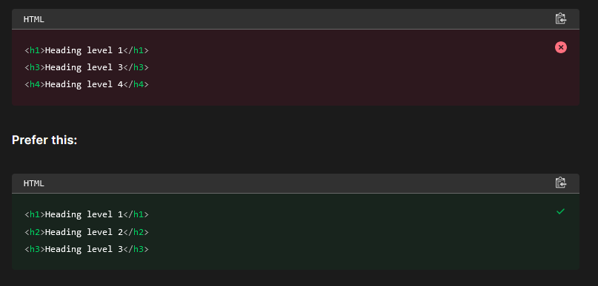

## Nesting

Headings may be nested as subsections to reflect the organization of the content of the page. Most screen readers can also generate an ordered list of all the headings on a page, which can help a person quickly determine the content hierarchy and navigate to different headings.

Given the following page structure:

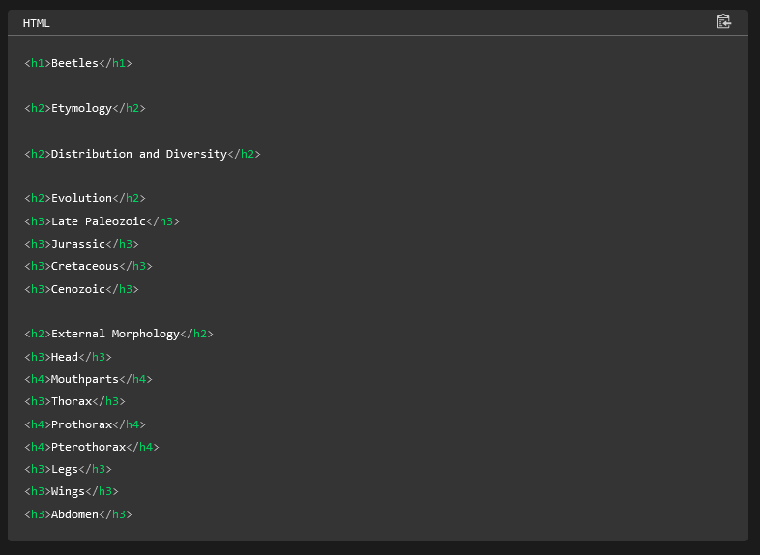

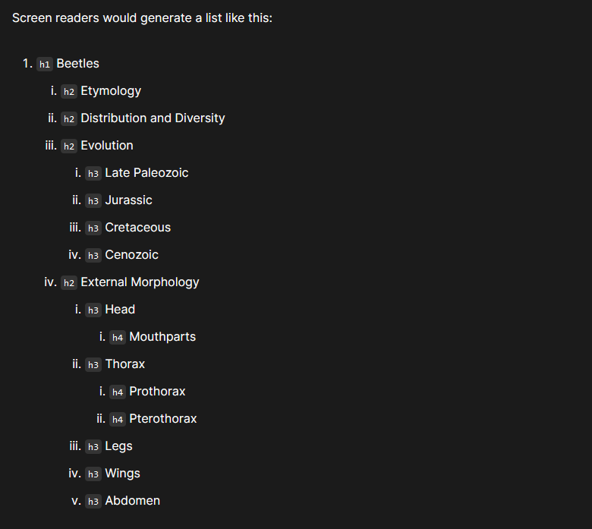

## CSS measurements

### fr

fr units allows a fraction of the whole. For example, 1fr, will set up even columns in the given space provided. MDN defines the fr unit as a unit which represents a fraction of the available space in the grid container.

### px

px units are measured in pixels

### rem

rem stands for “root em”, **a unit of measurement that represents the font size of the root element**. This means that 1rem equals the font size of the html element, which for most browsers has a default value of 16px. Using rem can help ensure consistency of font size and spacing throughout your UI.

# HTML Block and Inline Elements (Structure Alignments)

<https://www.w3schools.com/html/html_blocks.asp>

## Block-level Elements

A block-level element always starts on a new line, and the browsers automatically add some space (a margin) before and after the element.

A block-level element always takes up the full width available (stretches out to the left and right as far as it can).

Two commonly used block elements are: <p> and <div>.

The <p> element defines a paragraph in an HTML document.

The <div> element defines a division or a section in an HTML document.

The <p> element is a block-level element.

The <div> element is a block-level element.

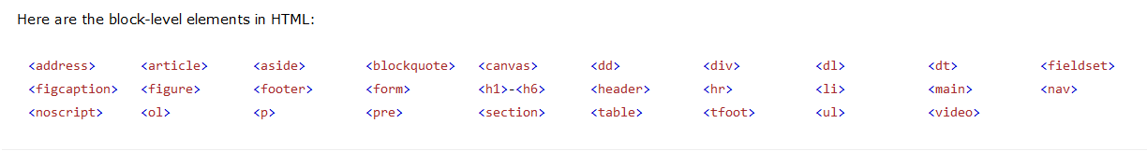

## Inline Elements

An inline element does not start on a new line.

An inline element only takes up as much width as necessary.

This is a <span> element inside a paragraph.

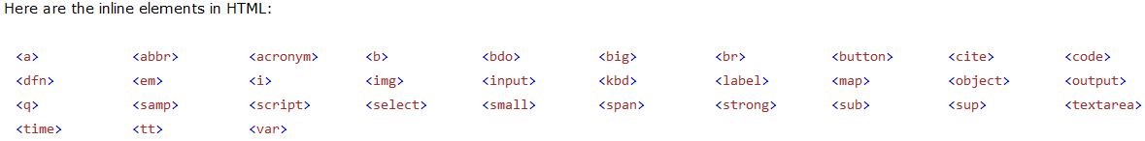

## The <div> Element

The <div> element is often used as a container for other HTML elements.

The <div> element has no required attributes, but style, class and id are common.

When used together with CSS, the <div> element can be used to style blocks of content:

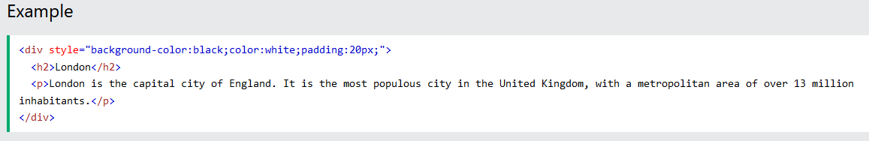

## The <span> Element

The <span> element is an inline container used to mark up a part of a text, or a part of a document.

The <span> element has no required attributes, but style, class and id are common.

When used together with CSS, the <span> element can be used to style parts of the text:

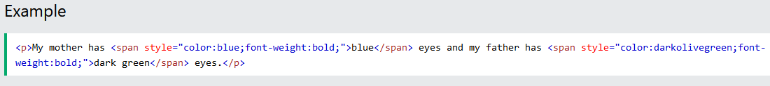

## Block Elements:

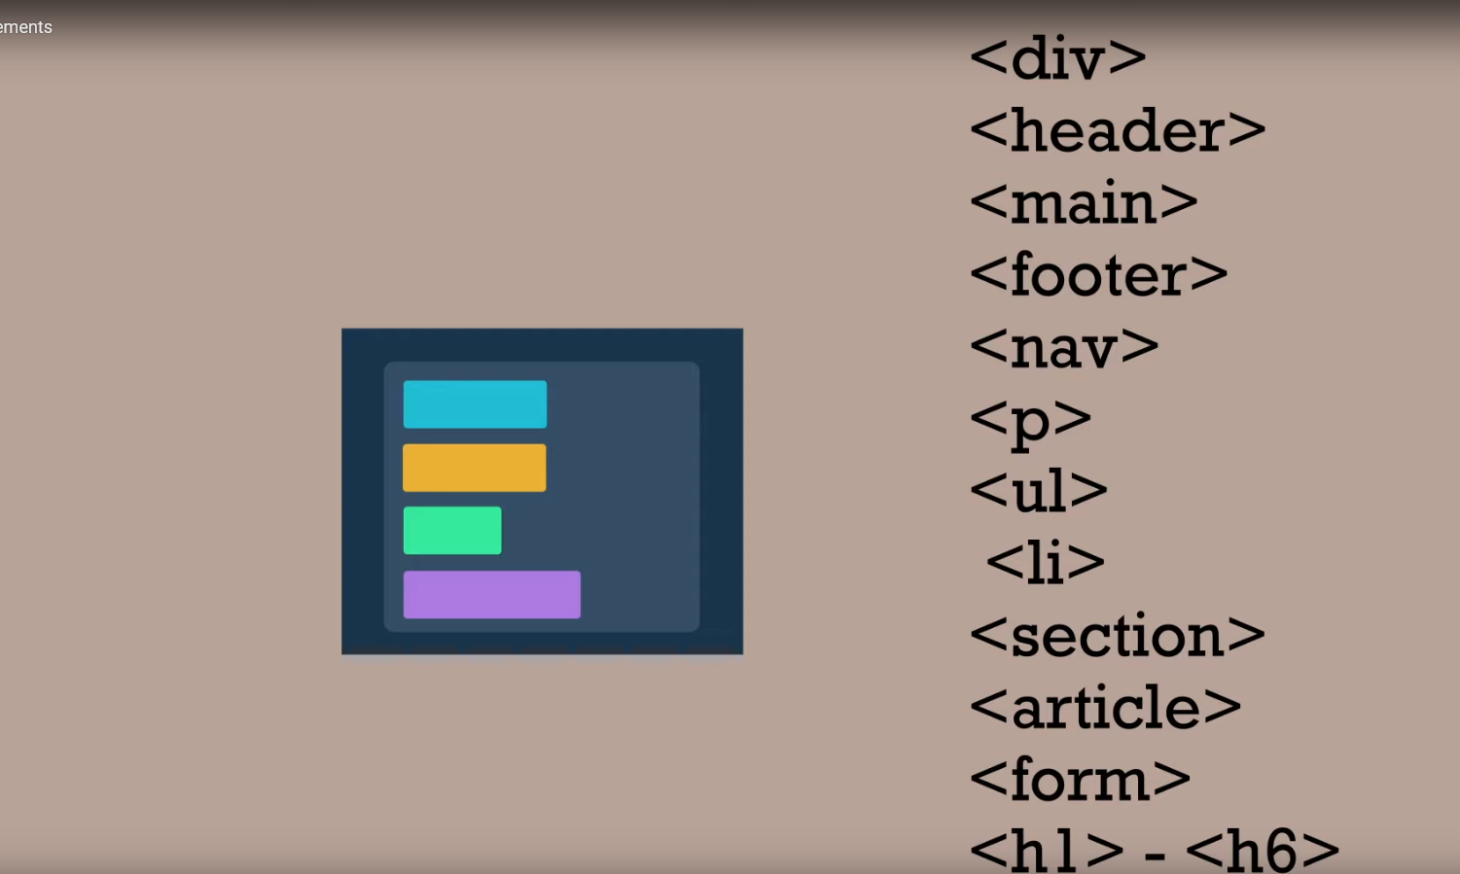

## Inline Elements:

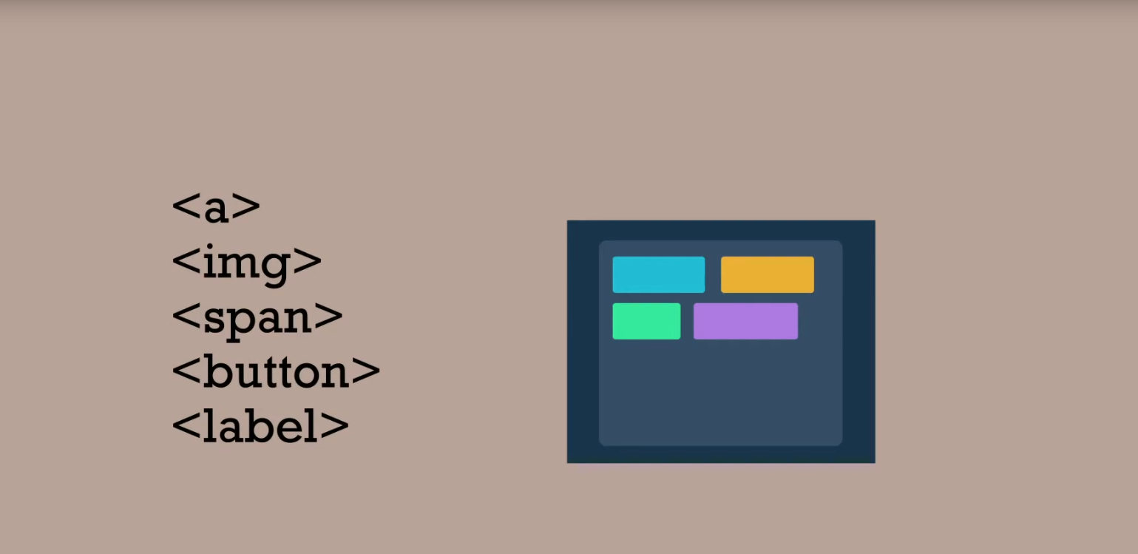

## Inline-Block

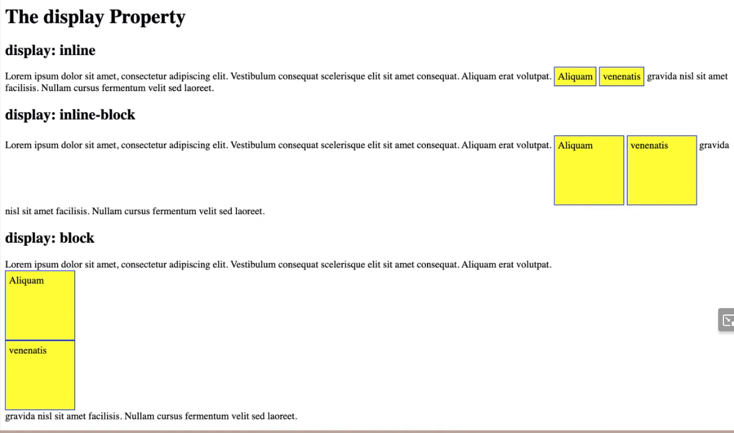

## Alignments with Block Information

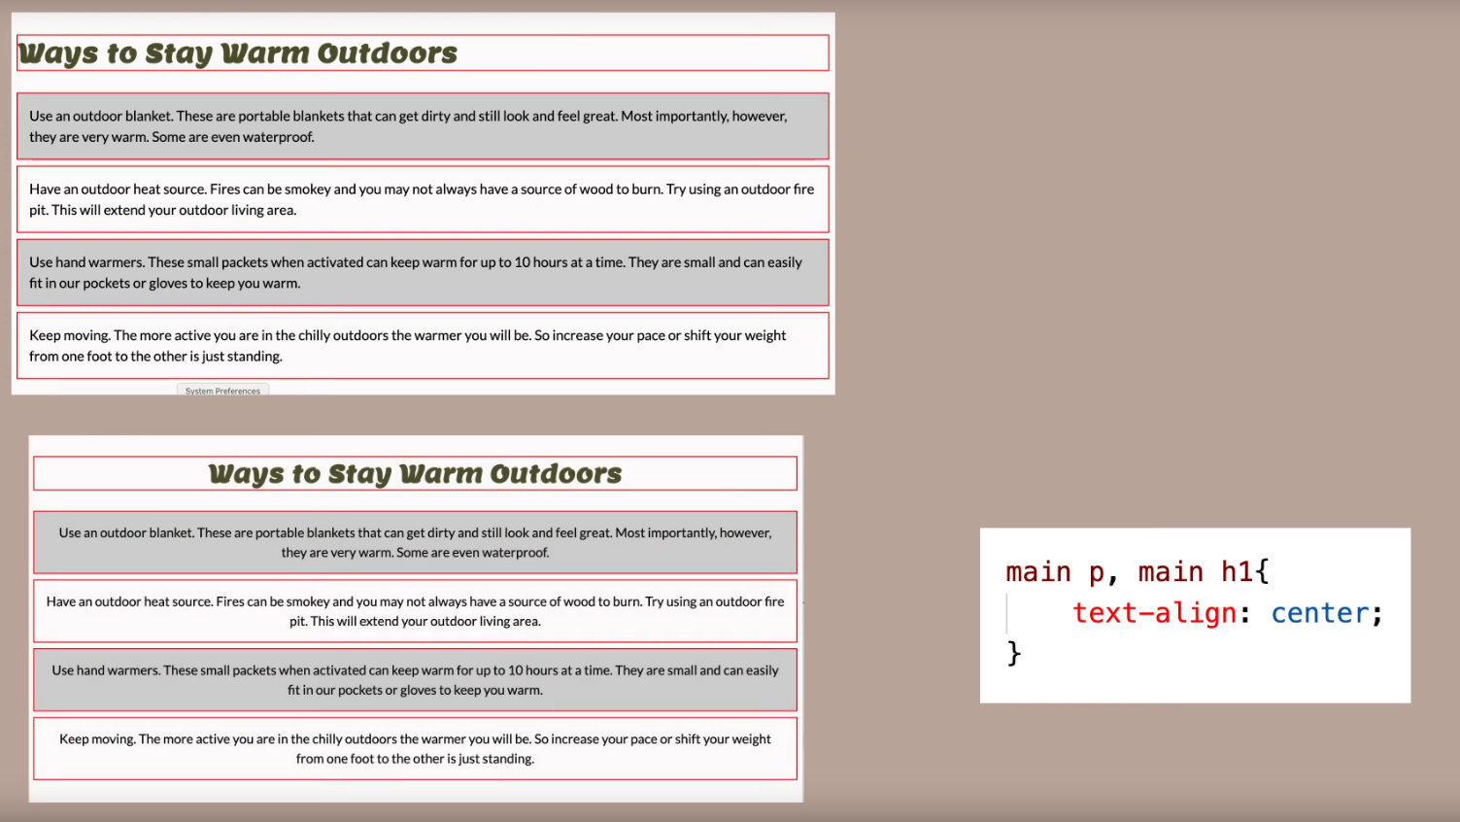

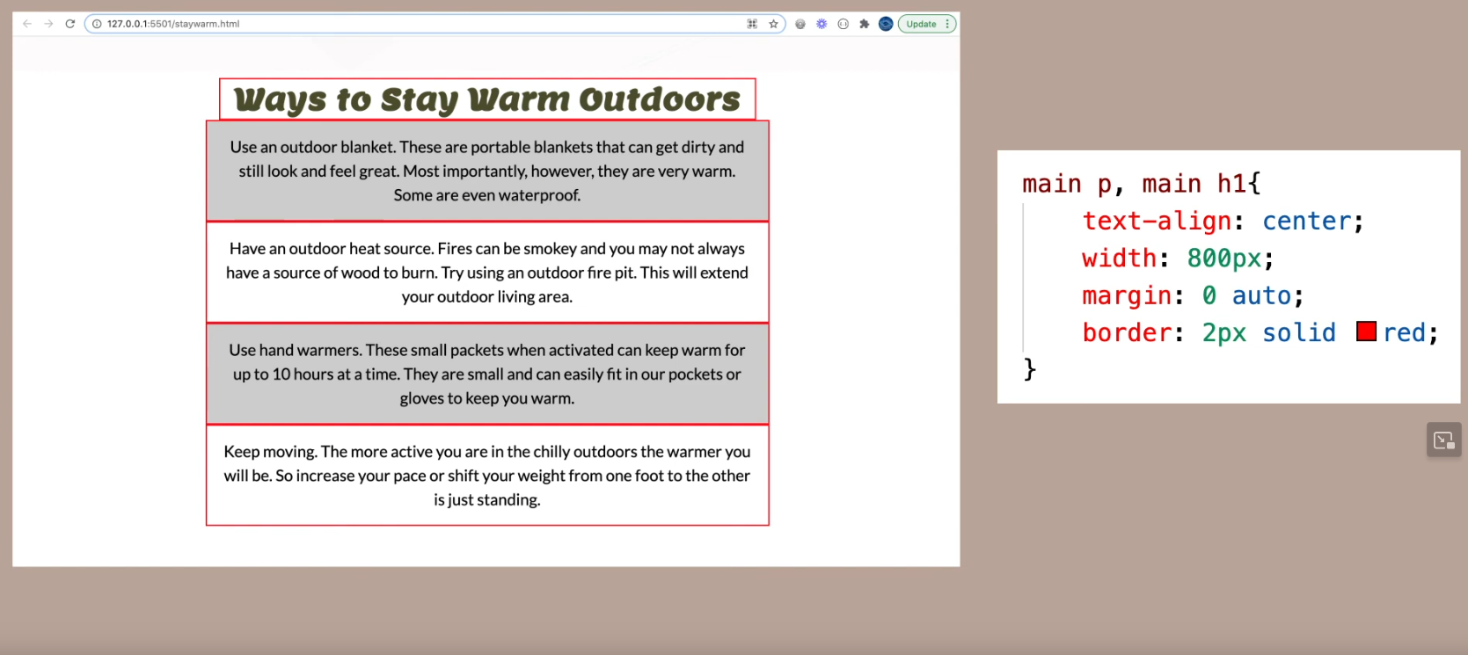

# CSS – Cascading Style Sheets (styling the webpage)

## Definition

CSS (Cascading Style Sheets) is a rule set language that defines the style and presentation of an HTML document. CSS is made up of rules that select elements from the document and that contain style declarations. An HTML document can have zero to many CSS references.

"Like HTML, CSS is not a programming language. It's not a markup language either. CSS is a style sheet language. CSS is what you use to selectively style HTML elements ... CSS is used to style and layout web pages — for example, to alter the font, color, size, and spacing of your content, split it into multiple columns, or add animations and other decorative features." - MDN

## Best/Not Best Practices

Not best to do “Inline CSS” or in other words writing it in line within a line of code.

Not best to embed within header information

Best to keep your HTML and CSS code separate in a separate file. This allows for multiple sheets to use the same style, and enables easier modifications with less coding. You can have multiple CSS files effecting a single page.

For example:

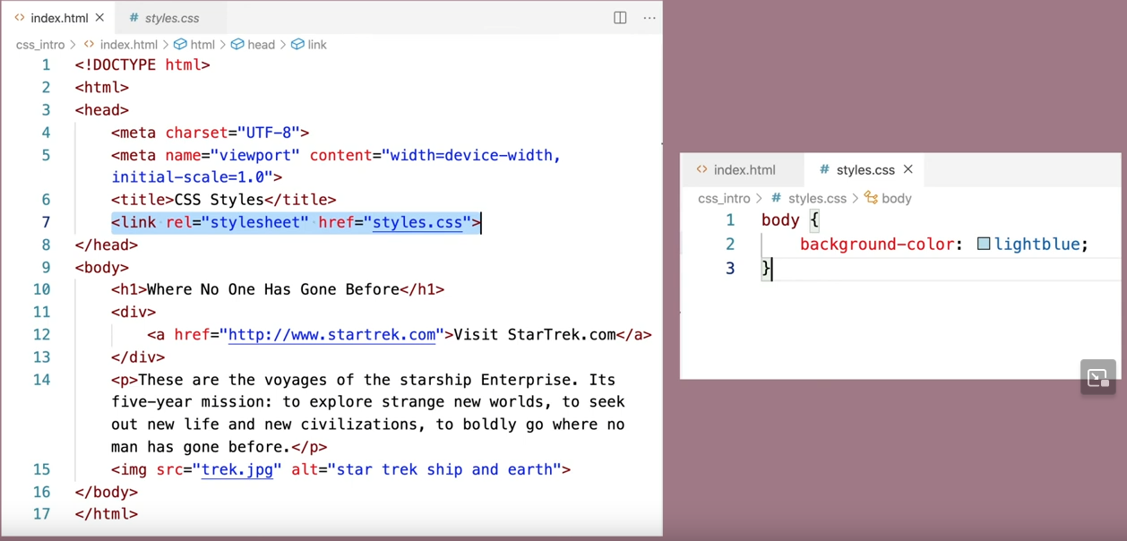

## Some Basic rules

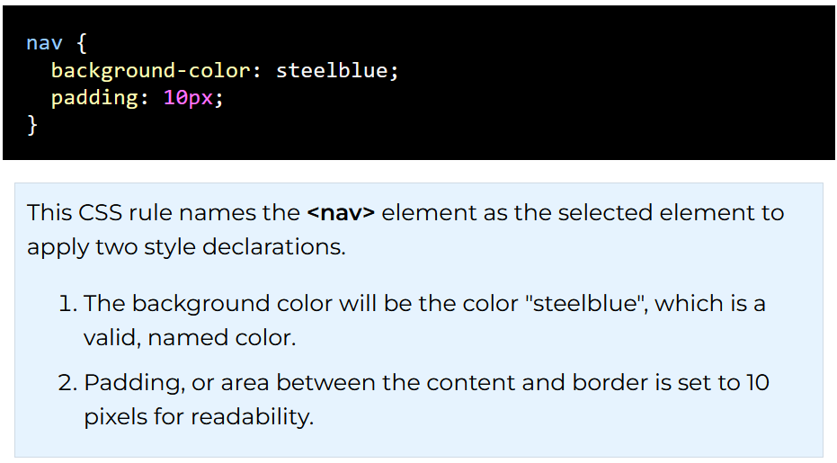

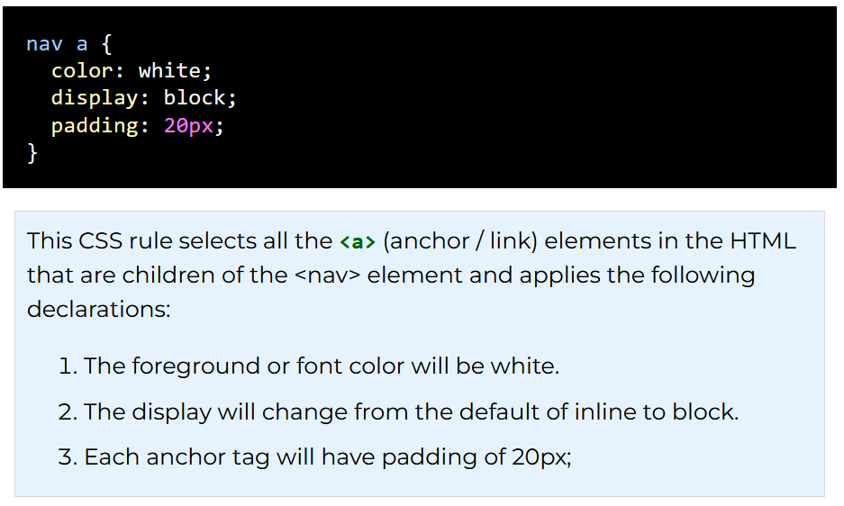

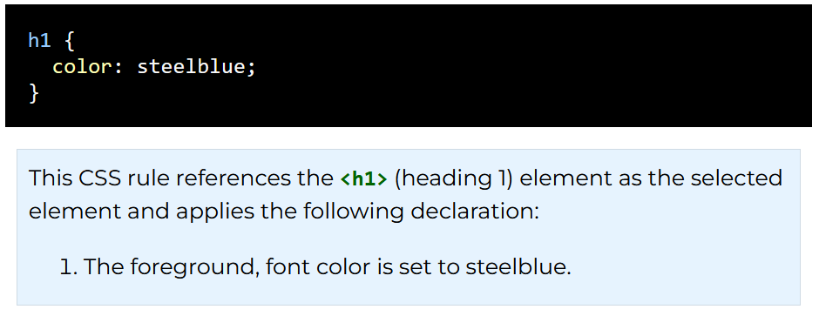

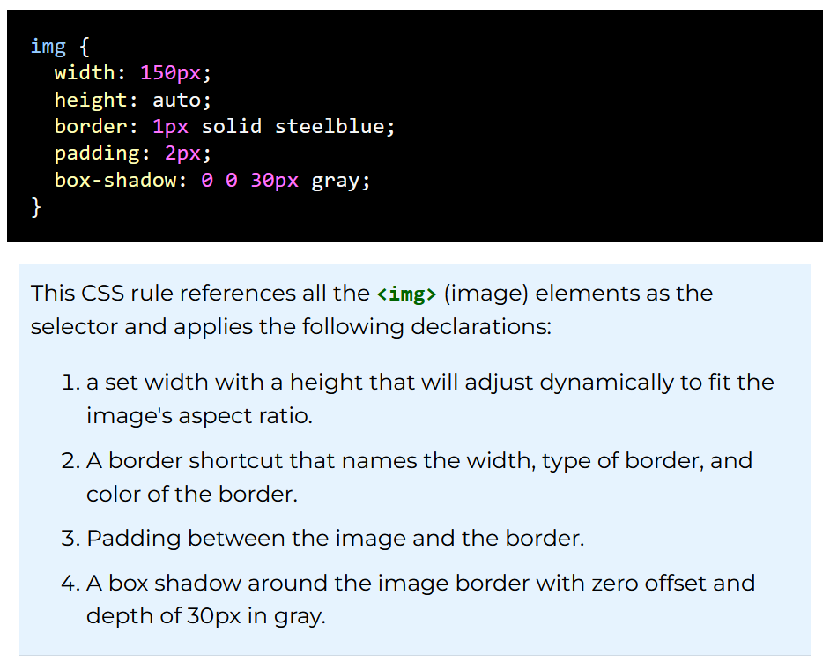

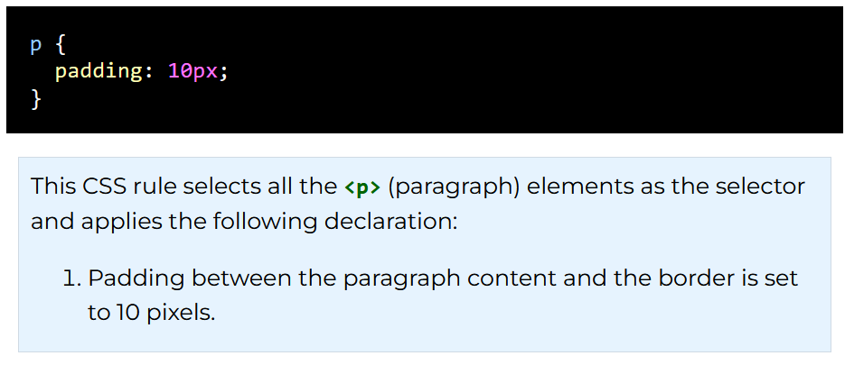

# CSS: Values and Units of Measurement

In CSS, property length values are needed to provide layout and presentation control. There are two main types - absolute and relative. The absolute type of length is not relative to anything else and is typically the same size on most devices. Relative types of lengths are dependent on other items including the parent, sibling, or the size of the viewport.

"Every property used in CSS has a value type defining the set of values that are allowed for that property."  
"The numeric type you will come across most frequently is the length (or unit of measurement). For example, 10px (pixels) or 30em. There are two types of lengths used in CSS — relative and absolute. It's important to know the difference in order to understand how big things will become." - MDN

## Unit Values

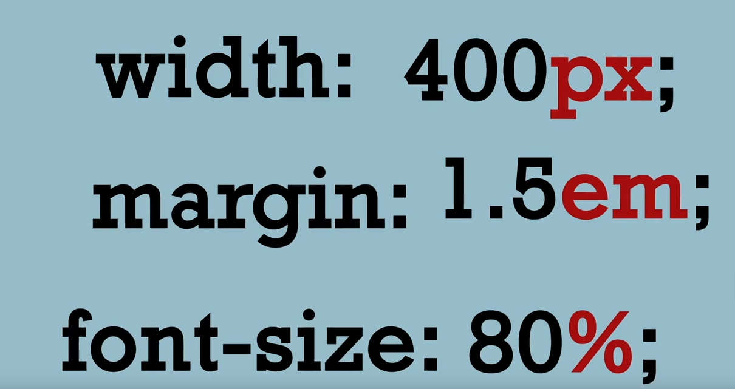

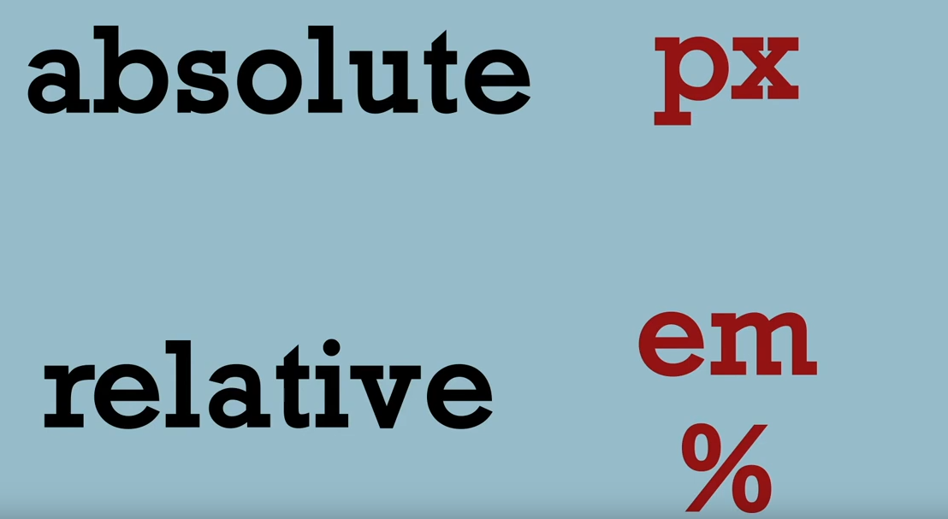

Relative will auto adjust to the size of the screen

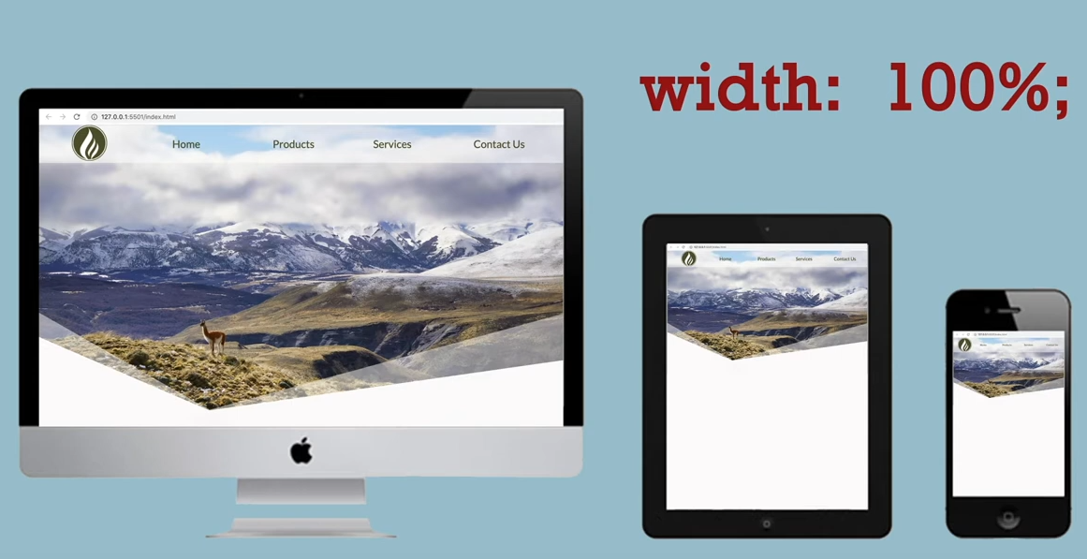

Absolutes will stay the same sized, no matter the size screen.

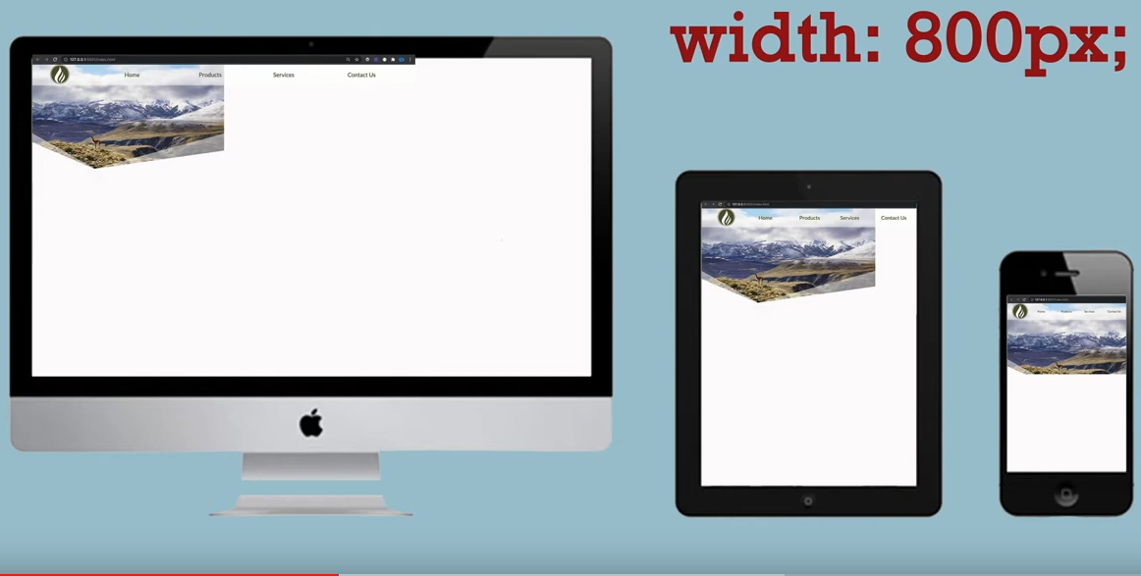

Rem = root em, or referencing the default font size.

[CSS: Units of Measurement](https://youtu.be/q7a7KX2N19U)

## Color values in CSS can be coded by:

* **keyword**: antiquewhite, burlywood, yellow, lightyellow, etc.
* **hexadecimal** RGB (red, green, blue): #faebd7  
  where the first two characters are the red value, the next two are the green value, and the last two are the blue value in hexadecimal (base16) format (0 to F).
* **RGB or RGBA**: rgb(250, 235, 215) or rgba(250, 235, 215, 1)  
  where r is a red value ranging from 0 to 255, g is a green value ranging from 0 to 255, b is a blue value ranging from 0 to 255, and the a is the alpha value ranging from 0 to 1.
* **HSLA** which is hue, saturation, lightness, and alpha: hsla(34, 78%, 91%, 1)

## CSS: Box Model

CSS Box Model is a box that wraps around every element. From the inside out the model defines for rendering the content, padding, border, and finally margin.

"When laying out a document, the browser's rendering engine represents each element as a rectangular box according to the standard CSS basic box model. CSS determines the size, position, and properties (color, background, border size, etc.) of these boxes." - MDN

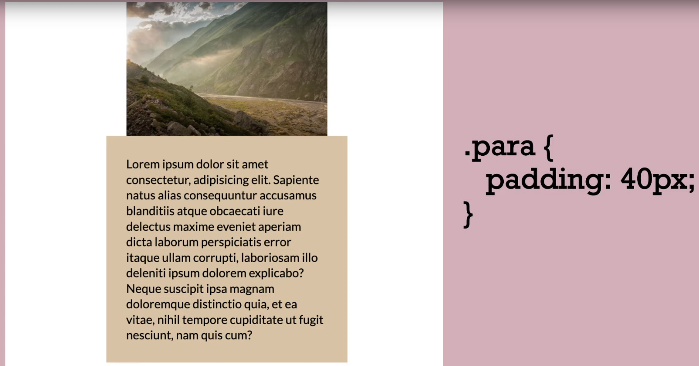

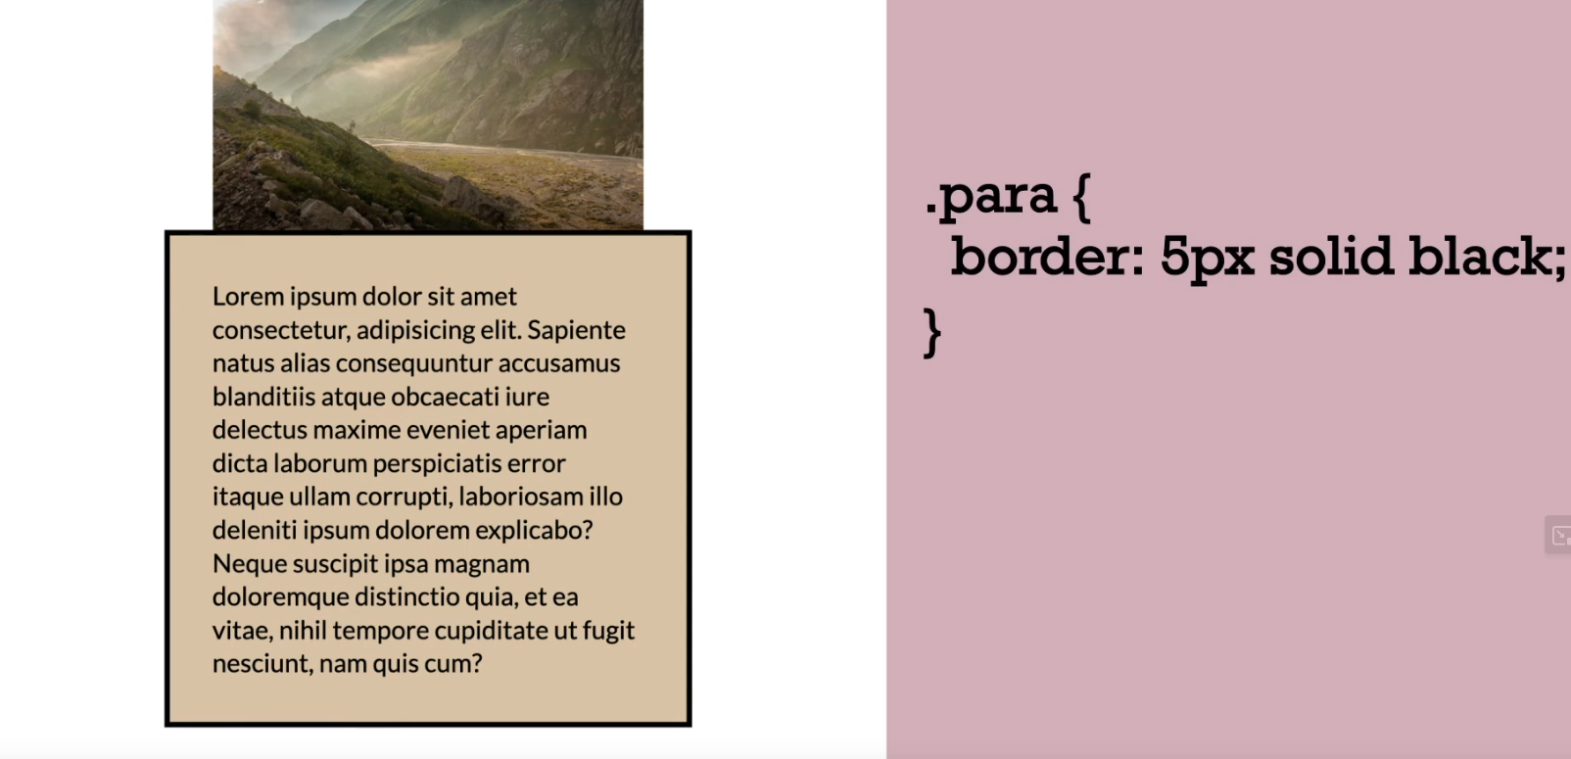

There are multiple types of boarders.

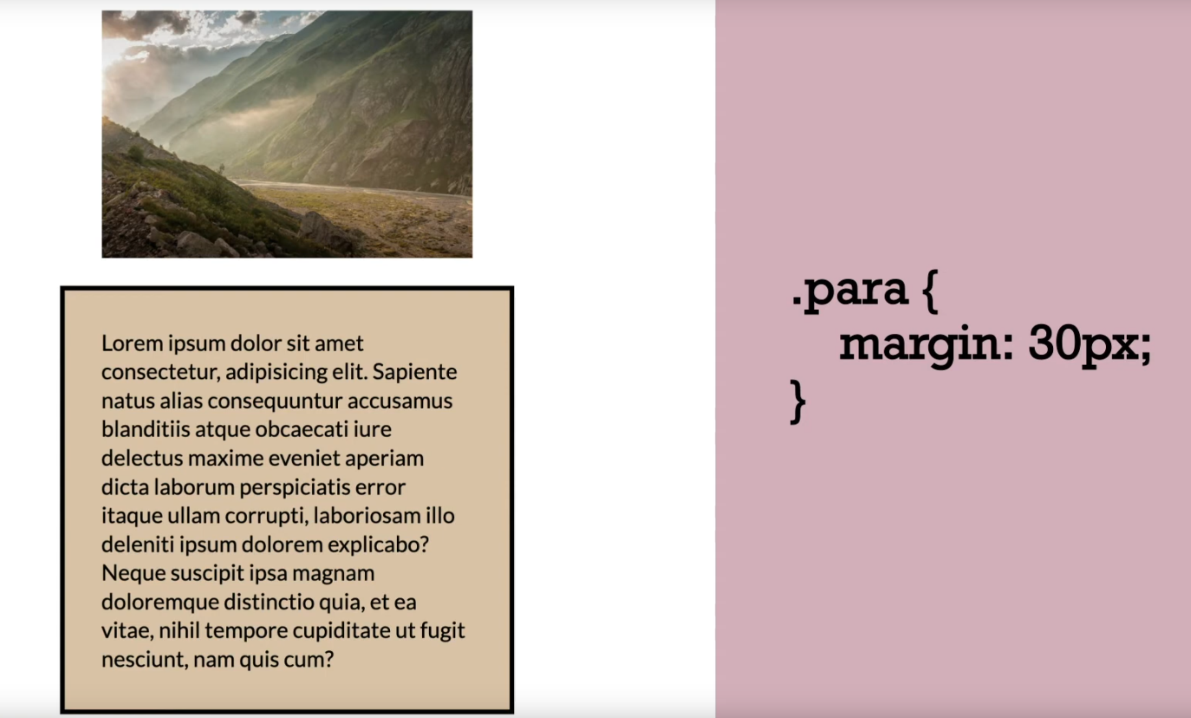

Margins space out items

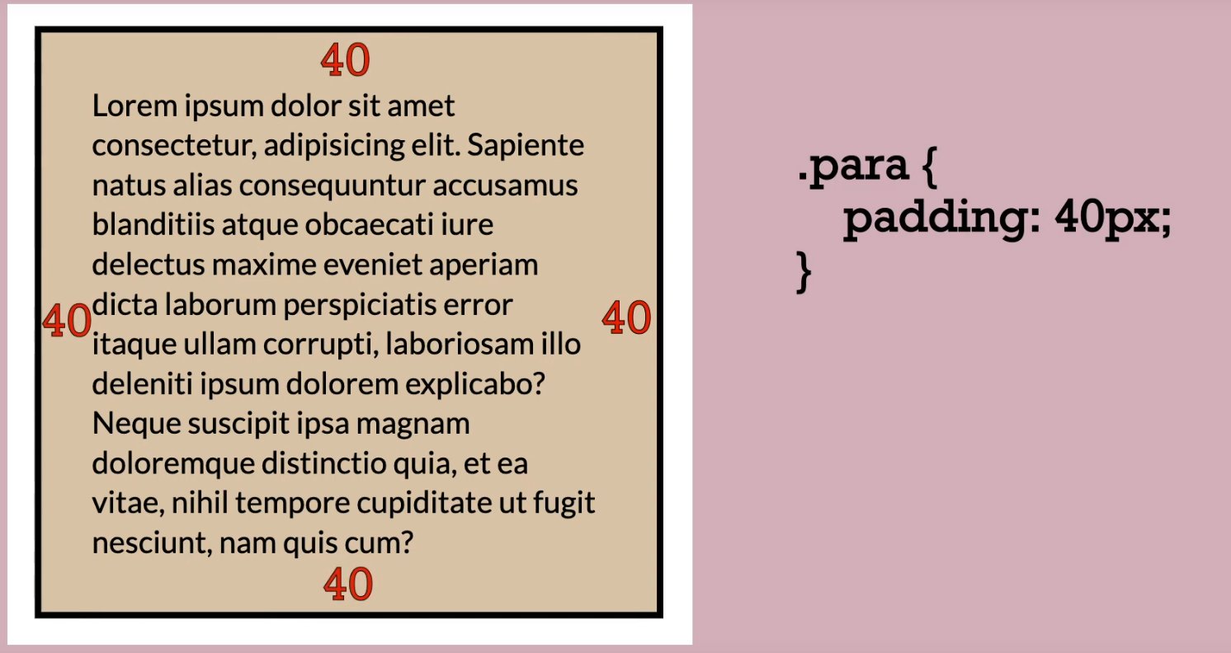

Padding values can be added singularly or to each side

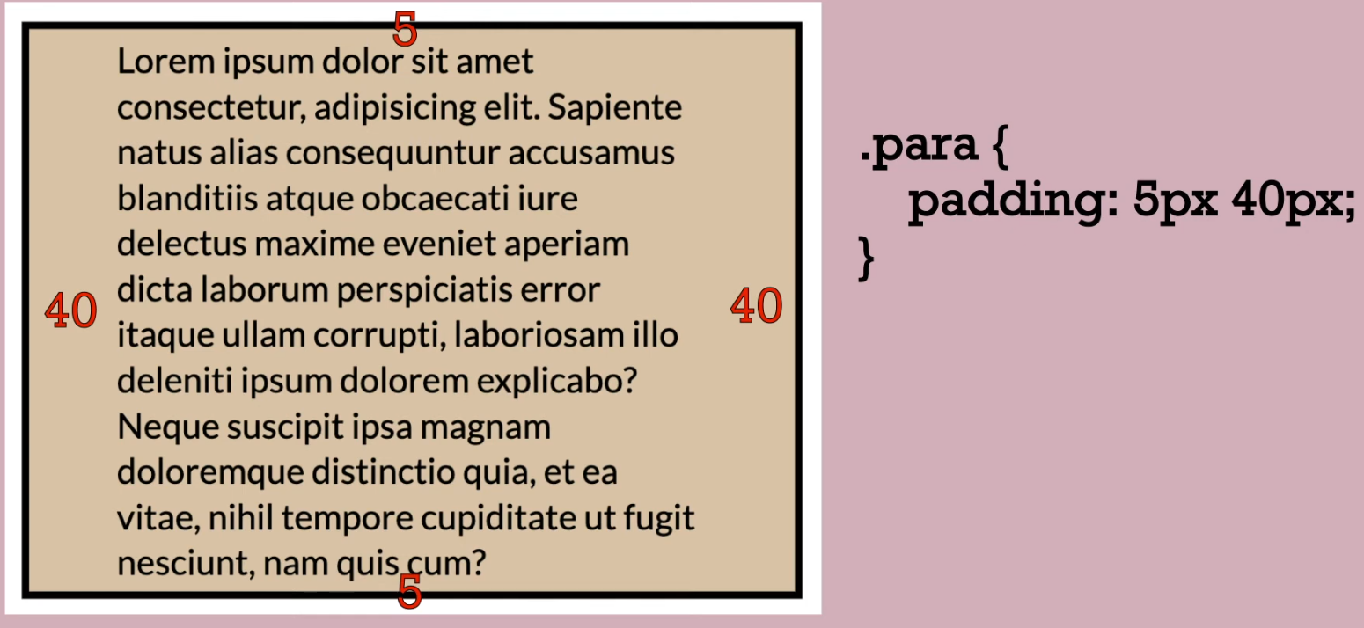

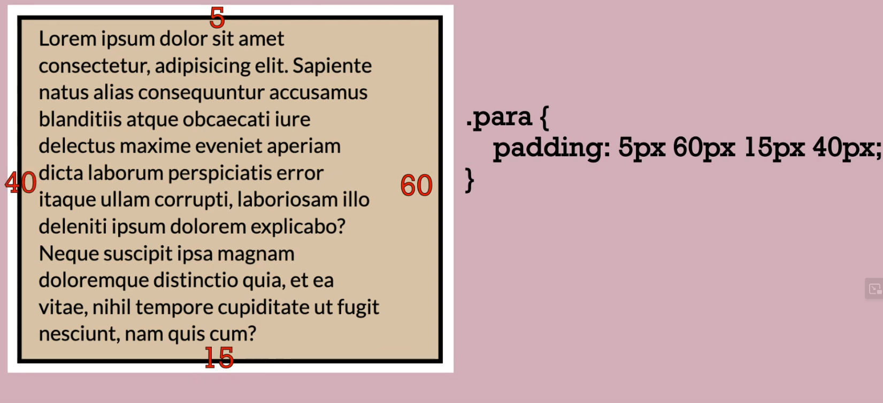

Or be added to specific

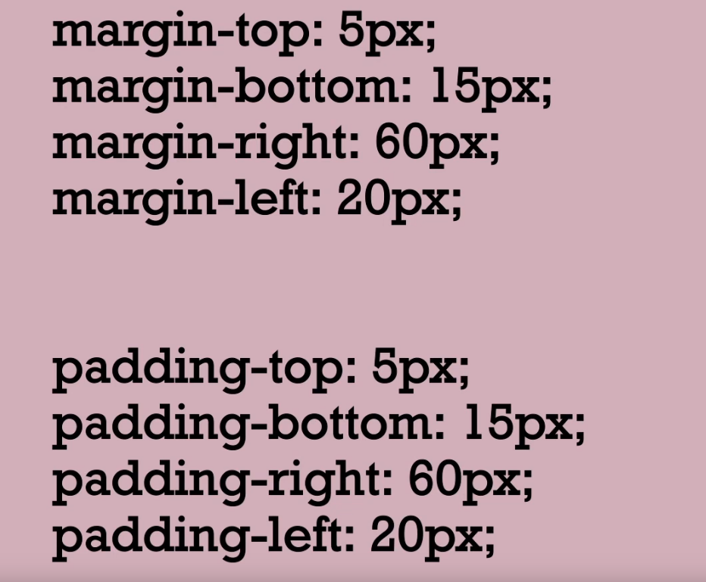

Width sizes do not include padding and boarders

## Box Model Diagram

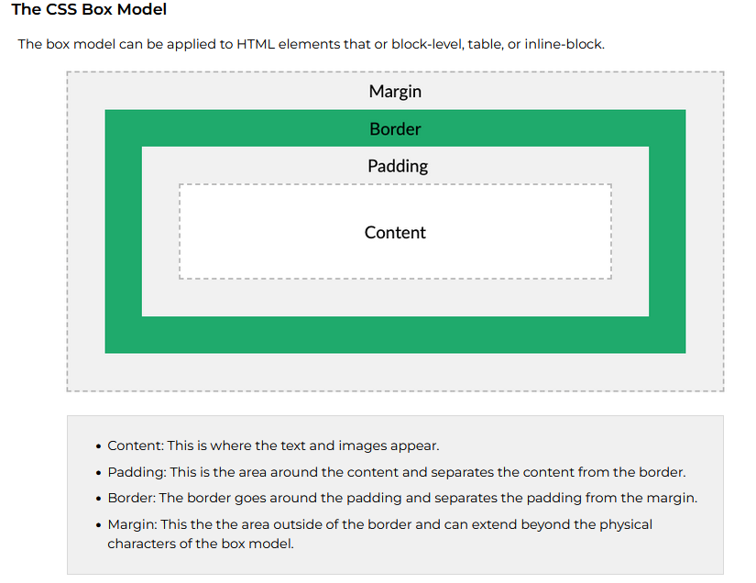

## CSS Shorthand Notation

CSS shorthand notation is generally considered best practice for conciseness, readability, and performance. However, longhand notation has its uses and can be more appropriate in certain situations where specificity is needed.

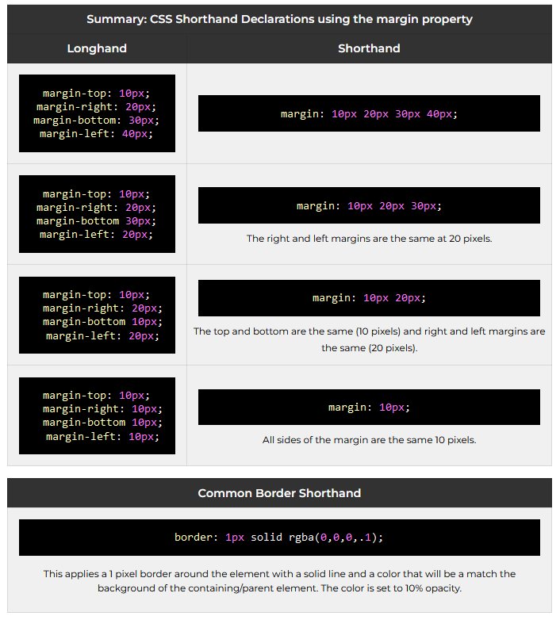

# Tools

## Contrast Checker

<https://www.siegemedia.com/contrast-ratio>

[Contrast Ratio](https://contrast-ratio.com/?ref=frontendchecklist)

## Image Resizer

[Squoosh.app](https://squoosh.app/).

[JPG to Webp](https://cloudconvert.com/jpg-to-webp)

## Auto Word Filler (Nonsensical)

The paragraph content can be filler/placeholder text. To automatically fill the paragraph with [Lorem ipsum text](https://en.wikipedia.org/wiki/Lorem_ipsum), in VS Code type lorem10 and then press the Tab key and ten (10) words will be written automatically. You can change the number 10 to the desired size.

## Built in Emoji Selector

**Windows/Linux**: Hold the windows key and press period (.)  
**macOS:** Hold down the following three keys at the same time: Command+Control+Spacebar or press the fn key.

## Font Selection

[Google Font Selection](https://fonts.google.com/)

## CSS Overview

[CSS Overview](https://learn.microsoft.com/en-us/microsoft-edge/devtools-guide-chromium/css/css-overview-tool)

## Useful Links

[How to choose breakpoints](https://web.dev/articles/responsive-web-design-basics%23breakpoints)

[10 Modern Layouts](https://www.youtube.com/watch?v=qm0IfG1GyZU)

[10 Modern Layouts Explorable](https://1linelayouts.glitch.me/)

[5+ Must Know HTML Tags That Almost Nobody Knows](https://www.youtube.com/watch?v=iX_QyjdctsQ&t=290s)

[00:00](https://www.youtube.com/watch?v=iX_QyjdctsQ&t=0s) - Introduction [00:35](https://www.youtube.com/watch?v=iX_QyjdctsQ&t=35s) - Fieldset [01:43](https://www.youtube.com/watch?v=iX_QyjdctsQ&t=103s) - Datalist [03:13](https://www.youtube.com/watch?v=iX_QyjdctsQ&t=193s) - Color Picker [04:11](https://www.youtube.com/watch?v=iX_QyjdctsQ&t=251s) - Progress Bar [04:52](https://www.youtube.com/watch?v=iX_QyjdctsQ&t=292s) - Open Graph [07:51](https://www.youtube.com/watch?v=iX_QyjdctsQ&t=471s) - Sub/Sup [09:18](https://www.youtube.com/watch?v=iX_QyjdctsQ&t=558s) - Picture [13:19](https://www.youtube.com/watch?v=iX_QyjdctsQ&t=799s) - Template [15:19](https://www.youtube.com/watch?v=iX_QyjdctsQ&t=919s) - Outro

## Wireframe

You can create your own, free **wireframe** designs using the online application [jGraph-Diagrams.net](https://app.diagrams.net) or you can install on your own system from [JGraph](https://github.com/jgraph/drawio-desktop/releases). There are many other viable choices including [Moqups](https://moqups.com/). Note that you will need to create your own wireframe designs later in the course.

<https://wireframe.cc/>

## Color Schemes

<https://coolors.co/>

# Favicon Creation

[https://favicon.cc](https://www.favicon.cc/)

## Meta Tags Tester for OpenGraph(og)

<https://www.opengraph.xyz/>

# Comments

## HTML <!--...--> Tag

<!--This is a comment. Comments are not displayed in the browser-->   
  
<p>This is a paragraph.</p>

You can use the comment tag to "hide" scripts from browsers without support for scripts (so they don't show them as plain text):

<script type="text/javascript">  
<!--  
function displayMsg() {  
  alert("Hello World!")  
}  
//-->  
</script>

## CSS /* */

/* A one-line comment */

/*

A comment

which stretches

over several

lines

*/

/* The comment below is used to

disable specific styling */

/*

span {

color: blue;

font-size: 1.5em;

}

*/

**HTML Comment Example**

<!-- This is a comment -->

**CSS Comment Example**

/* This is a comment */

# Absolute URL References

An absolute URL is a complete URL that includes the protocol, domain, and path. For example, the following is an absolute URL to the BYU-Idaho about us page where https is the protocol, byui.edu is the domain and about is the path:

<a href="https://www.byui.edu/about/" target="_blank">BYU-Idaho</a>

The target attribute allows you to specify to open up the link in a new tab with the _blank value. Normally that should be left up to the user, who can open any link in their browser in a new tab, new window, private/incognito window, etc.

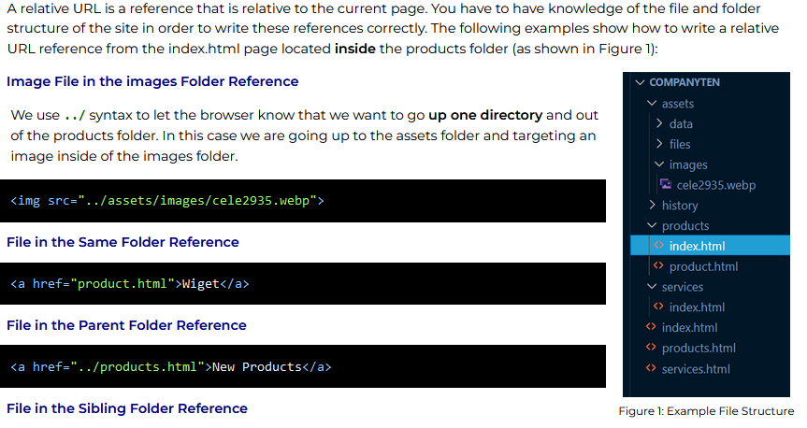

This reference will automatically load the default file in the **services** directory, which is **index.html**. We do not need to reference index.html files, just their directories.

<a href="../services">Services</a>

**Element on the Same Page**

<a href="#section-six">Section Six of the Report</a>

# CSS Selector Types

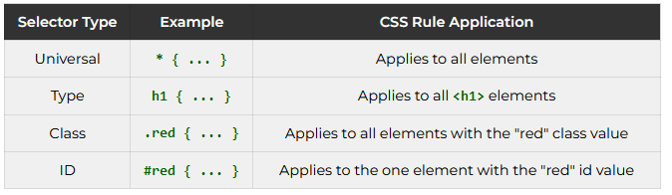

• A **class** attribute can be applied to many elements on a document. More than one class can be applied to a single element. The class can be selected by using period (.) notation.

**HTML class attribute and CSS class selector examples**

|  |  |
| --- | --- |
| **HTML** | **CSS** |
| <div class="callout highlight active"> <span class="highlight"> | .highlight {*declarations*} .callout {*declarations*} .active {*declarations*} |

• A **id** attribute can only be applied to one element per document. An element may only have one id per element. The id can be selected by [CSS id selector](https://developer.mozilla.org/en-US/docs/Web/HTML/Global_attributes/id) using hash (#) notation.

**HTML id attribute and CSS id selector example**

|  |  |
| --- | --- |
| **HTML** | **CSS** |
| <nav id="sub-menu"> | #sub-menu {*declarations*} |

# CSS Layouts: Float and Clear

CSS Float is a property that can be applied to elements to remove them from the normal flow of the page and allow other elements to wrap around them. The float property can be applied to block-level elements and inline elements. The float property can be set to left or right to move the element to the left or right in the document flow. For example, this code block in this paragraph is floated to the right and contains a shorthand margin declaration that applies a margin on all sides of the element.

* By default, the CSS float property is none. There is no need to apply the float declaration unless you intend to float the element.
* To avoid unexpected layout issues, using the clear declaration to manage elements following a floated element as needed.

<https://developer.mozilla.org/en-US/docs/Web/CSS/float>

css

/* Keyword values */

float: left;

float: right;

float: none;

float: inline-start;

float: inline-end;

/* Global values */

float: inherit;

float: initial;

float: revert;

float: revert-layer;

float: unset;

css

/* Keyword values */

clear: none;

clear: left;

clear: right;

clear: both;

clear: inline-start;

clear: inline-end;

/* Global values */

clear: inherit;

clear: initial;

clear: revert;

clear: revert-layer;

clear: unset;

# Images and position/sizing

Working with images can be challenging because they have a set width and height that must be maintained wherever it is used on the page or else the image will appear pixelated and/or distorted. Normally, a general rule of thumb is to set only the width or the height, not both in CSS in order to maintain the image's aspect ratio. If the image containers are set, then setting the width to 100% is a common practice to ensure the image fills the container.

It is recommended that you start with the following CSS declaration for all of your work in this class to help control the aspect ratio of your images.

img {

width: 100%;

height: auto;

}

The CSS sets **all** image widths in the document to 100% the width of their containers and the height to auto, thus maintaining the intrinsic aspect ratio of the image.

The **aspect ratio**, which is the width by height measurement is often shown as **2:1** where the width is twice the height.

In the example above from the Church's website, the intrinsic dimensions of the image may not fit the actual container dimensions by just using an auto height. In these cases, the object-fit property can be used to set the image to fill the container. Here is an example of the CSS rule:

img { /* be careful as this rule applies to all images */

width: 100%;

height: 100%;

object-fit: cover;

}

# CSS Variables

CSS Variables are a powerful tool for managing the design of a website. They allow for the creation of reusable values that can be used throughout a stylesheet thus maintaining the design congruency. This activity will introduce you to CSS variables and how to use them in your projects.

"Complex websites have very large amounts of CSS, and this often results in a lot of repeated CSS values. For example, it's common to see the same color used in hundreds of different places in stylesheets. Changing a color that's been duplicated in many places requires a search and replace across all rules and CSS files. Custom properties allow a value to be defined in one place, then referenced in multiple other places so that it's easier to work with." - MDN

How are CSS variables used in website projects?

**Where: The :root Pseudo-Class**

* The :root pseudo-class is used to select the root element of the document. (The html element.)
* It is common to see the :root rule at the top of the CSS document, especially since global CSS variables will be declared within that rule.

**How: Writing Global CSS Variables**

* Global CSS variables are declared within the :root selector.
* Global CSS variables are declared using the -- prefix followed by the variable name, of your choice but follow the naming conventions.

Using Kebab notation with hyphens (-) is OK when naming CSS variables, e.g., *primary-color*

* Global CSS variables are used by calling the variable name with the var() function.

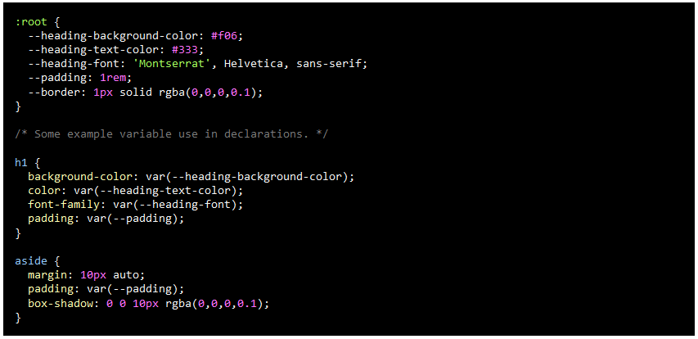

# Flex Box Containers

[Web Dev Simplified: Flex Box Containers](https://www.youtube.com/watch?v=fYq5PXgSsbE)

[Flexbox Fundamentals](https://developer.mozilla.org/en-US/docs/Learn/CSS/CSS_layout/Flexbox)

[Flexbox Frog Activity](https://flexboxfroggy.com/)

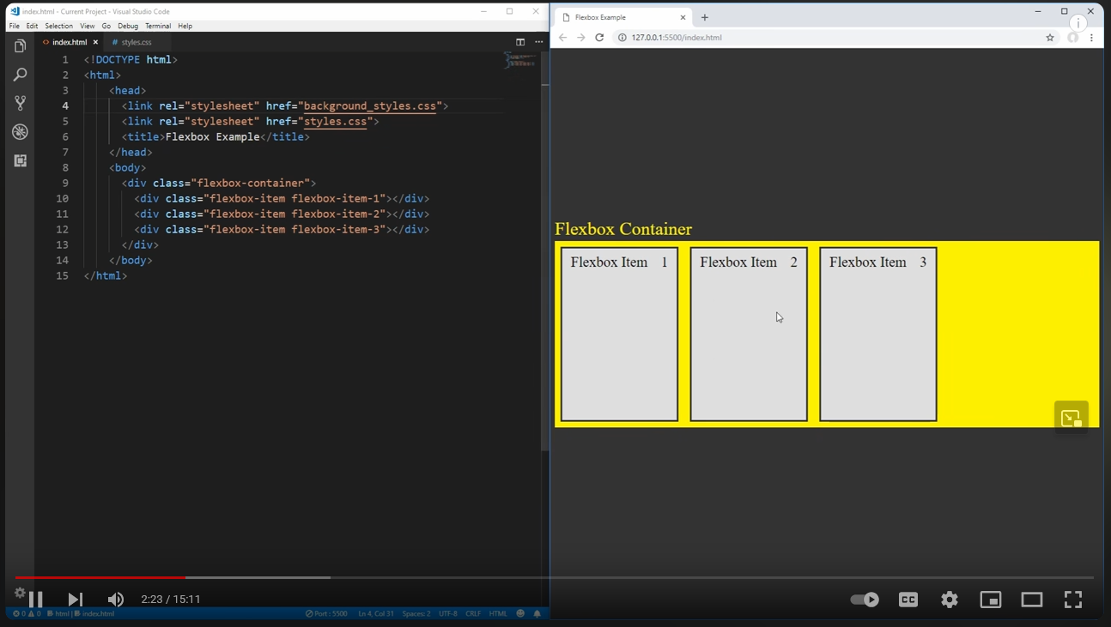

Remember the Main Axis aligning horizontally

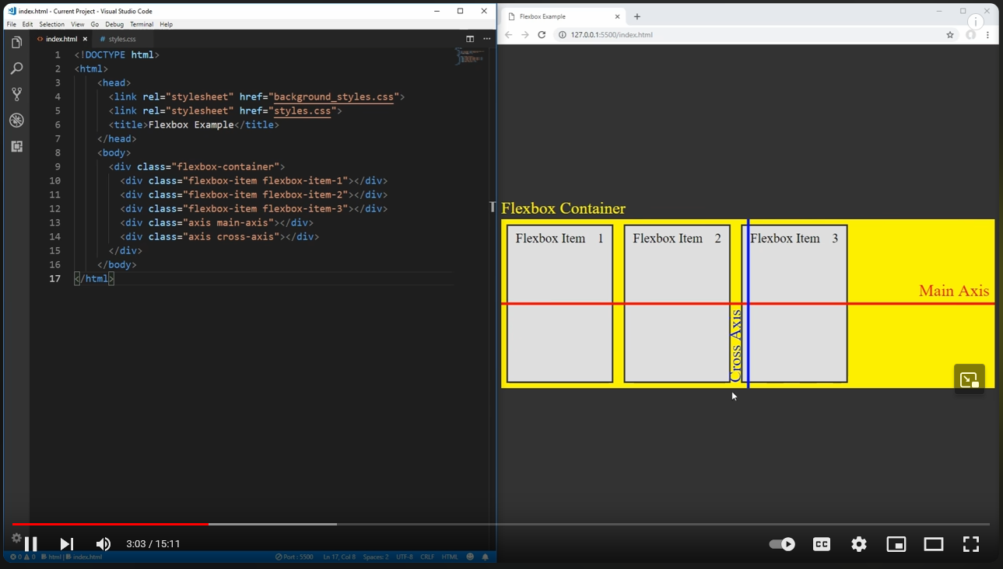

Or Vertically

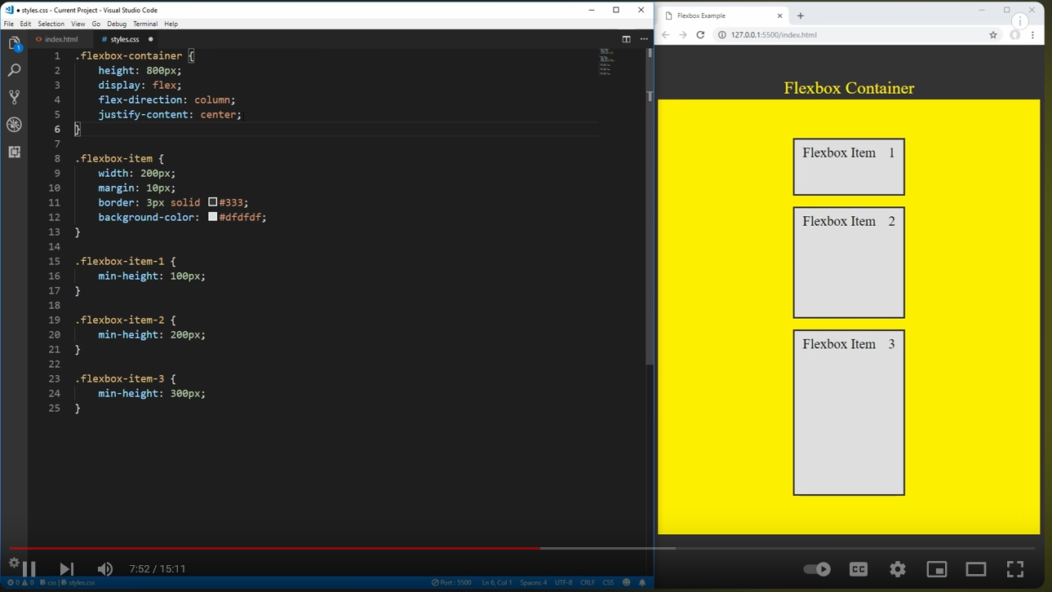

## Elements of Flexbox

Justify-content: allows you to move all items by justification, such as left and right, center, or spacing

For example: justify-content: center; (moves the flex boxes to the center)

* flex-start: Items align to the left side of the container.
* flex-end: Items align to the right side of the container.
* center: Items align at the center of the container.
* space-between: Items display with equal spacing between them.
* space-around: Items display with equal spacing around them.

Align-items: allows you to move all items by alignment, such as top to bottom.

For example: align-items: flex-start (moves flex boxes to bottom)

* flex-start: Items align to the top of the container.
* flex-end: Items align to the bottom of the container.
* center: Items align at the vertical center of the container.
* baseline: Items display at the baseline of the container.
* stretch: Items are stretched to fit the container.

Flex-direction: allows you to arrange all items and which are displayed first

For example: flex-direction: row-reverse; (reverses the order of which items are displayed via the HTML coding.

* row: Items are placed the same as the text direction.
* row-reverse: Items are placed opposite to the text direction.
* column: Items are placed top to bottom.
* column-reverse: Items are placed bottom to top.

Order: allows you to arrange specific items and which order they are displayed first.

For example: order:3 (moves this item to be the 3rd displayed from left to right)

* By default, items have a value of 0, but we can use this property to also set it to a positive or negative integer value (-2, -1, 0, 1, 2)

Align-self: allows you to arrange a single item similar to align-items

For example: align-self: flex-end; (moves single item to bottom of flexbox container)

* flex-start: Items align to the top of the container.
* flex-end: Items align to the bottom of the container.
* center: Items align at the vertical center of the container.
* baseline: Items display at the baseline of the container.
* stretch: Items are stretched to fit the container.

Flex-wrap: allows you to wrap which shifts all items to new line automatically based upon given space.

For example: flex-wrap: wrap (automatically shifts items to a new line based upon available space)

* nowrap: Every item is fit to a single line.
* wrap: Items wrap around to additional lines.
* wrap-reverse: Items wrap around to additional lines in reverse.

Flex-flow: a shorthand that allows both flex-direction and flex-wrap to combine together in 1 line.

For example: flex-flow: column wrap (sets items to be in a column and wrap to available space)

Align-content: used to set how multiple lines are spaced apart from each other. Determines the spacing between lines. (Different from align-items which determines how the items as a whole are aligned within the container.)

For example: align-content: flex-start (aligns all rows at the top of the flexbox)

* flex-start: Lines are packed at the top of the container.
* flex-end: Lines are packed at the bottom of the container.
* center: Lines are packed at the vertical center of the container.
* space-between: Lines display with equal spacing between them.
* space-around: Lines display with equal spacing around them.
* stretch: Lines are stretched to fit the container.

# CSS Layouts: Grid

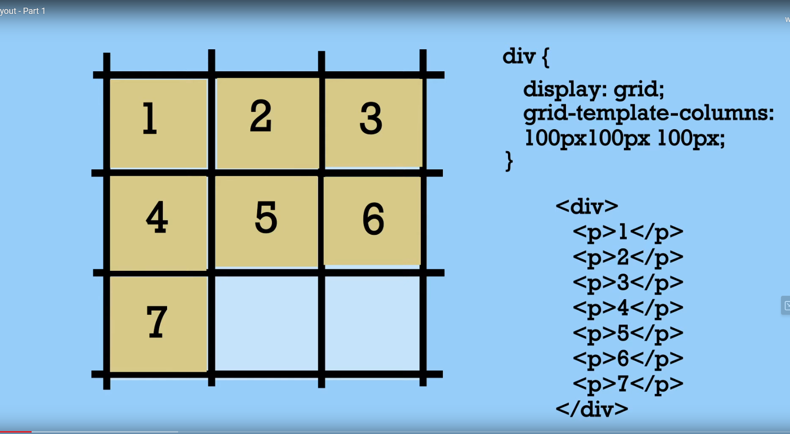

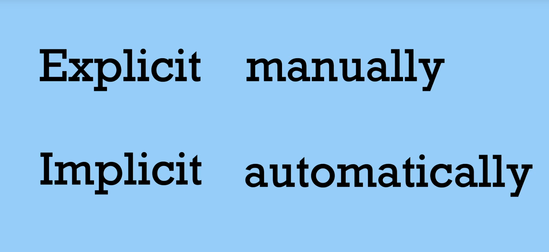

## Creating Columns

[Creating Columns](https://www.youtube.com/embed/1FyVcc1pIVU)

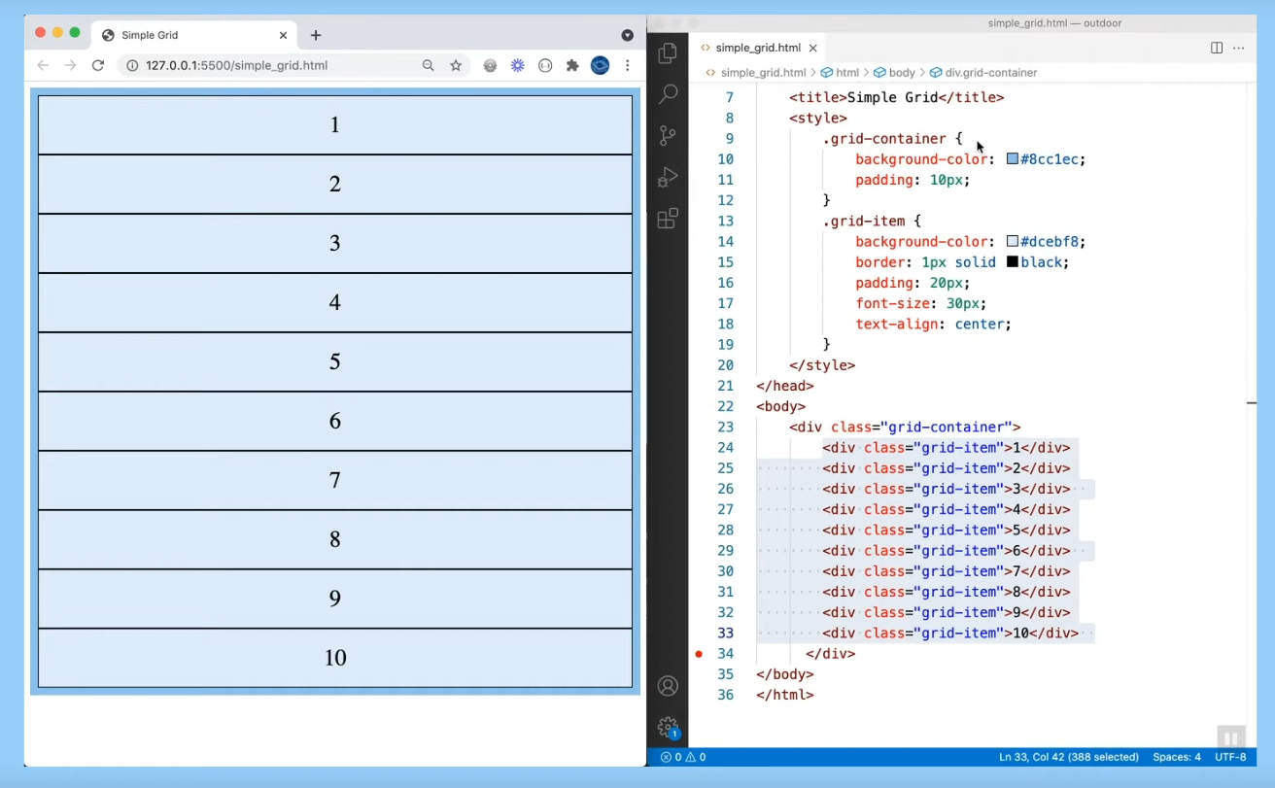

Add the column information. In this example it adds 3 columns

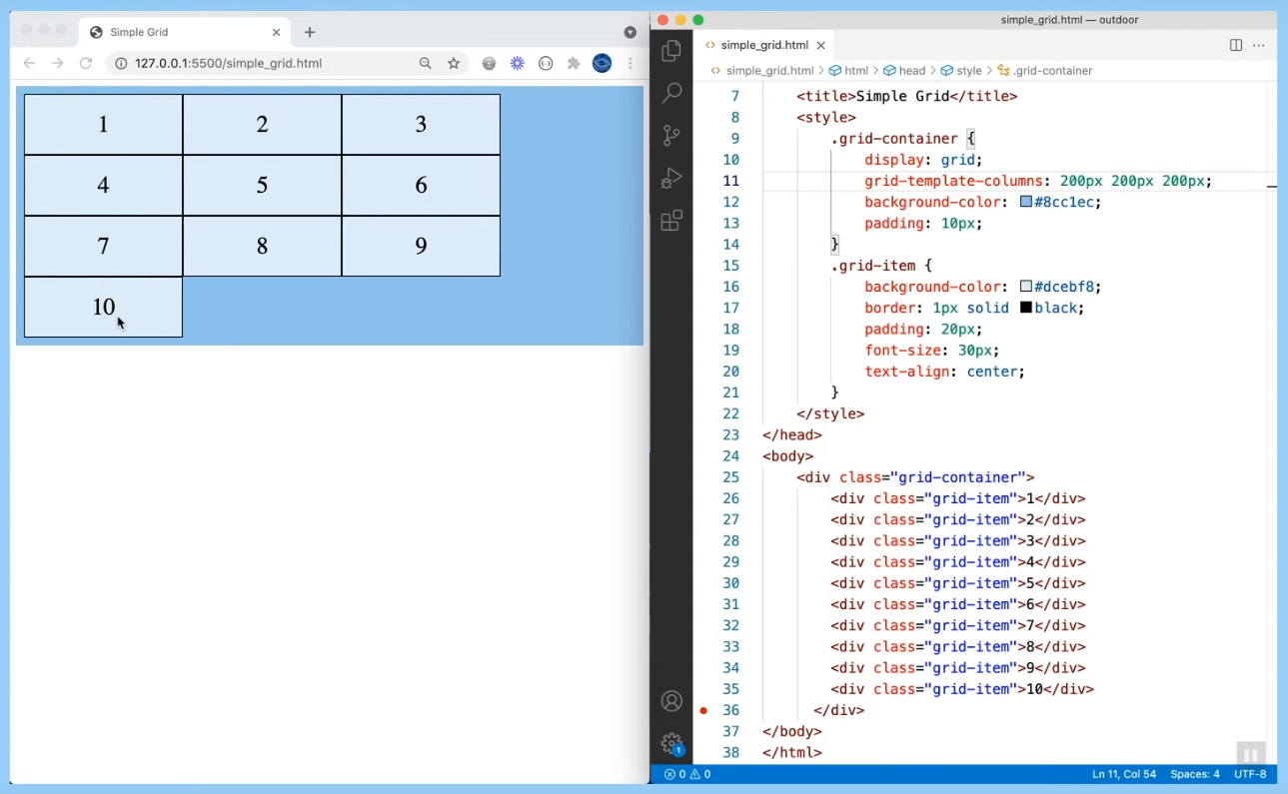

Adding spacing between grid parts

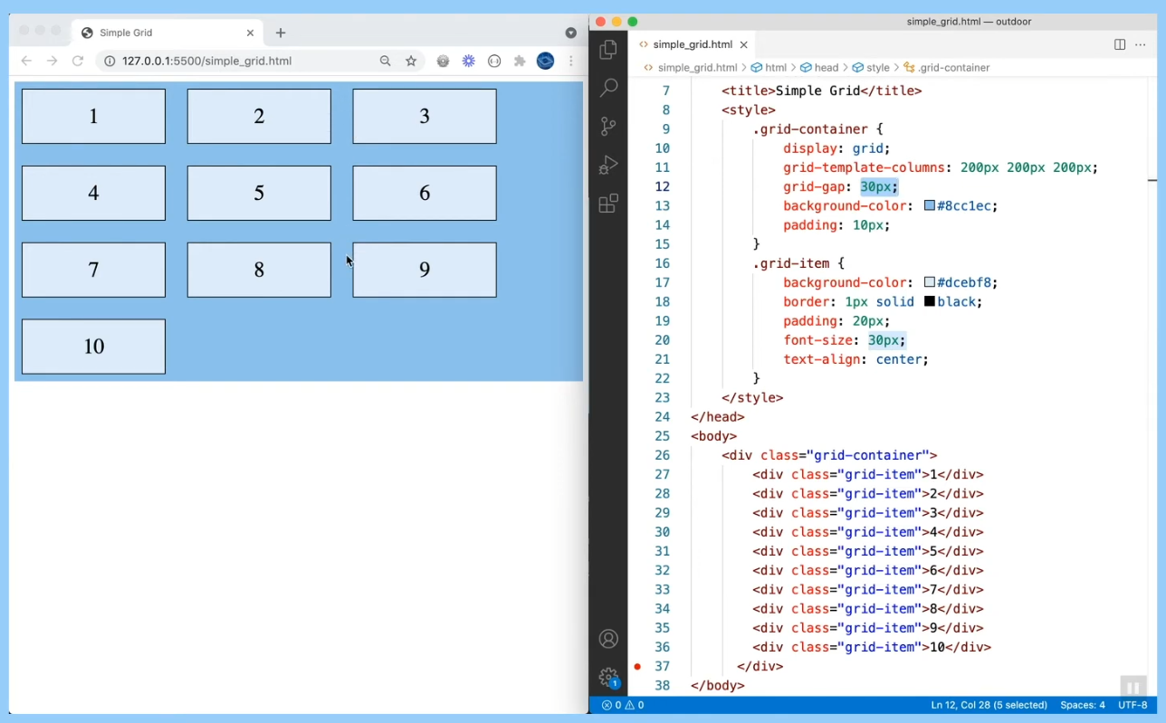

Using auto for column width

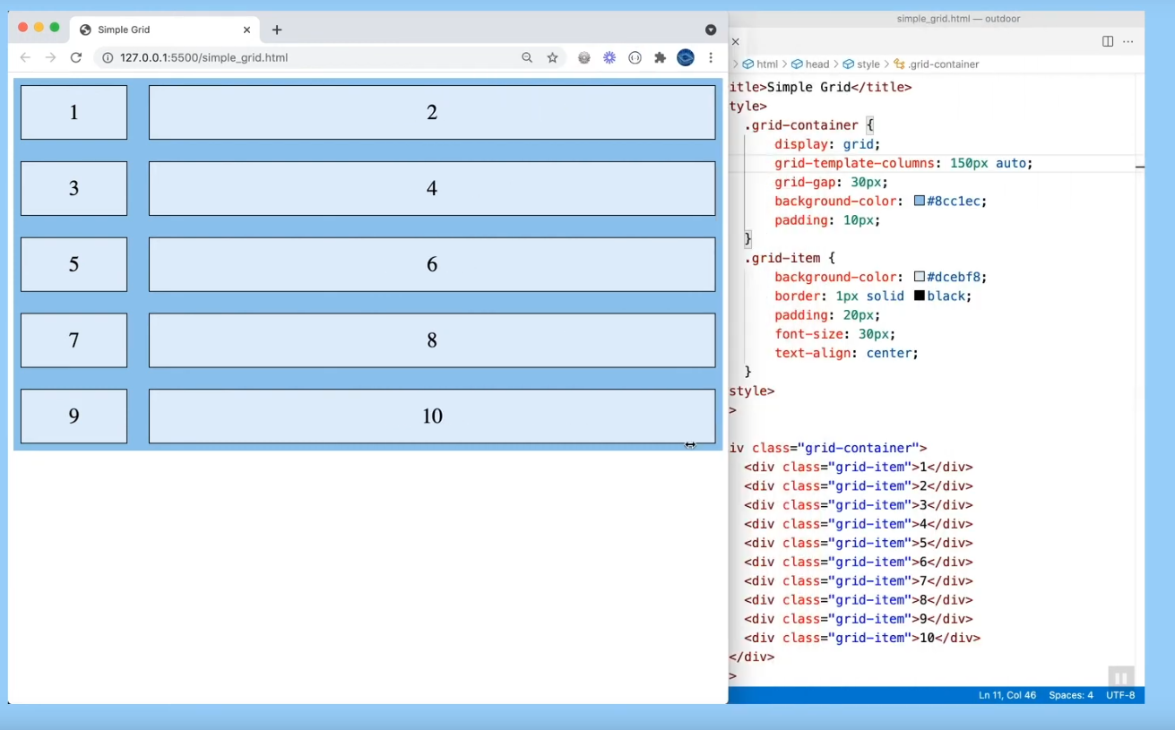

fr units allows a fraction of the whole. For example, 1fr, will set up even columns in the given space provided.

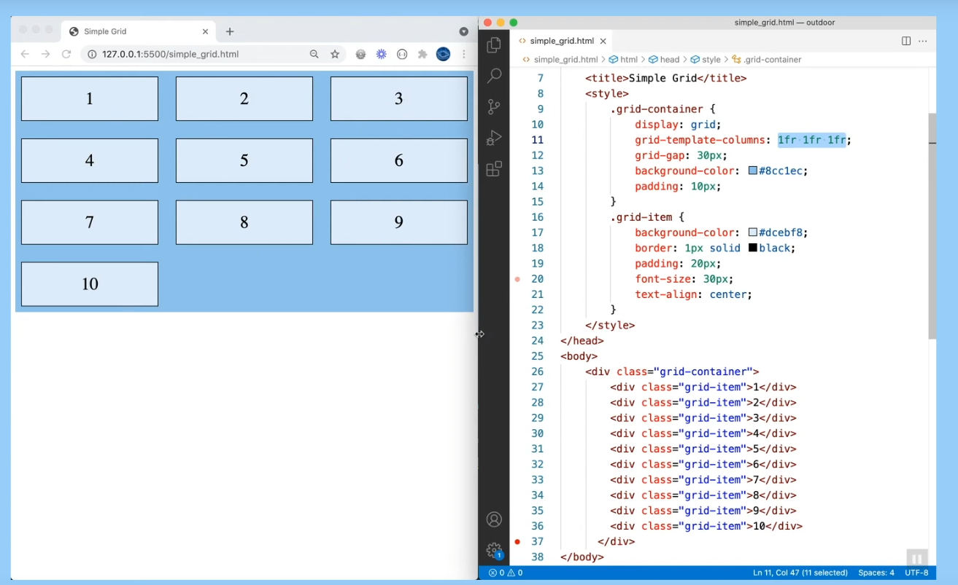

Short hand for measurements that are the same:

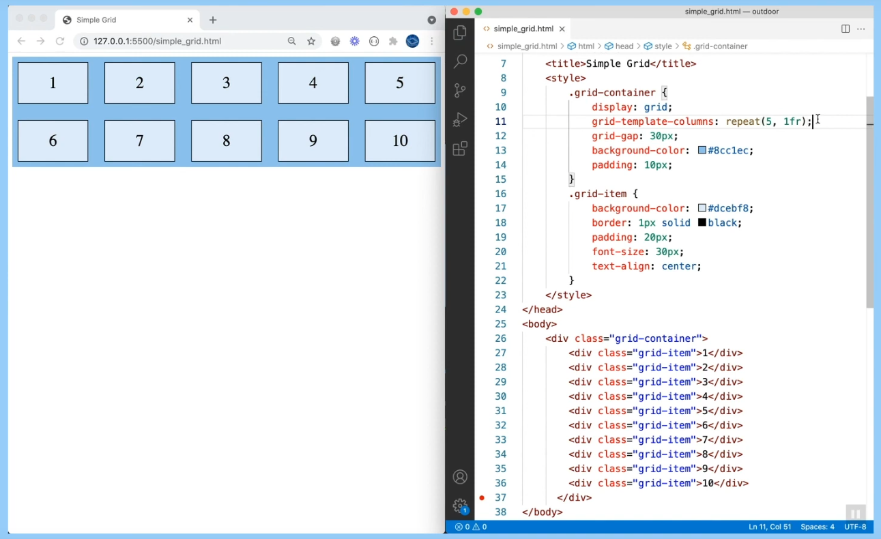

You can increase the size of a column to be larger:

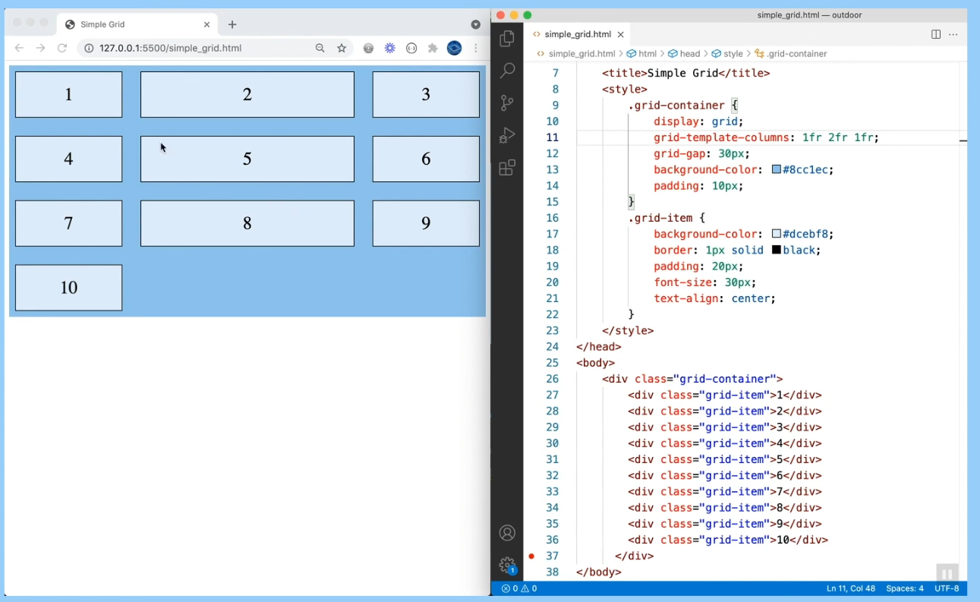

## Fine Tuning Grid

[Fine Tuning the Grids](https://www.youtube.com/embed/e3_70BJglG4)

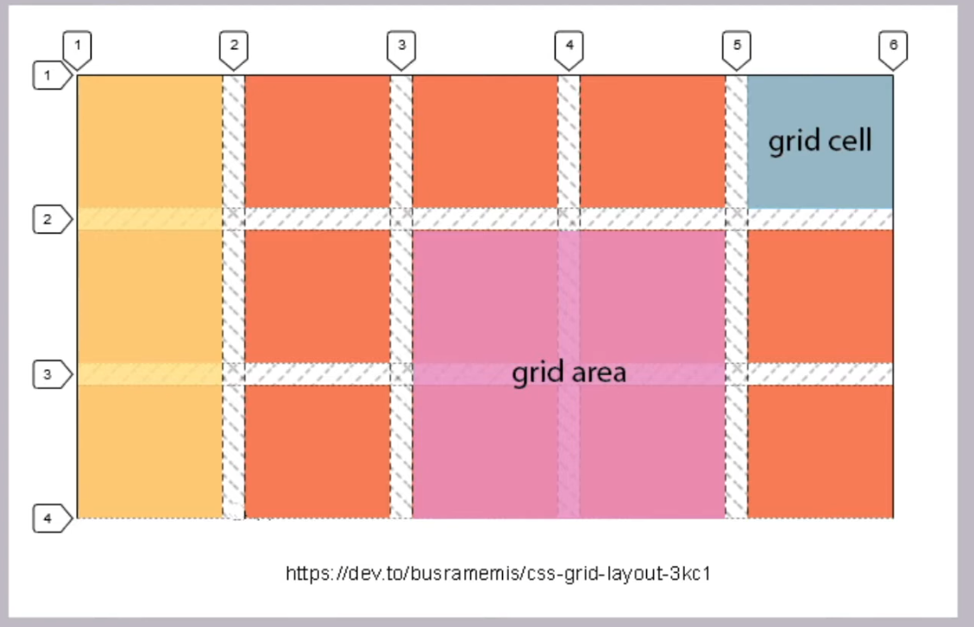

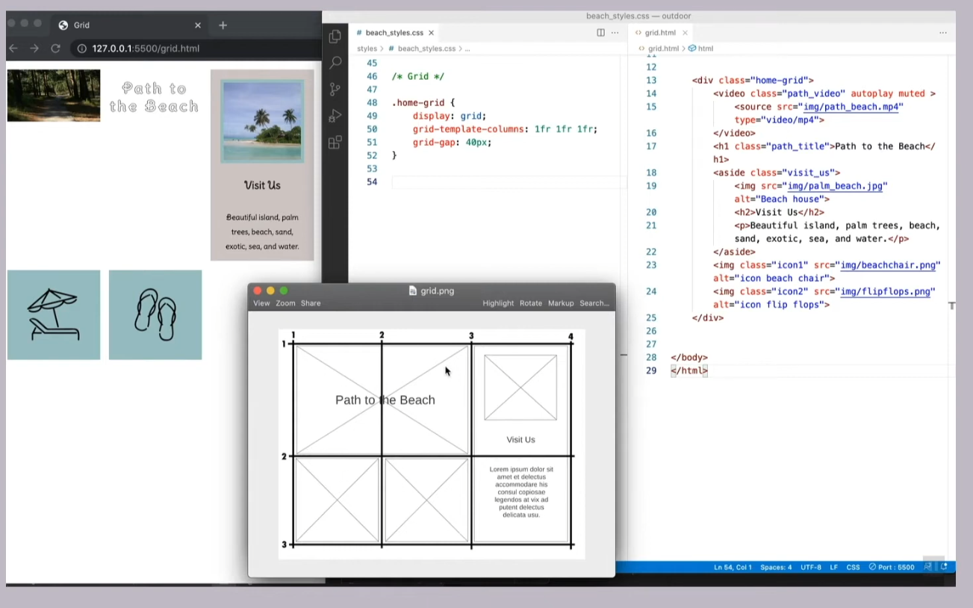

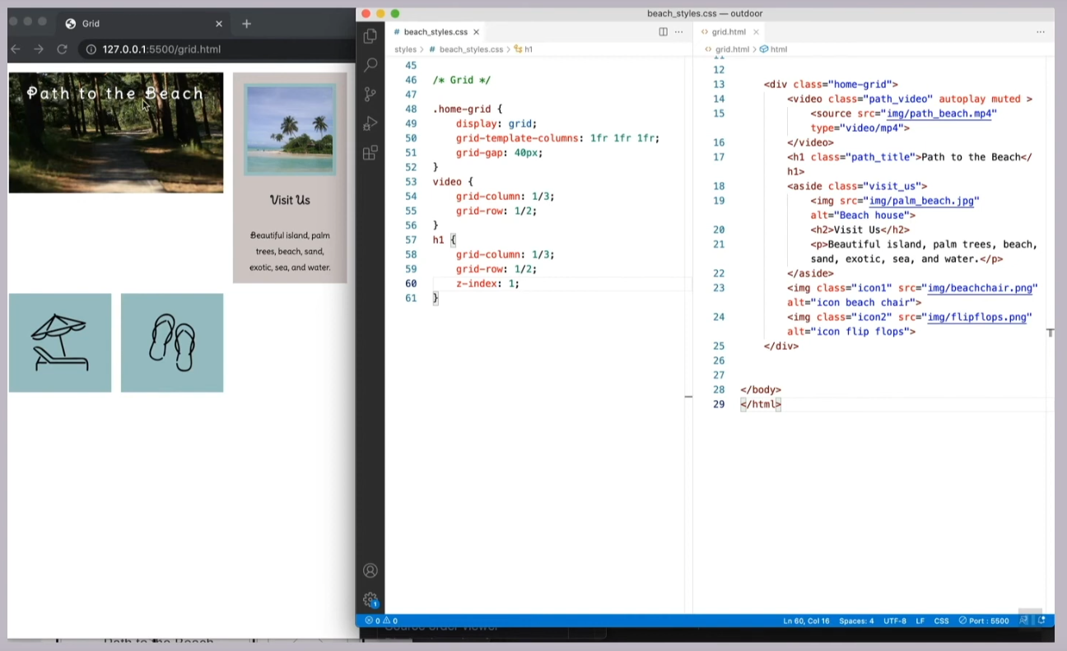

The grid-column and grid-row refer to the lines between the columns and rows, not the actual column or rows.

## Properties of the Grid

Grid-column-start: Allows you to set the starting location of the grid When grid-column-start is used alone, the grid item by default will span exactly one column.

Example: move the item from grid 1 to grid 5

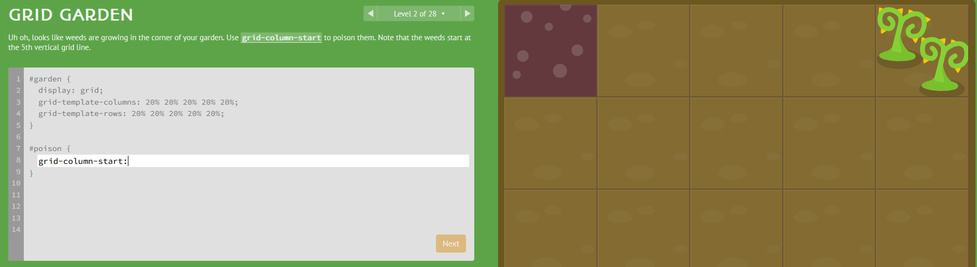

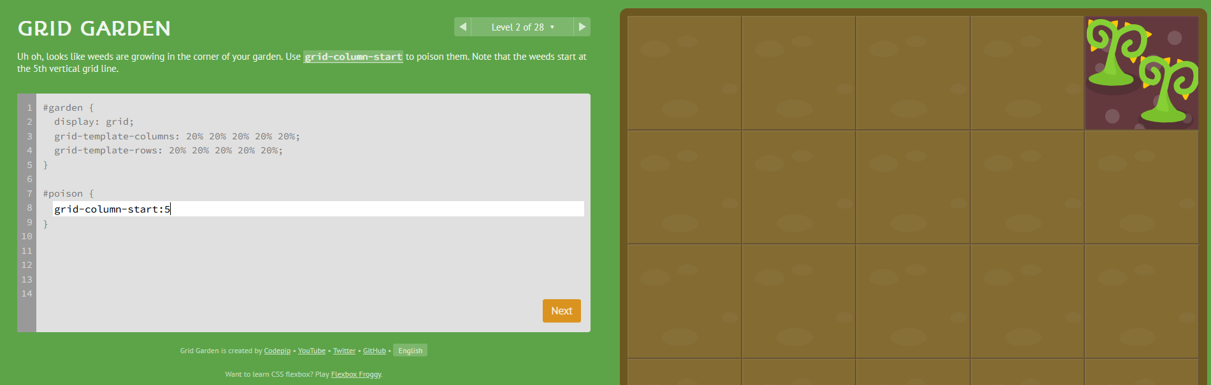

Works using a negive number, the grid box is still to the right of the column line

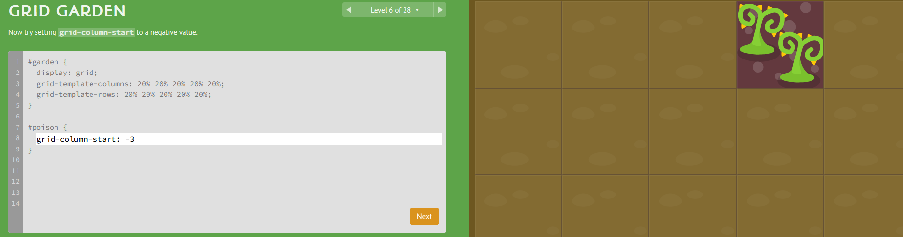

* grid-column-start: # (1-99)

Grid-column-end: used to extend the grid column to the desired end point

Example: extend the object from column 1 to column 3

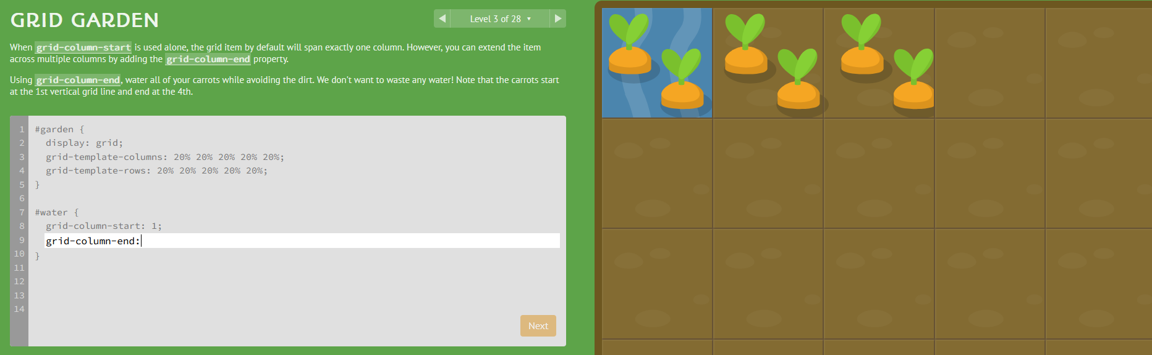

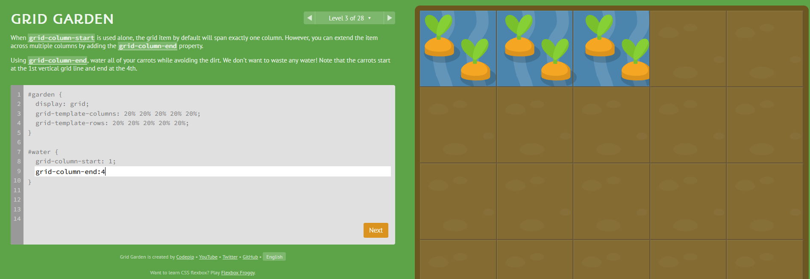

This is where its important to remember that the column is a “line” to the left of the viewed column (where the carrots are)

Works in reverse as well

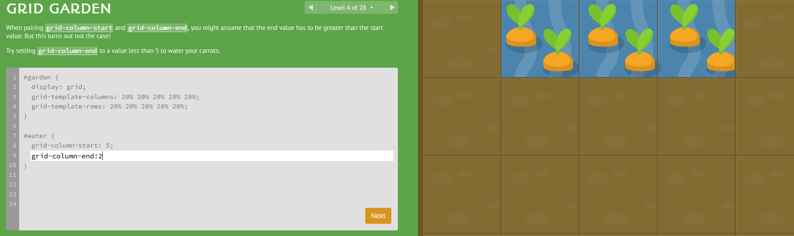

Can count backwards from the right side column as well

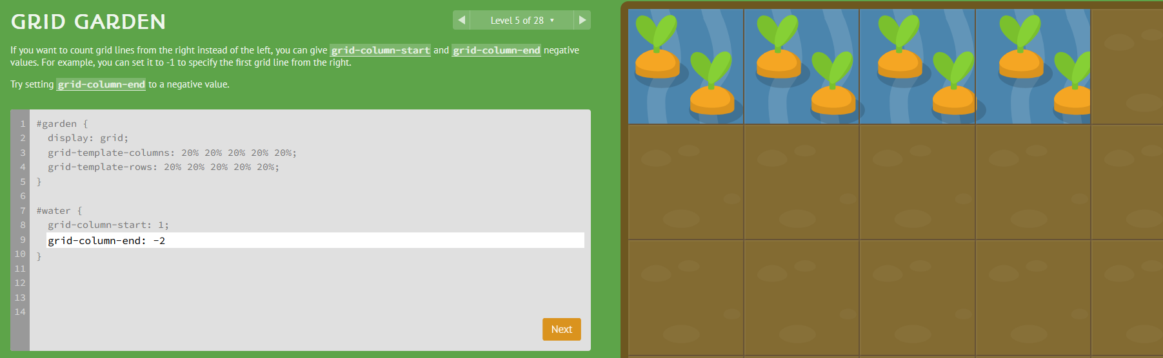

* grid-column-end: # (1 to 99) or (-2 to -99)

span: Instead of defining a grid item based on the start and end positions of the grid lines, you can define it based on your desired column width using the span keyword. Keep in mind that span only works with positive values. You can also use the span keyword with grid-column-start to set your item's width relative to the end position.

For Example: grid-column-end: span 2; and grid-column-start: span 3

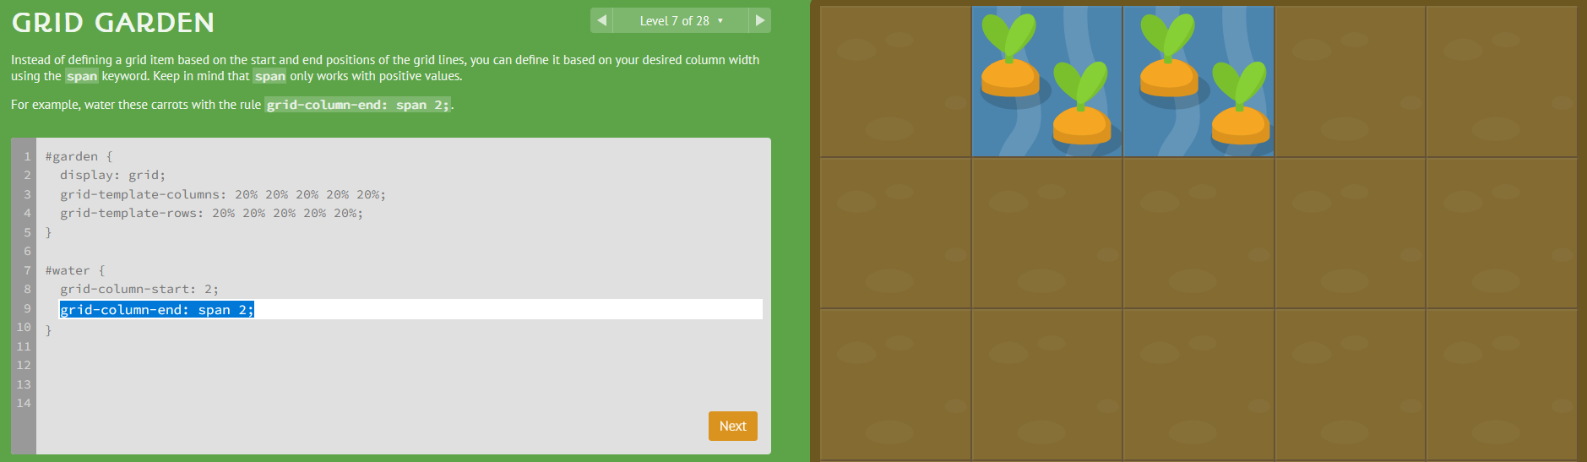

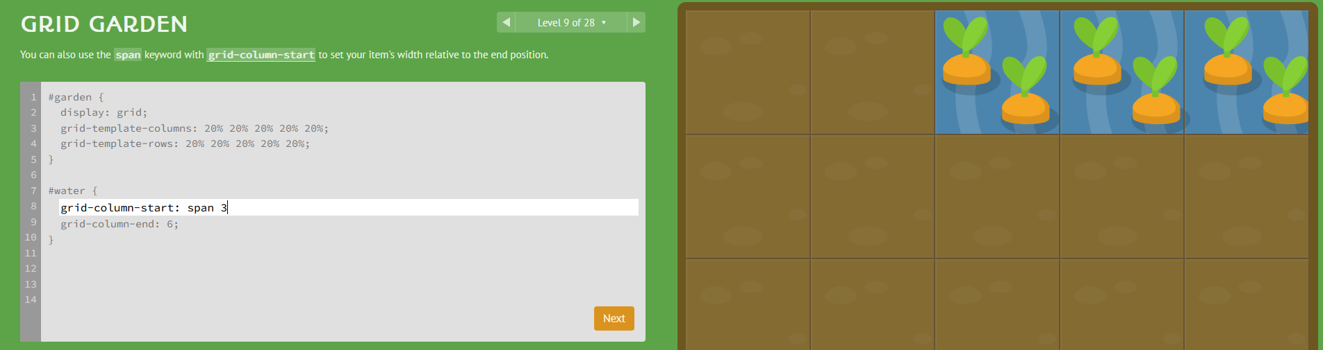

Grid-column: #/# is a shorthand that allows you to compress start span and end into one line

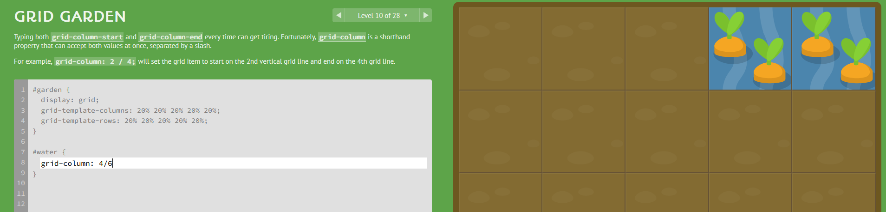

Grid-column: #/ span# also works

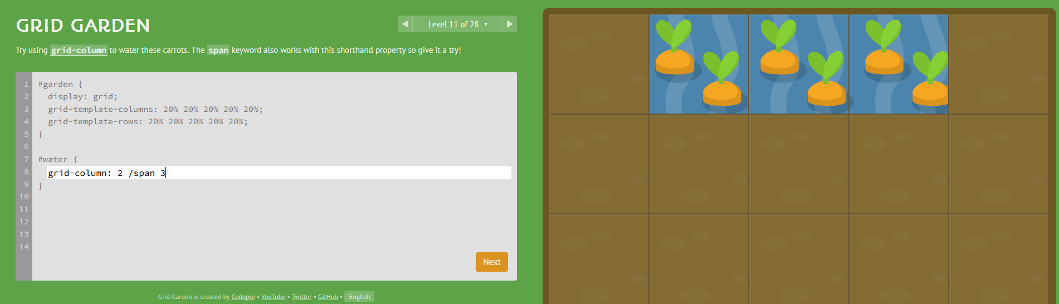

Grid-row-start: One of the things that sets CSS grids apart from flexbox is that you can easily position items in two dimensions: columns and rows. grid-row-start works much like grid-column-start except along the vertical axis.

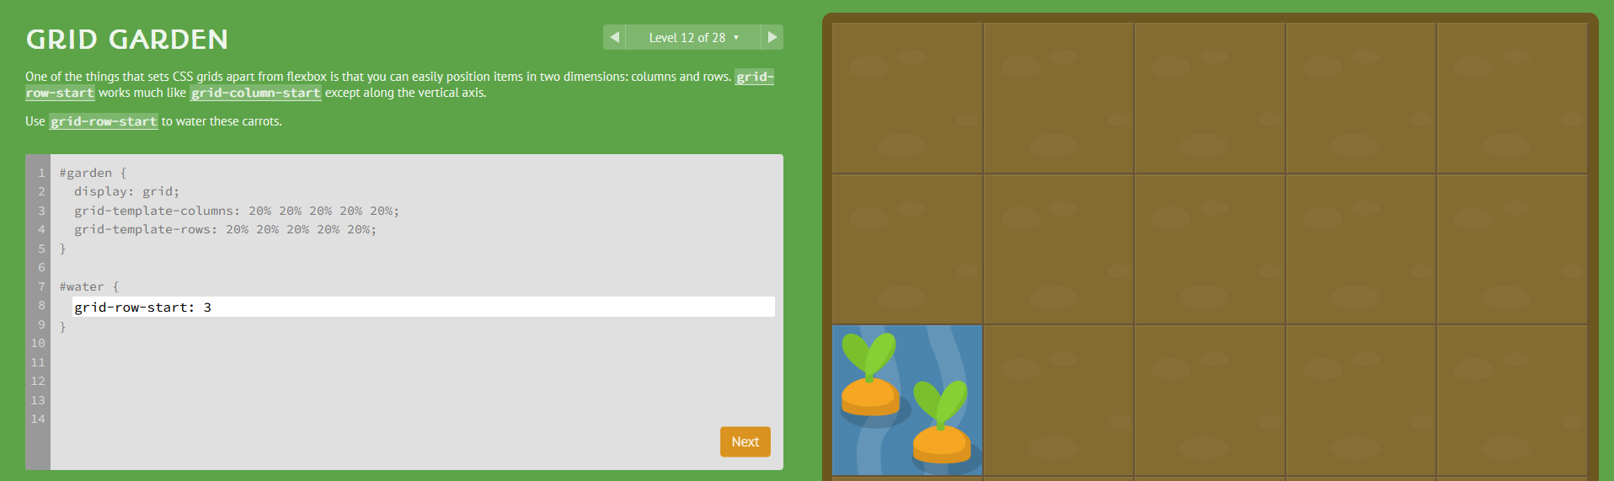

Grid-row: #/# is a short hand that works the same way as grid column

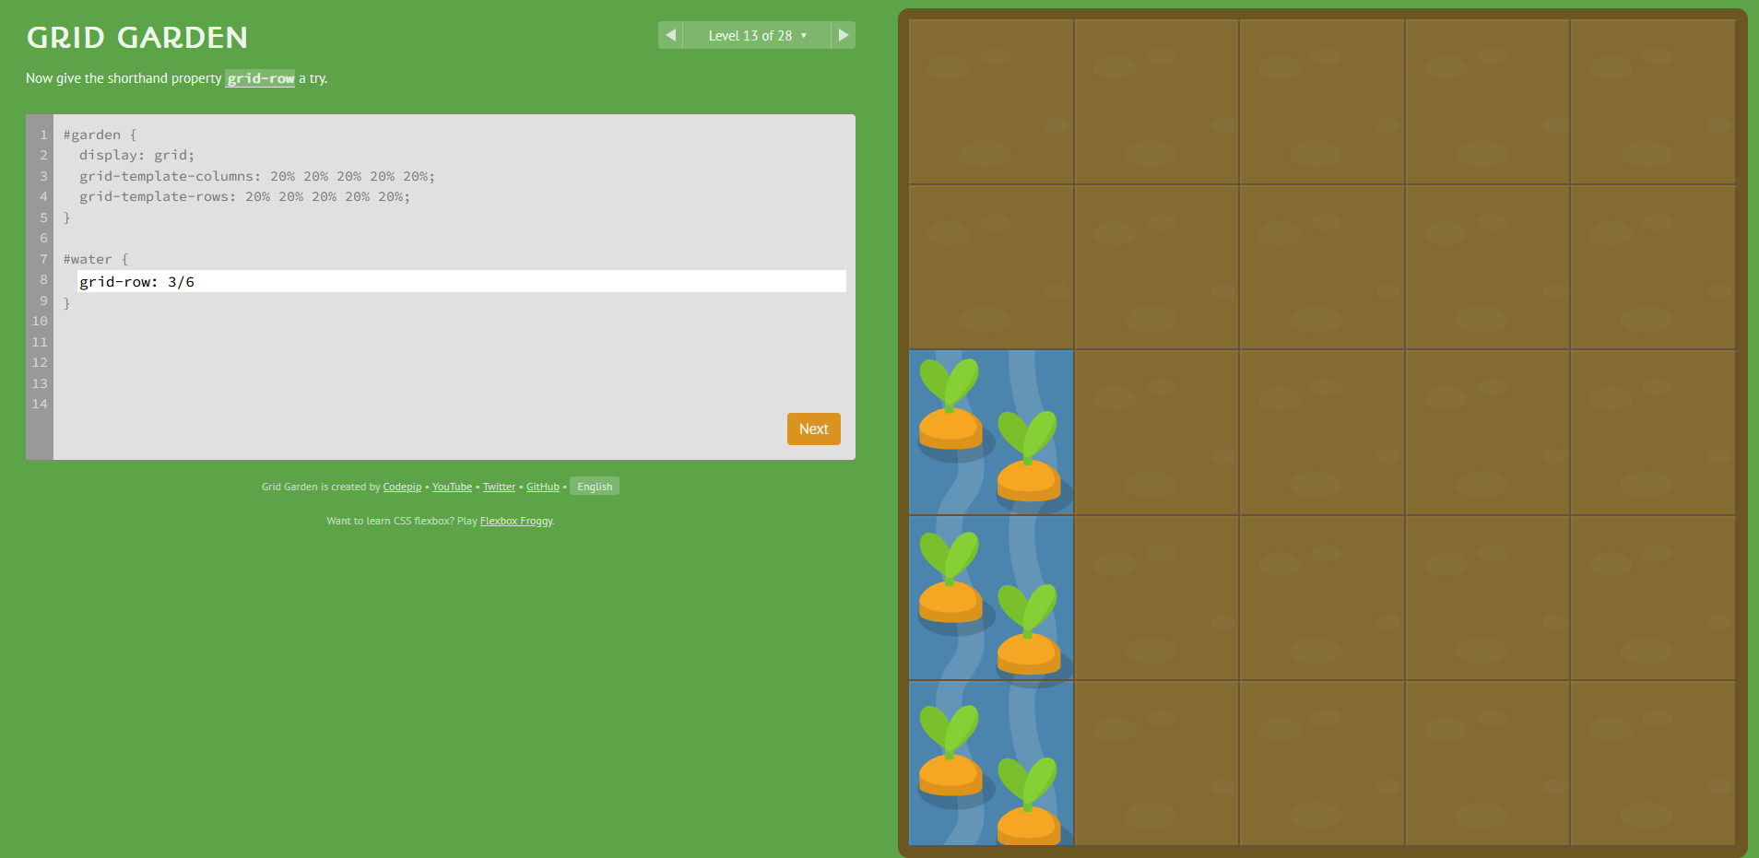

Combining grid-column and grid-row

Don’t forget the “;” after each line of code

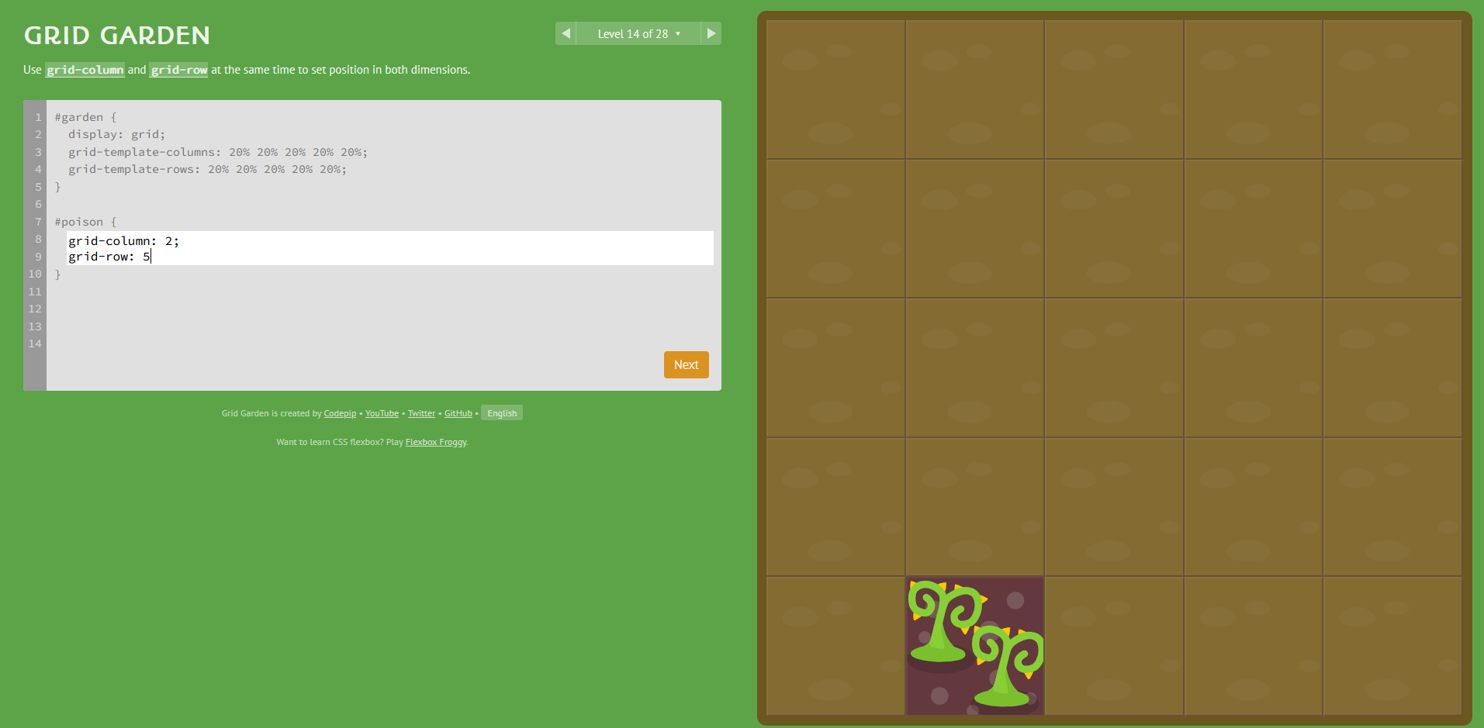

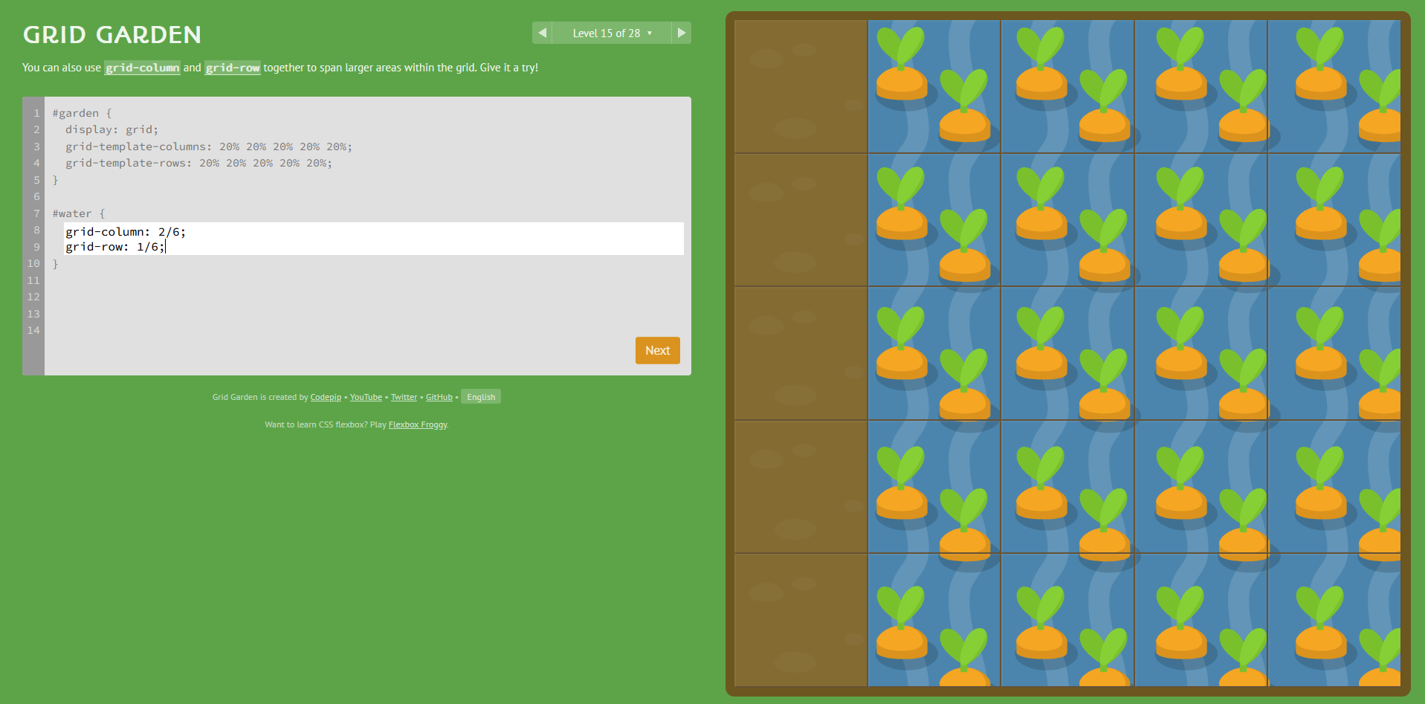

Grid-area: row#/column#/row#/column# allows the combination of both lines of code into one line of code

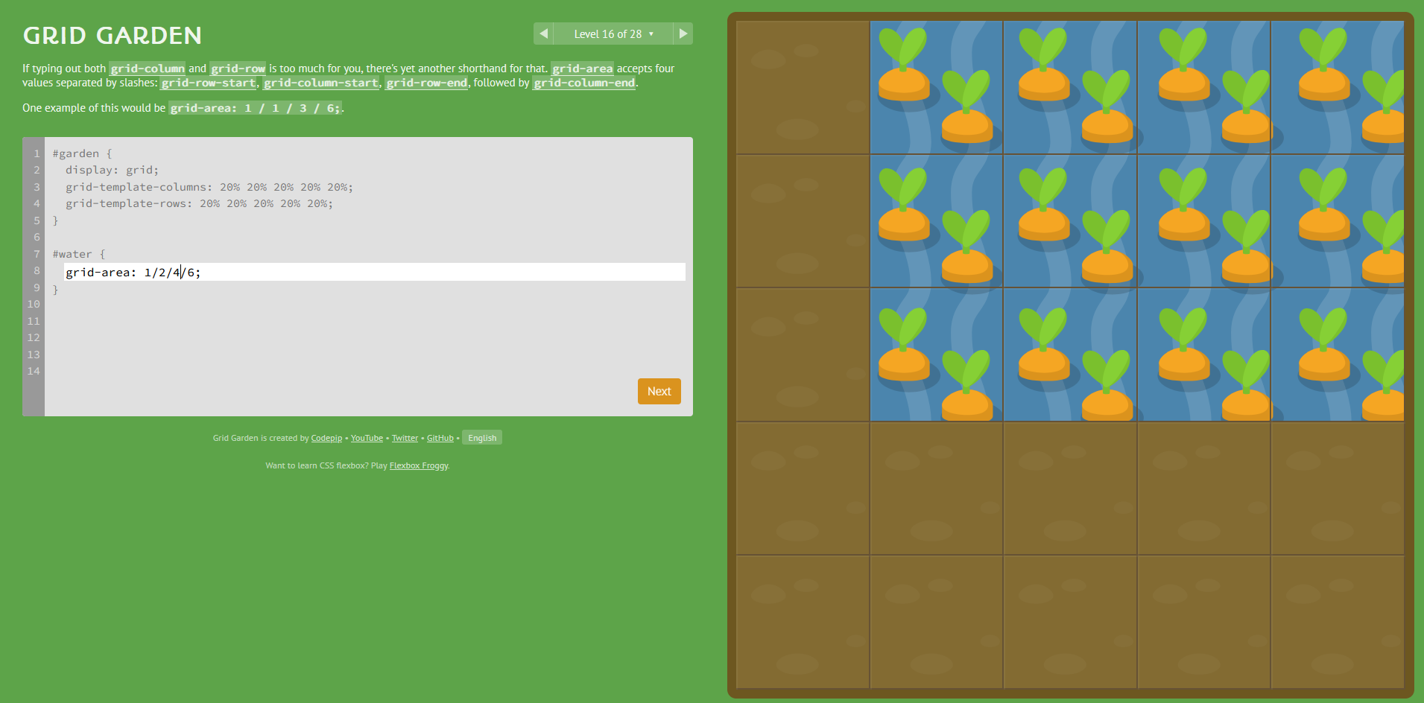

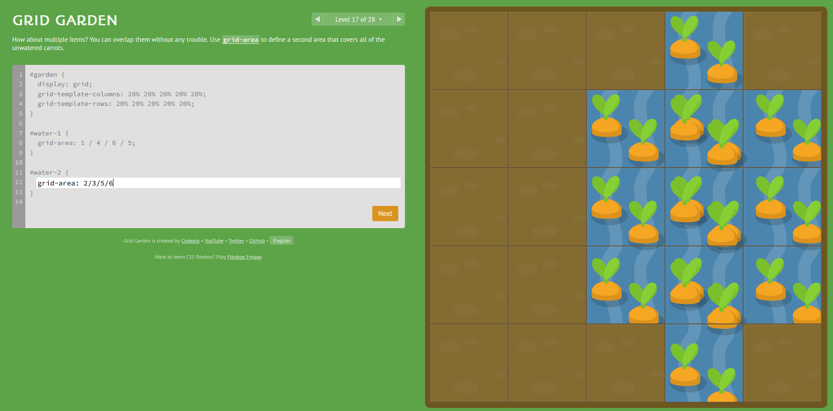

Order: # allows an item to be ordered in a specific spot:

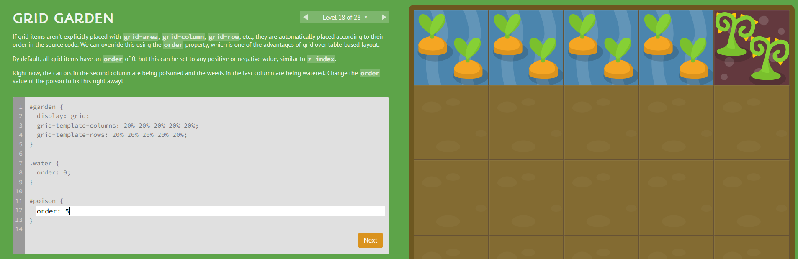

Grid-template-columns #% changes the size of the grid to allow for a percentage of the available space.

For example: grid-template-columns: 50% will set the columns to 50 % of the available space

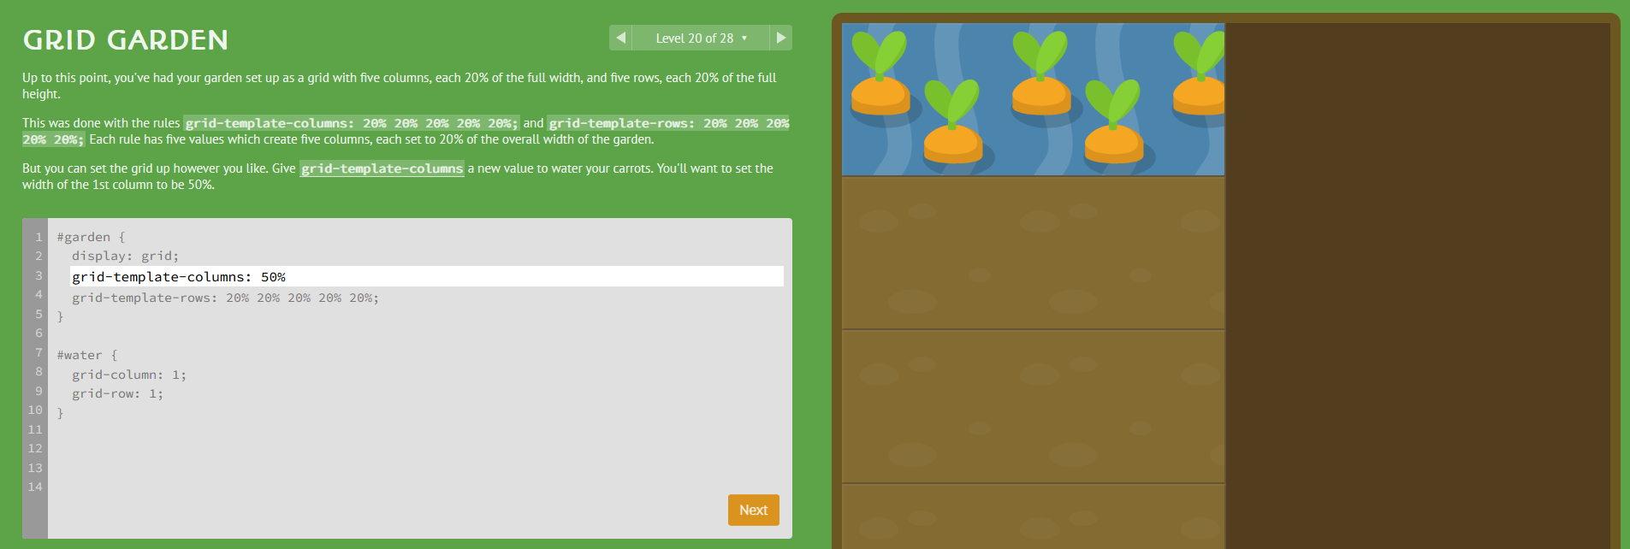

Grid-template-columns Repeat #%

For example: grid-template-columns: repeat(1, 12.5%); will set the columns to be the same width

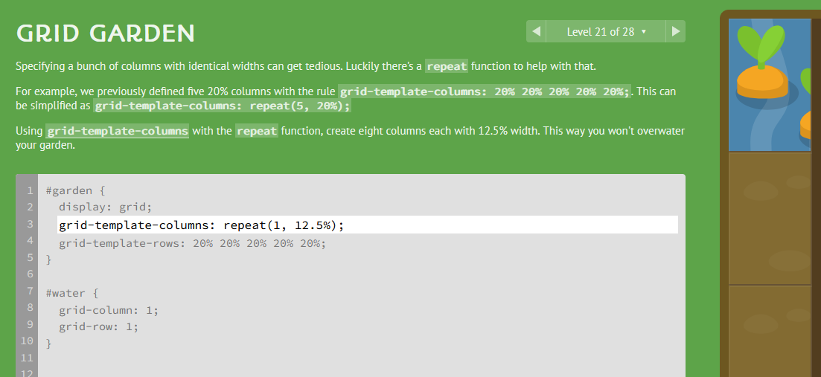

Grid-template-columns: mixed# mixed# mixed#

For example: grid-template-columns: 100px 3em 40%

Remember to use spaces and not / or , with this

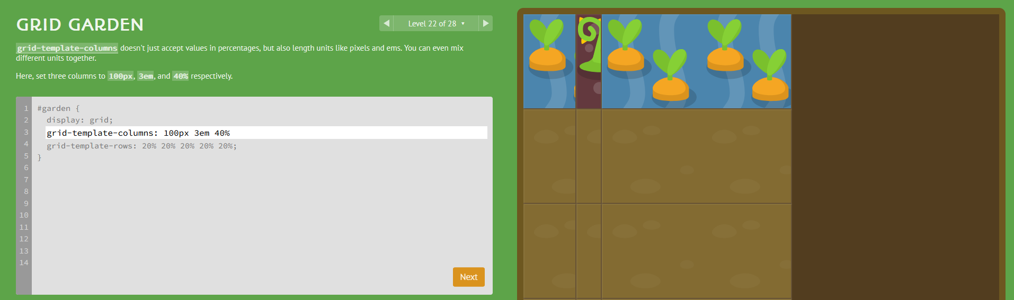

grid-template-columns: #fr #fr fr units are fractional units that take up space between parts set

For example: grid-template-columns:1.25fr 6fr

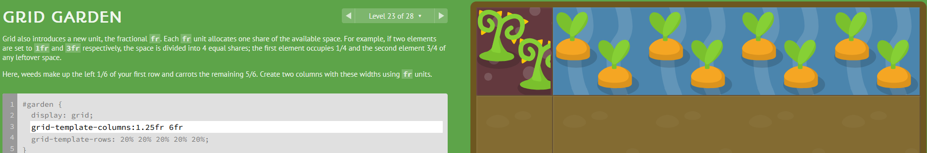

grid-template is a shorthand property that combines grid-template-rows and grid-template-columns.

For example:   
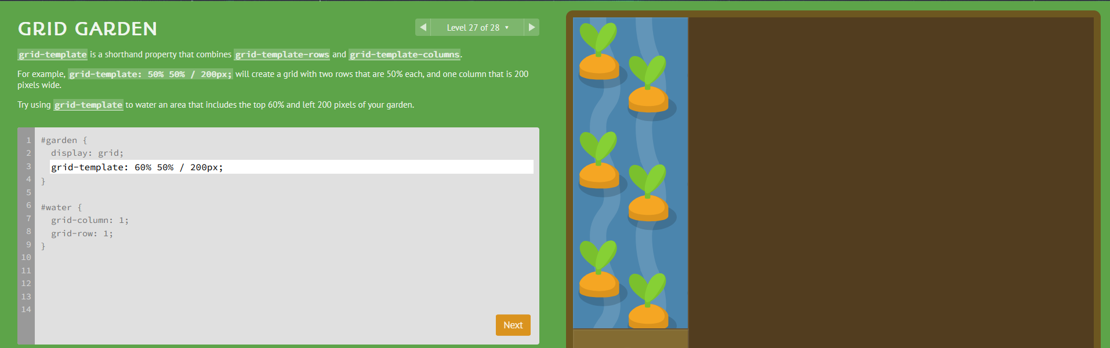

grid-template: 60% 50% / 200px;

# HTML: The Table Element

HTML table elements are used to display tabular data that offer a visual representation of data, allowing users to quickly compare and analyze different values.

[Example of Table Code](https://developer.mozilla.org/en-US/docs/Web/HTML/Element/table) (The Table Elemnt)

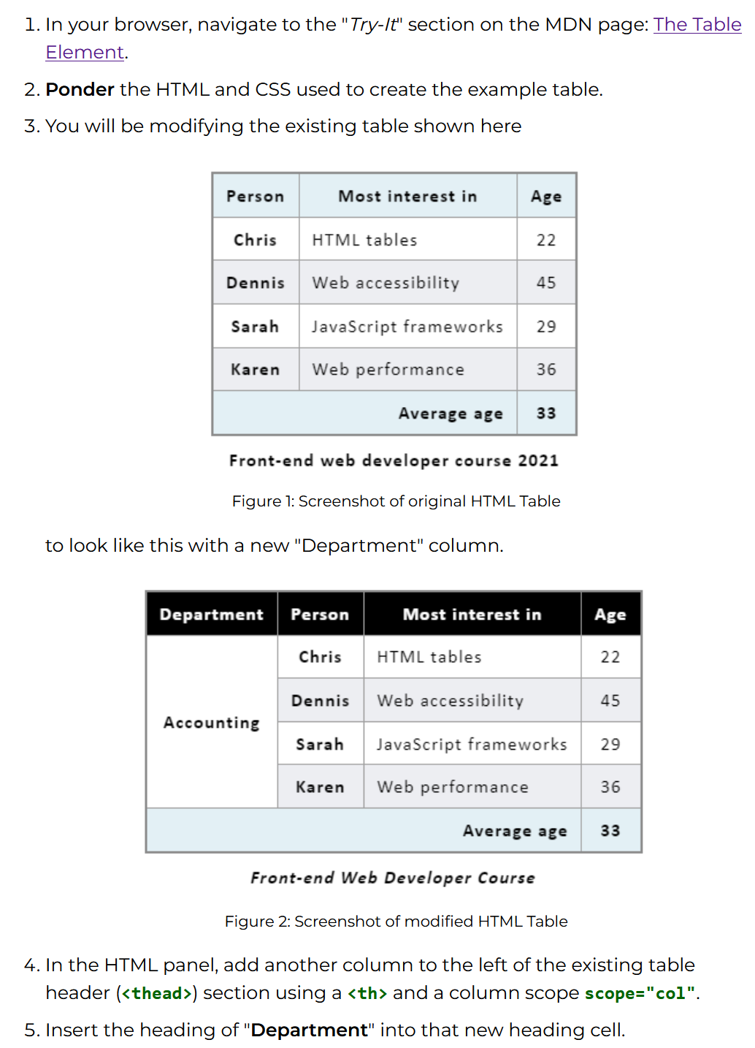

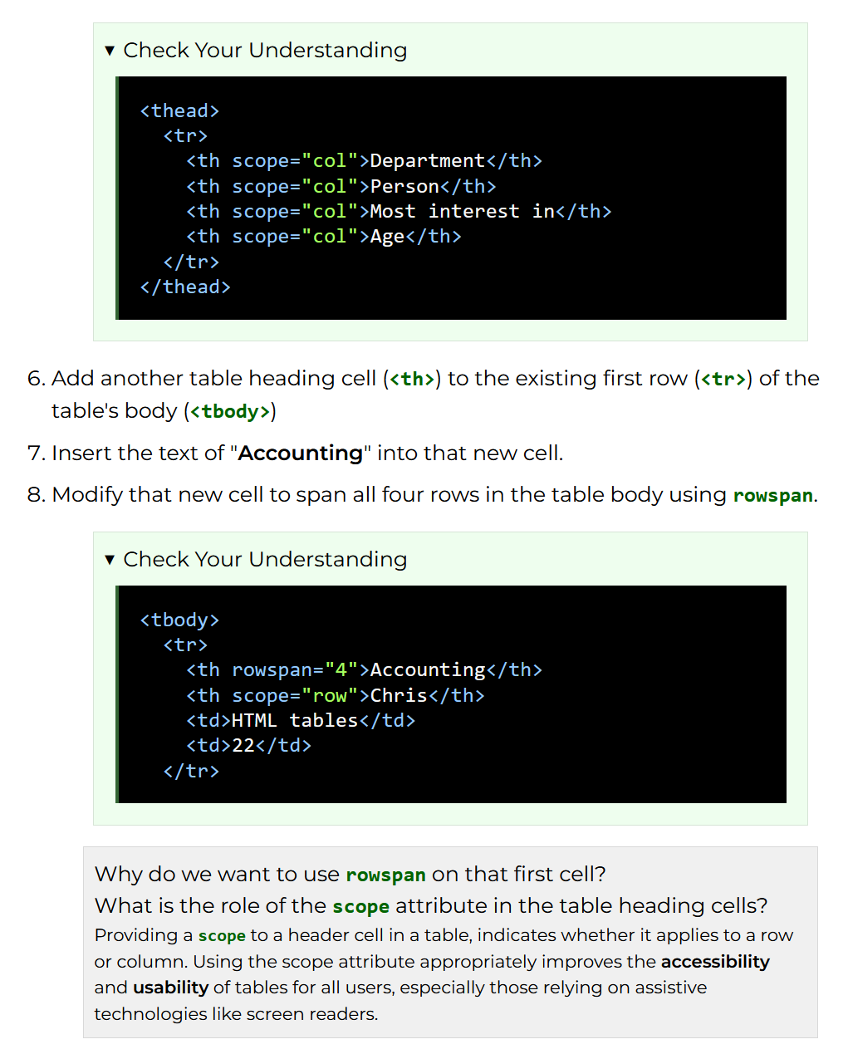

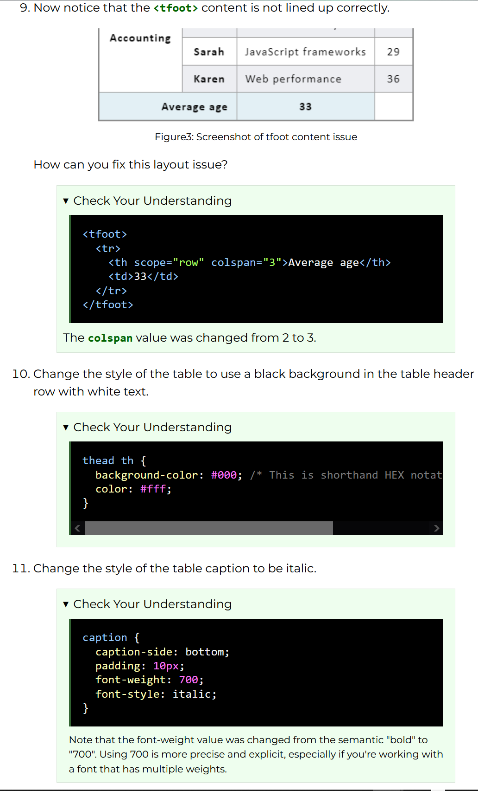

# HTML: The Form Element

## The components of forms

[Best Practices for Forms](https://xd.adobe.com/ideas/principles/web-design/best-practices-form-design/)

The typical form has the following five components:

* **Structure:** This includes the order of fields, the form’s appearance on the page and the logical connections between multiple fields.
* **Input fields:** These include text fields, password fields, checkboxes, radio buttons, sliders and any other fields designed for user input.
* **Field labels:** These tell users what the corresponding input fields mean.
* Action button: When the user presses this button, an action is performed (such as submission of the data).
* **Feedback:** The user is made to understand the result of their input through feedback. Most apps and websites use plain text as a form of feedback. A message will notify the user about the result and can be positive (indicating that the form was submitted successfully) or negative (“The number you’ve provided is incorrect”).

Forms may also have the following components:

* **Assistance:** This is any explanation of how to fill out the form.
* **Validation:** This automatic check ensures that the user’s data is valid.

This article covers many aspects related to structure, input fields, labels, action buttons, and validation.

### Form structure

A form is a type of conversation. And like any conversation, it should consist of logical communication between two parties: the user and the app. The form structure defines a skeleton for your form and that is the reason why we explore form best practices in the context of form structure.

#### Ask only what’s required

Make sure to ask only what you really need. Every extra field you add to a form will affect its conversion rate. Always consider why you are requesting certain information from the user and how you will use it.

#### Order the form logically

Ask details logically from the user’s perspective, not from the application or database’s perspective. Typically, asking for someone’s address before their name would be unusual.

#### Group related information

Group related information into logical blocks or sets. The flow from one set of questions to the next will better resemble a conversation. Grouping together related fields will also help users make sense of the information they must fill in. Compare how it works in the contact information form below.

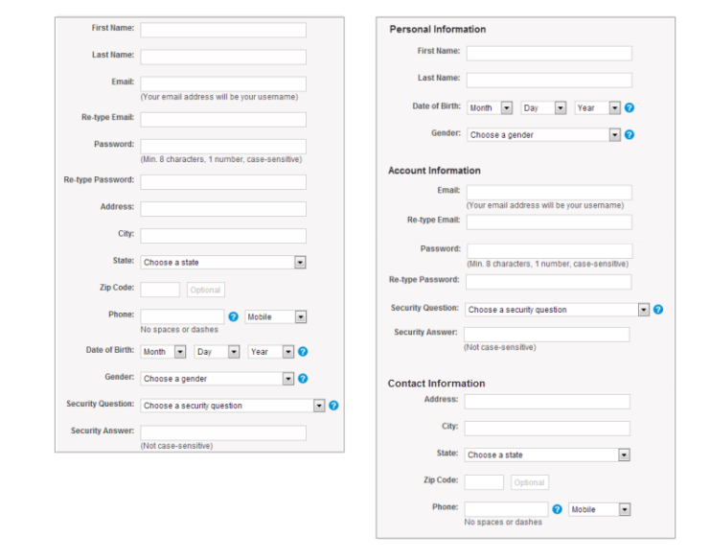

### One column vs. multiple columns

When it comes to web design, designers often experiment with [website layouts](https://xd.adobe.com/ideas/principles/web-design/11-website-layouts-that-made-content-shine-in-2019/) to convey visual interest for the site’s visitors. However, when it comes to form design, it’s better to resist the temptation to have any layouts that have more than one column.

One of the problems with arranging form fields into multiple columns is that users will likely interpret the fields inconsistently. If a form has horizontally adjacent fields, then the user must scan in a Z pattern, slowing the speed of comprehension and muddying the path to completion. But if a form is in a single column, the path to completion is a straight line down the page.

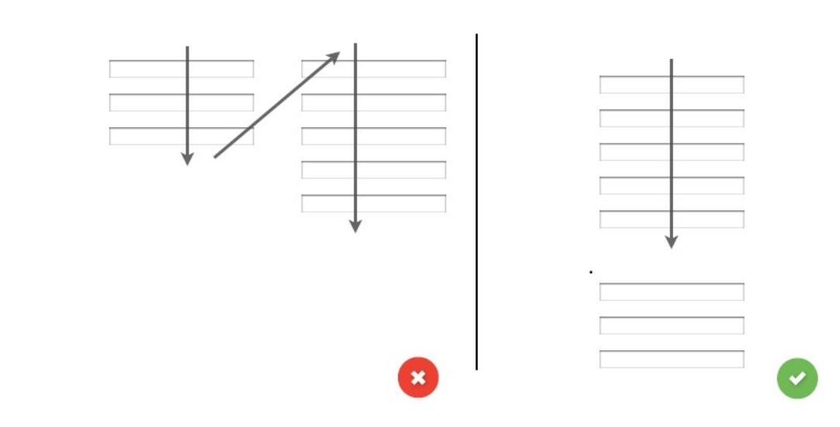Standard two-column layout, versus a straight line down the page.

On the left, one of many ways to interpret how the form fields relate when they are arranged in a standard two-column layout, versus on the right, a straight line down the page.

### Input fields

Input fields are what enable users to fill in a form. Various types of fields exist for the information you need: text fields, password fields, dropdowns, checkboxes, radio buttons, date-pickers and more.

#### Number of fields

When it comes to designing forms, a rule of thumb is that shorter is better. And this certainly seems intuitive: less effort on the part of the user will lead to higher conversion. Thus, minimize the number of fields as much as possible. This will make your form feel less bloated, especially when you’re requesting a lot of information. Displaying only [five to seven input fields](https://en.wikipedia.org/wiki/The_Magical_Number_Seven,_Plus_or_Minus_Two) at a given time is a common practice.

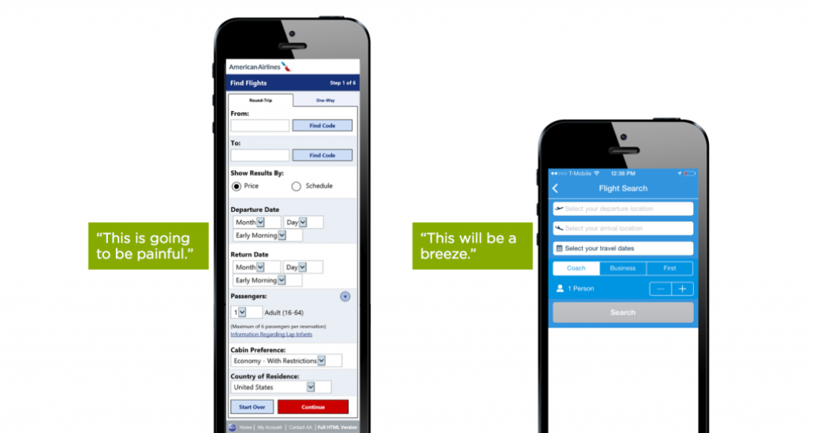

#### Mandatory vs. optional

Try to avoid optional fields in forms. But if you use them, at least clearly distinguish which input fields may not be left blank. The convention is to use an asterisk (*) for required fields or the word “optional” for non-required fields (which is preferable in long forms with multiple required fields). If you decide to use an asterisk for mandatory fields, show a hint at the bottom of the form explaining what the asterisk is for.

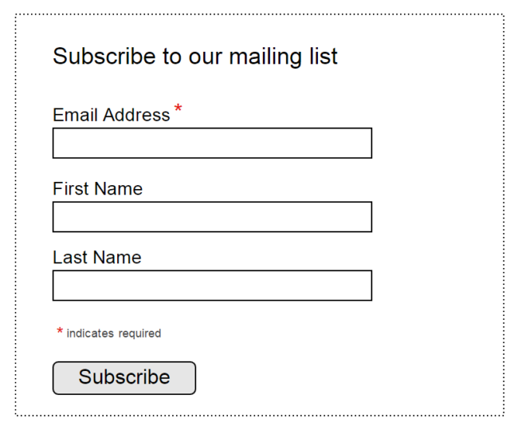

#### Setting default values

Many best practices for form design stress the risk of using static defaults (predefined values in input fields). It’s better to avoid setting default values unless you believe a large portion of your users (say, 95% of them) will select the same values. People scan online forms quickly, and they don’t spend much time parsing through all of the choices. As a result, they can easily skip something that already has a value.

But this rule doesn’t apply to smart defaults, which are pre-set values based on available information about the user.  Smart defaults can make form completion faster and more accurate. For example, preselect the user’s country based on geo-location data. Still, use these with caution, because users tend to leave preselected fields as they are.

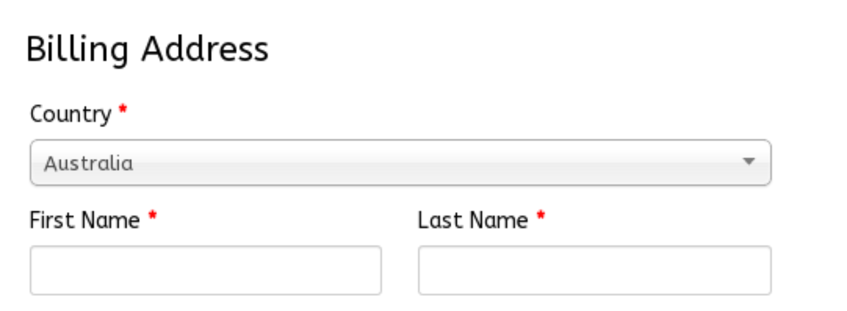

#### Input masks

Field masking is a technique that helps users format inputted text. A mask appears once a user focuses on a field, and it formats the text automatically as the field is being filled out, helping users to focus on the required data and to more easily notice errors. In the example below, the parentheses, spaces, and dashes are applied automatically as the phone and credit card numbers are entered. This simple technique saves time and effort with phone numbers, credit cards, currencies and more.

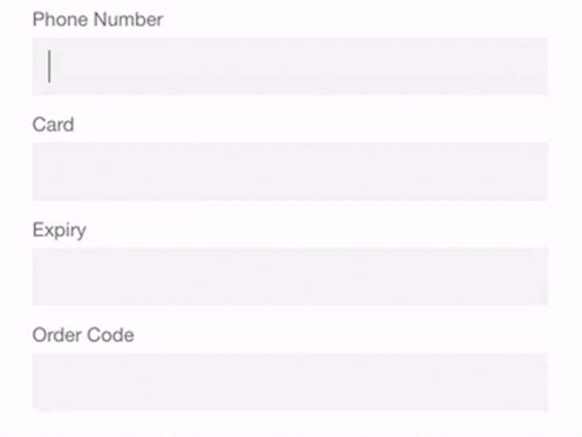

#### Designing forms for desktop: make form keyboard-friendly

Users should be able to focus on and edit every field using only the keyboard. Power users, who tend to use the keyboard heavily, should be able to easily tab through and edit fields, all without lifting their fingers off the keyboard. You can find detailed requirements for keyboard interaction in the [W3C’s guidelines on design patterns](https://www.w3.org/TR/wai-aria-practices/%23aria_ex).

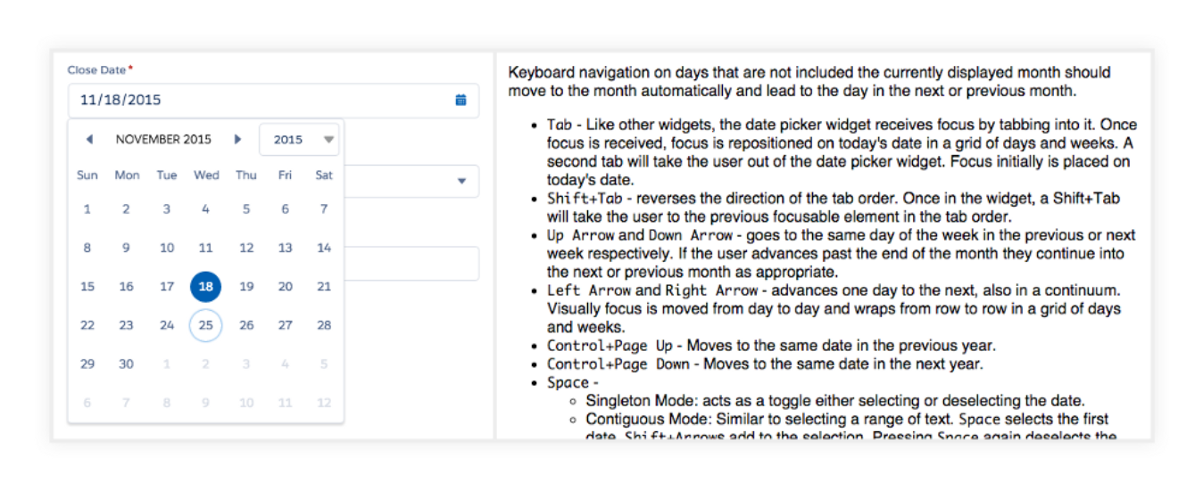

#### Designing forms for desktop: autofocus for input field

Autofocusing a field gives the user an indication and a starting point to quickly begin filling out a form. Provide a clear visual signal that focus has moved there, whether by changing color, fading in a box, flashing an arrow, whatever. Amazon’s registration form has both autofocus and visual indicators.

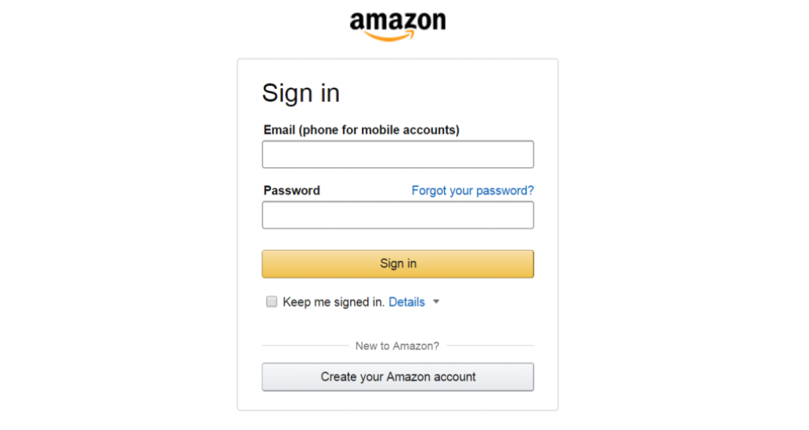

#### Designing forms for mobile: match keyboard to input

Phone users appreciate apps that provide the appropriate keyboard for the text being requested. Implement this consistently throughout the app, rather than merely for certain tasks but not others.

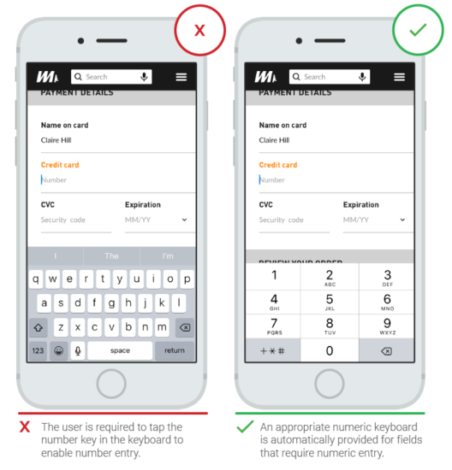

#### Limit typing (autocompletion)

With more and more people using  mobile screens, anything that can be done to prevent unnecessary typing will improve the user experience and decrease errors. Autocompletion makes it possible to eliminate a huge amount of typing. For example, filling out an address field is often the most problematic part of any registration form. A tool such as [Place Autocomplete Address Form (which uses both geolocation](https://developers.google.com/maps/documentation/javascript/examples/places-autocomplete-addressform) and address prefilling to provide accurate suggestions based on the user’s exact location) enables users to enter their address with fewer keystrokes than regular input fields.

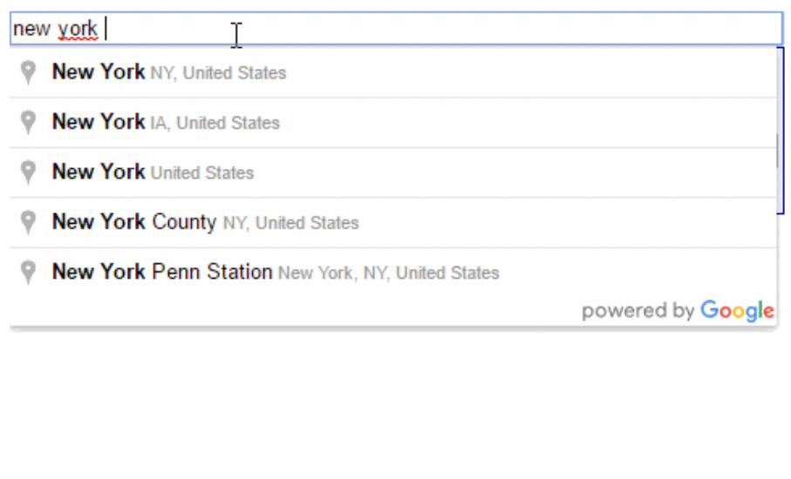

#### Example

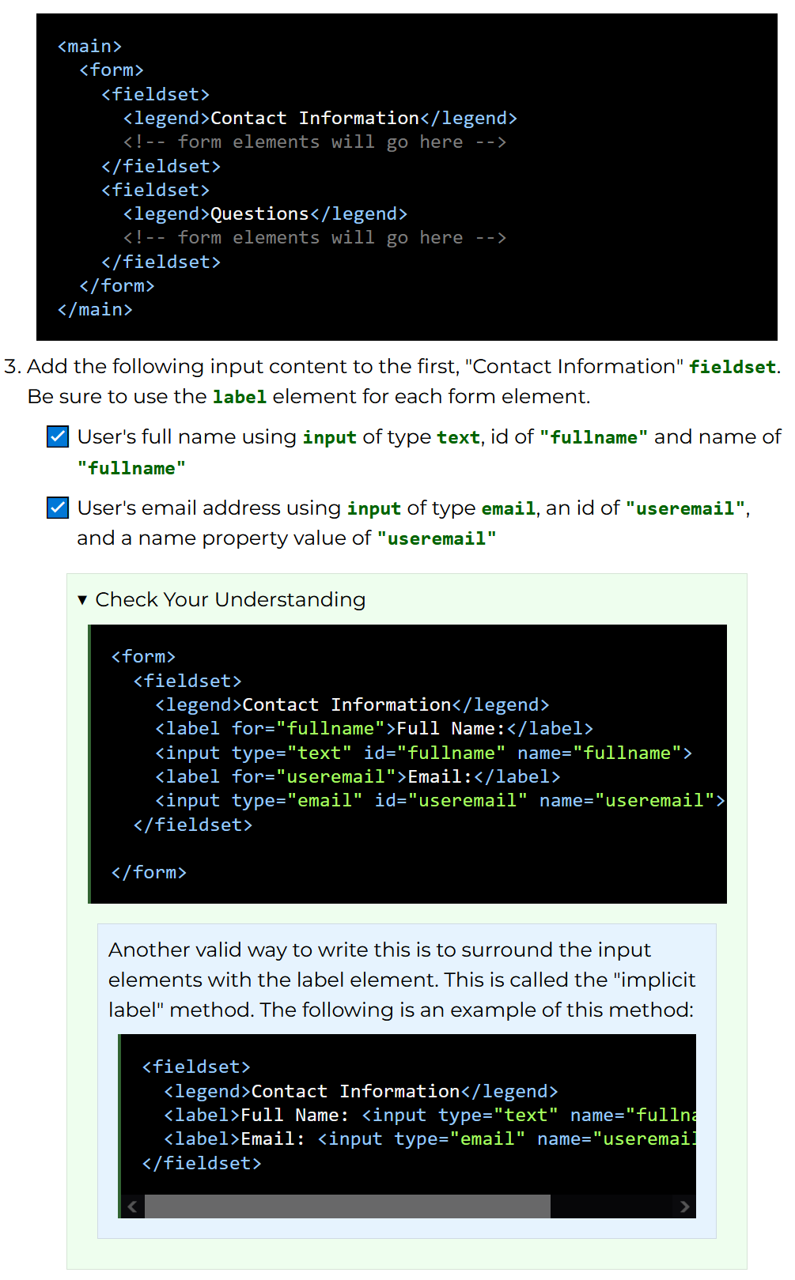

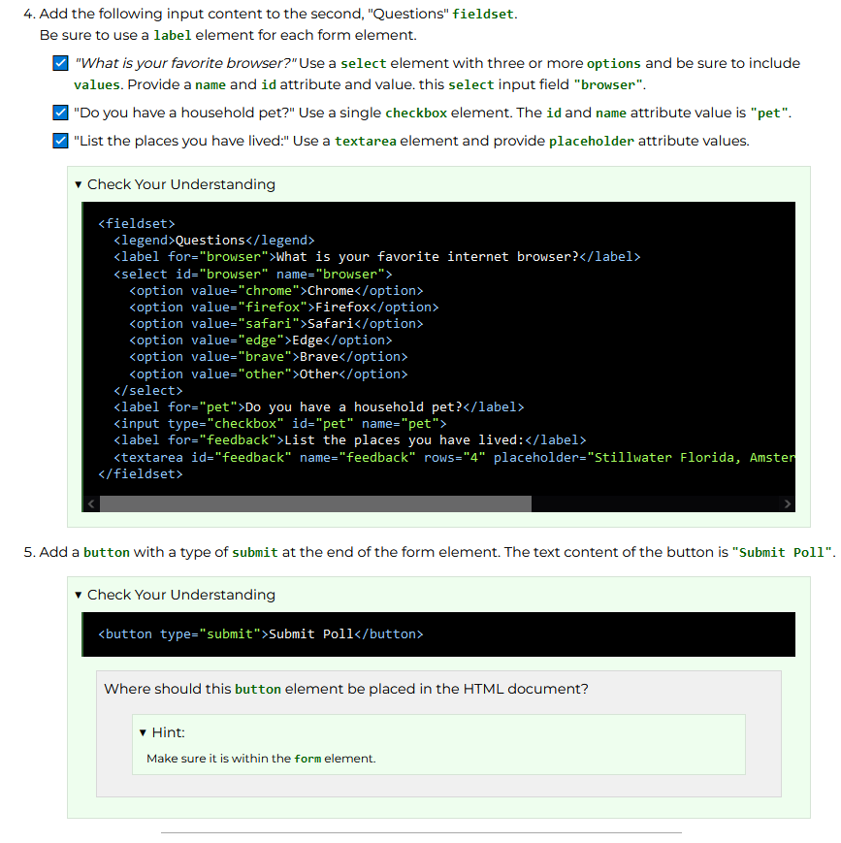

# Additional Information

<https://gridbyexample.com/video/align-grid/>

<https://gridbyexample.com/video/align-grid/>

WDD 131 Dynamic Web Fundamentals

# Page Layouts

[Page Layout Video](https://d.docs.live.net/860536349841BA81/Documents/WDD%20130/Page%20Layout%20Video) https://www.youtube.com/watch?v=qm0IfG1GyZU&t=465s

Video goes over grid-templates

Includes

# Java Script

JavaScript is one of the three, core technologies of web frontend development.The other two are HyperText Markup Language (HTML) and Cascading Styles Sheets (CSS).

* HTML defines the **structure** and meaning of a page.
* CSS defines the style or **presentation** of a page.
* JavaScript handles the **behavior** based upon user interaction and other events.

JavaScript is a scripting or programming language that allows you to implement complex features on web pages — every time a web page does more than just sit there and display static information for you to look at — displaying timely content updates, interactive maps, animated 2D/3D graphics, scrolling video jukeboxes, etc. — you can bet that JavaScript is probably involved. It is the third layer of the layer cake of standard web technologies, two of which ([HTML](https://developer.mozilla.org/en-US/docs/Learn_web_development/Core/Structuring_content) and [CSS](https://developer.mozilla.org/en-US/docs/Learn_web_development/Core/Styling_basics)) we have covered in much more detail in other parts of the Learning Area.

* [HTML](https://developer.mozilla.org/en-US/docs/Glossary/HTML) is the markup language that we use to structure and give meaning to our web content, for example defining paragraphs, headings, and data tables, or embedding images and videos in the page.
* [CSS](https://developer.mozilla.org/en-US/docs/Glossary/CSS) is a language of style rules that we use to apply styling to our HTML content, for example setting background colors and fonts, and laying out our content in multiple columns.
* [JavaScript](https://developer.mozilla.org/en-US/docs/Glossary/JavaScript) is a scripting language that enables you to create dynamically updating content, control multimedia, animate images, and pretty much everything else. (Okay, not everything, but it is amazing what you can achieve with a few lines of JavaScript code.)

[What is Java Script?](https://developer.mozilla.org/en-US/docs/Learn_web_development/Core/Scripting/What_is_JavaScript)This includes how Java Script is implemented

Internal JavaScript

• First of all, make a local copy of our example file [apply-javascript.html](https://github.com/mdn/learning-area/blob/main/javascript/introduction-to-js-1/what-is-js/apply-javascript.html). Save it in a directory somewhere sensible.

• Open the file in your web browser and in your text editor. You'll see that the HTML creates a simple web page containing a clickable button.

• Next, go to your text editor and add the following at the bottom of your body — just before your closing </body> tag:

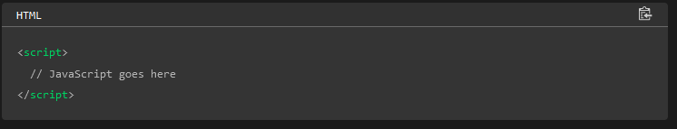

• Note that the code in your web documents is generally loaded and executed in the order it appears on the page. By placing the JavaScript at the bottom, we ensure that all HTML elements are loaded. (See also [Script loading strategies](https://developer.mozilla.org/en-US/docs/Learn_web_development/Core/Scripting/What_is_JavaScript#script_loading_strategies) below.)

• Now we'll add some JavaScript inside our [<script>](https://developer.mozilla.org/en-US/docs/Web/HTML/Element/script) element to make the page do something more interesting — add the following code just below the "// JavaScript goes here" line:

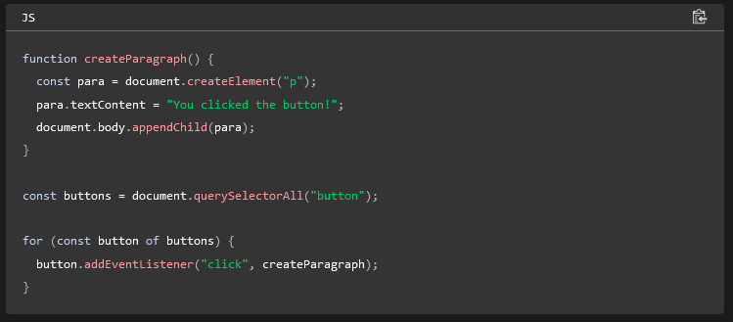

External JavaScript

• First, create a new file in the same directory as your sample HTML file. Call it script.js — make sure it has that .js filename extension, as that's how it is recognized as JavaScript.

• Remove your current [<script>](https://developer.mozilla.org/en-US/docs/Web/HTML/Element/script) element at the bottom of the </body> and add the following just before the closing </head> tag (that way the browser can start loading the file sooner than when it's at the bottom):

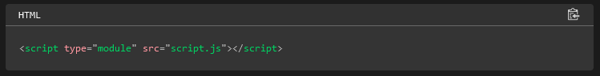

Inside script.js, add the following script:

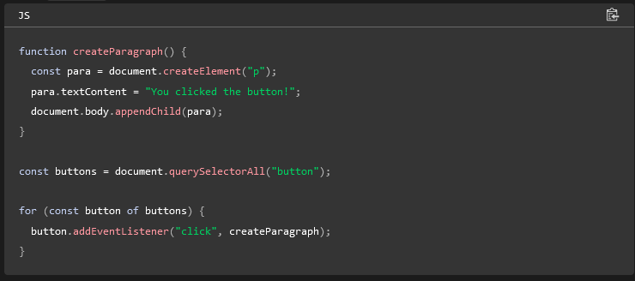

• Save and refresh your browser. You'll discover that clicking the button has no effect, and if you check your browser's console, you'll see an error along the lines of Cross-origin request blocked. That's because like many external resources, JavaScript modules need to be loaded from the [same origin](https://developer.mozilla.org/en-US/docs/Web/Security/Same-origin_policy) as the HTML, and file:// URLs don't qualify. There are two solutions to fix this problem:

* Our recommended solution is to [set up a local testing server](https://developer.mozilla.org/en-US/docs/Learn_web_development/Howto/Tools_and_setup/set_up_a_local_testing_server). With the server program running and serving the apply-javascript-external.html and script.js files on port 8000, open your browser and go to http://localhost:8000.
* If you cannot run a local server, you can also use <script defer src="script.js"></script> instead of <script type="module" src="script.js"></script>. See [Script loading strategies](https://developer.mozilla.org/en-US/docs/Learn_web_development/Core/Scripting/What_is_JavaScript#script_loading_strategies) below for more information. But note that features we use in other parts of the tutorial may require a local HTTP server anyway.

• Now the website works just the same as before, but now we've got our JavaScript in an external file. This is generally a good thing in terms of organizing your code and making it reusable across multiple HTML files. Plus, the HTML is easier to read without huge chunks of script dumped in it.

Inline JavaScript Handlers

Note that sometimes you'll come across bits of actual JavaScript code living inside HTML. It might look something like this:

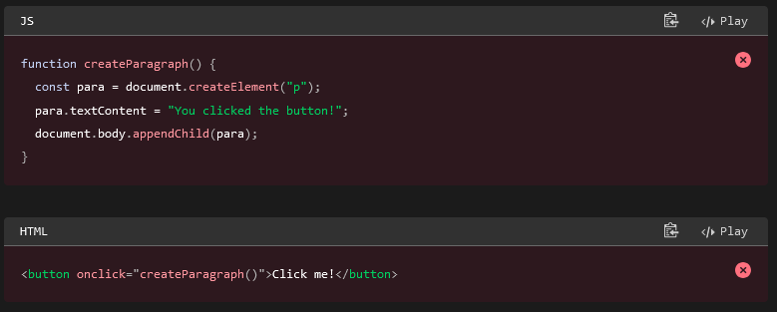

Answer the following questions. You can use this MDN Web Docs resource [What is JavaScript?](https://developer.mozilla.org/en-US/docs/Learn/JavaScript/First_steps/What_is_JavaScript) or use your own research.

You are encouraged to responsibly use contemporary language models and generative AI tools like [ChatGPT](https://chat.openai.com/), [Gemini](https://gemini.google.com/app), [Bard](https://bard.google.com/chat), [Bing Chat](https://www.bing.com/search?q=Bing+AI&showconv=1&FORM=hpcodx), [Meta AI](https://www.meta.ai/), etc. Learn to cautiously use these tools as an on demand tutor to help define concepts, clarify questions, and to provide guidance.

* What is the file extension used for JavaScript files? Check Your Understanding

.js

* How is JavaScript included on web pages? Check Your Understanding

A <script> HTML tag is used to include JavaScript code in an HTML like this:

<script></script>

The script tag can be used anywhere on the page.   
This course uses external script files and places the source reference in the head of the HTML document.

* What standard way does this course reference JavaScript?
  + Use external JavaScript files.
  + Place the .js JavaScript files in the scripts subfolder.
  + Reference the script file in the head of the HTML document.
  + Use the defer attribute to ensure that the HTML loads first in order for JavaScript to interact with the HTML.

Check Your Understanding

<head>

...

<script src="scripts/myscripts.js" defer></script>

</head>

**Common Misconceptions and Language Issues**

* JavaScript is not the same programming language as the [**Java**](https://www.java.com/en/download/help/whatis_java.html) programming language. They are two different languages with different syntax and purposes.
* The plural form of "code" in programming is just "**code**", not "codes".   
  *Example: "Please review my code." or "Please review my program". Not "Please review my codes."*
* JavaScript is not just for the browser and client-side scripting. With the introduction of server-side frameworks like Node.js, JavaScript can be used for server-side development as well. JavaScript is a mature language and has become more powerful and versatile over time.

# Using Java Script

[Using Variables](https://developer.mozilla.org/en-US/docs/Learn_web_development/Core/Scripting/Variables)

## Variables

A variable is a container for a value, like a number we might use in a sum, or a string that we might use as part of a sentence.

### Variable Example

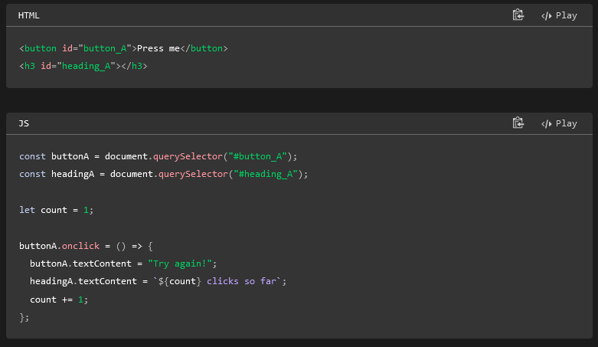

(Results in a button that counts the number of clicks)

### Without a Variable

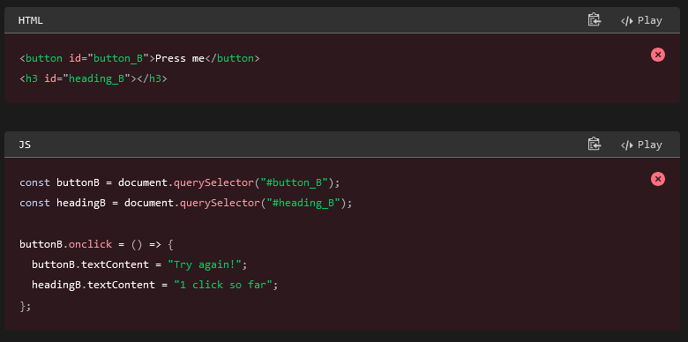

Results in a button that doesn’t count the clicks

### Declaring Variables

To use a variable, you've first got to create it — more accurately, we call this declaring the variable. To do this, we type the keyword let followed by the name you want to call your variable:

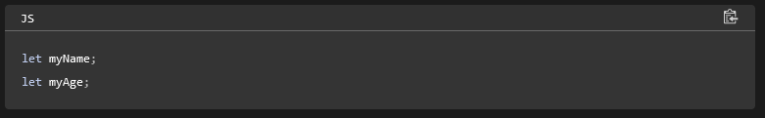

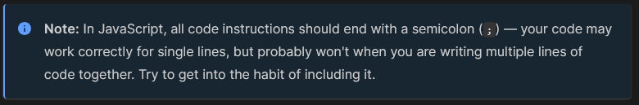

You can test whether these values now exist in the execution environment by typing just the variable's name, e.g.

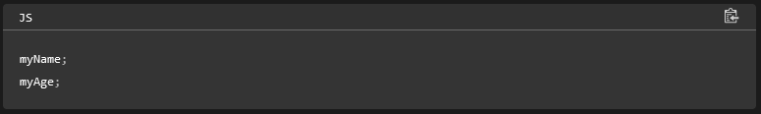

They currently have no value; they are empty containers. When you enter the variable names, you should get a value of undefined returned. If they don't exist, you'll get an error message — try typing in

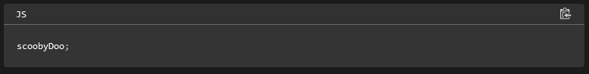

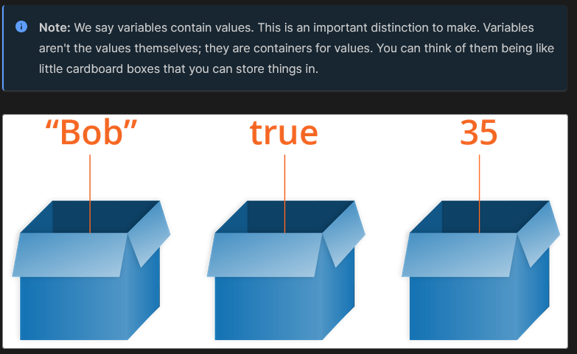

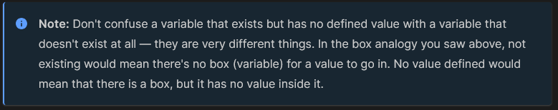

### Initializing Variables

Once you've declared a variable, you can initialize it with a value. You do this by typing the variable name, followed by an equals sign (=), followed by the value you want to give it. For example:

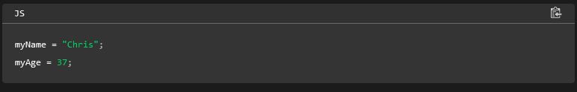

You can declare and initialize a variable at the same time, like this:

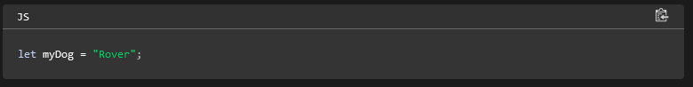

### Using Var

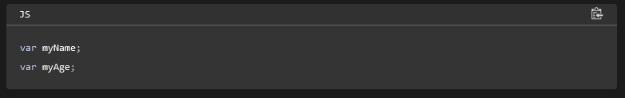

Back when JavaScript was first created, this was the only way to declare variables. The design of var is confusing and error-prone. So let was created in modern versions of JavaScript, a new keyword for creating variables that works somewhat differently to var, fixing its issues in the process.

A couple of simple differences are explained below. We won't go into all the differences now, but you'll start to discover them as you learn more about JavaScript (if you really want to read about them now, feel free to check out our [let reference page](https://developer.mozilla.org/en-US/docs/Web/JavaScript/Reference/Statements/let)).

For a start, if you write a multiline JavaScript program that declares and initializes a variable, you can actually declare a variable with var after you initialize it and it will still work. For example:

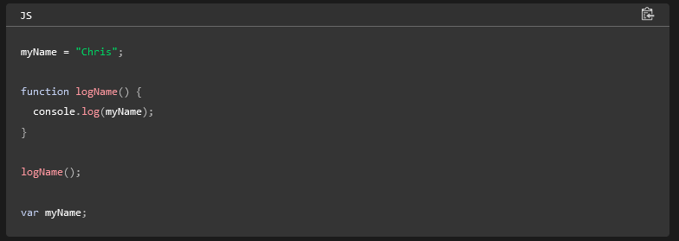

This works because of **hoisting** — read [var hoisting](https://developer.mozilla.org/en-US/docs/Web/JavaScript/Reference/Statements/var#hoisting) for more detail on the subject.

Hoisting no longer works with let. If we changed var to let in the above example, it would fail with an error. This is a good thing — declaring a variable after you initialize it results in confusing, harder to understand code.

Secondly, when you use var, you can declare the same variable as many times as you like, but with let you can't. The following would work:

Answer the following questions using these resources or through your own research:

* [Storing the information you need — Variables](https://developer.mozilla.org/en-US/docs/Learn/JavaScript/First_steps/Variables) - MDN
* [JavaScript data types and data structures](https://developer.mozilla.org/en-US/docs/Web/JavaScript/Data_structures) - MDN

1. What is the difference between const and let? Check Your Understanding
2. Define the string data type. Check Your Understanding
3. What is the data type of each of the following?

Let your mouse rest on each of the bulleted values to reveal the answer.

* + "101"
  + 101
  + true
  + null
  + undefined

Want to know more about any of these examples?  
Enter the following prompt into an AI system: "In JS, what is the null data type"

1. Which should you use to wrap strings, single quotes('), double quotes("), or backticks(`)? Check Your Understanding

In JavaScript you can use single quotes ('), double quotes ("), or backticks (`) to define string literals.

The most traditional way is to use single quotes.

'This a string.'

Double quotes are also commonly used. They can help you avoid escaping single quotes.

"It's a beautiful day!"

Since HTML attributes are often enclosed in double quotes, some developers prefer to use single quotes for JavaScript strings to visually distinguish them.

Template literals use backticks and support multi-line strings naturally. They also allow embedding variables and JS expressions directly.

1. What is a [template literal](https://byui-cse.github.io/wdd131-ww-course/resources/javascript-template-literals.html) and why is it used to build strings? Check Your Understanding

Template literals are string literals that allow for embedded expressions. They are enclosed by the backtick (`) character instead of single or double quotes. Template literals can contain placeholders, which are indicated by the dollar sign and curly braces (${expression}).

let name = 'Alicia';

let age = 25;

let message2 = `My name is ${name} and I am ${age} years old.`;

1. What are **code comments** and how are they written in JavaScript? Check Your Understanding

**Activity Instructions**

1. Open up this CodePen ⚙️ [JavaScript Variables](https://codepen.io/BYU-Idaho/pen/NWQmxwa).

You might consider creating your own free [CodePen](https://codepen.io) account to use to store snippets of code. CodePen provides a web-based code editor where you can write HTML, CSS, and JavaScript code and see the results in real-time.

1. Read the instructions in the JavaScript panel in the CodePen window.
2. Ponder the given questions as you work through the code examples and review the output.

Demonstration Video: ▶️ [JavaScript Variables Activity](https://www.loom.com/share/91a41ac62cdf4369a8a51aac32bbbde4) [5:50 minutes]

**Optional Resources**

1. [JavaScript Basics - Variables](https://developer.mozilla.org/en-US/docs/Learn/Getting_started_with_the_web/JavaScript_basics#Variables) - MDN Web Docs.
2. [Test your skills: variables](https://developer.mozilla.org/en-US/docs/Learn/JavaScript/First_steps/Test_your_skills:_variables) - MDN Web Docs

### Constants

#### [**Constants in JavaScript**](https://developer.mozilla.org/en-US/docs/Learn_web_development/Core/Scripting/Variables#constants_in_javascript)

As well as variables, you can declare constants. These are like variables, except that:

* you must initialize them when you declare them
* you can't assign them a new value after you've initialized them.

For example, using let you can declare a variable without initializing it:

#### [**When to use const and when to use let**](https://developer.mozilla.org/en-US/docs/Learn_web_development/Core/Scripting/Variables#when_to_use_const_and_when_to_use_let)

If you can't do as much with const as you can with let, why would you prefer to use it rather than let? In fact const is very useful. If you use const to name a value, it tells anyone looking at your code that this name will never be assigned to a different value. Any time they see this name, they will know what it refers to.

In this course, we adopt the following principle about when to use let and when to use const:

*Use const when you can, and use let when you have to.*

This means that if you can initialize a variable when you declare it, and don't need to reassign it later, make it a constant.

# CSS Media Query

CSS media queries are essential to responsive web design. The @media at-rule specifies condition(s) to create a block of CSS rules that are applied if the condition(s) evaluates to true. This is extremely useful as selected elements can be repositioned, resized, hidden, exposed, etc. based upon the user's viewport size.

Here is the general syntax is setting up a CSS media query:

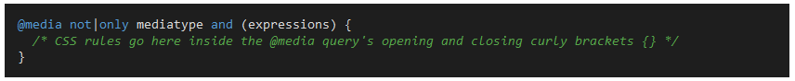

Here is an example CSS media query:

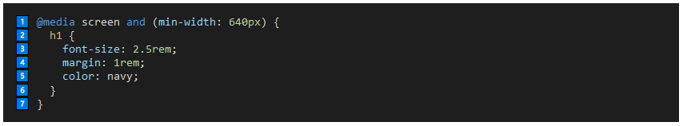

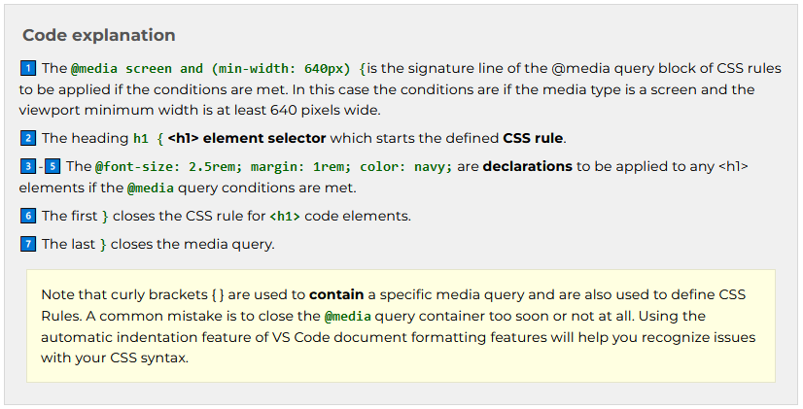

# JavaScript: Fundamental Programming Constructs

## Programming Constructs

Some of the common controls structures or building blocks in JavaScript include:



**if** statement: Executes a block of code if a specified condition is true.

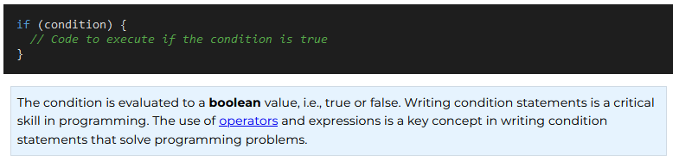

**else** statement: Provides an alternative block of code to execute if the condition in the if statement is false.

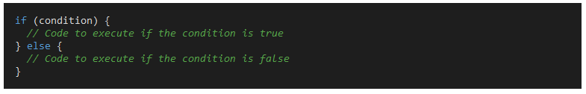

**else if** statement: This structure allows for the checking of multiple conditions in sequence.

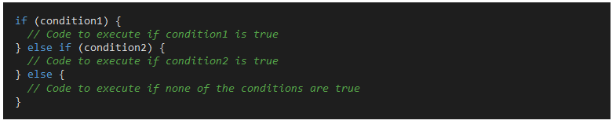

**Switch Statements**: Provides a way to execute selective blocks of code based on the value of an expression.

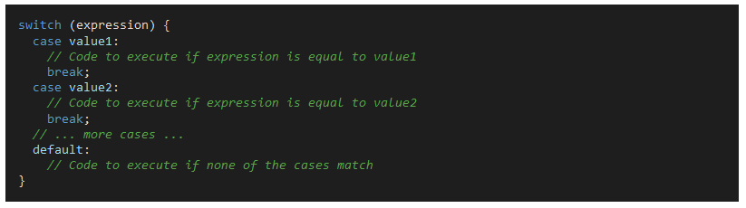

**Looping Statements**:

* **for Loop**: Repeats a block of code a specified number of times.

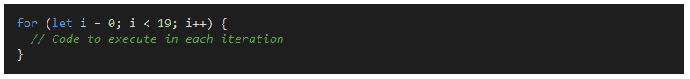

**while Loop**: Repeats a block of code as long as a specified condition is true.

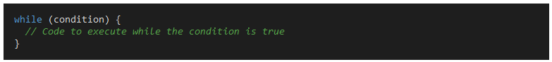

**forEach Loop**: This loop structure is for **arrays**. It iterates over each element of the array.

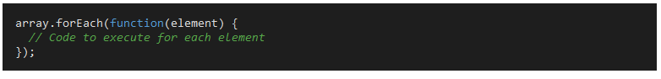

## Loops and Iteration

Repeating code is a common task in programming. JavaScript provides several ways to repeat code including for, while, do...while, and for...in statements. Each of these statements has a specific use case and syntax. forEach is a method that can be used on arrays to iterate over each item in the array.

[Loops and Iteration](https://developer.mozilla.org/en-US/docs/Web/JavaScript/Guide/Loops_and_iteration)

Loops offer a quick and easy way to do something repeatedly. This chapter of the [JavaScript Guide](https://developer.mozilla.org/en-US/docs/Web/JavaScript/Guide) introduces the different iteration statements available to JavaScript.

You can think of a loop as a computerized version of the game where you tell someone to take *X* steps in one direction, then *Y* steps in another. For example, the idea "Go five steps to the east" could be expressed this way as a loop:

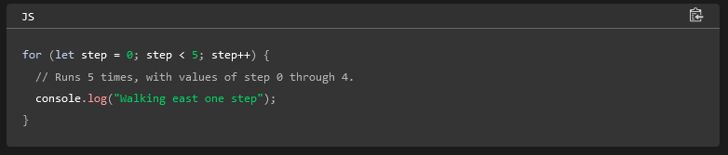

There are many different kinds of loops, but they all essentially do the same thing: they repeat an action some number of times. (Note that it's possible that number could be zero!)

The various loop mechanisms offer different ways to determine the start and end points of the loop. There are various situations that are more easily served by one type of loop over the others.

The statements for loops provided in JavaScript are:

* [for statement](https://developer.mozilla.org/en-US/docs/Web/JavaScript/Guide/Loops_and_iteration#for_statement)
* [do...while statement](https://developer.mozilla.org/en-US/docs/Web/JavaScript/Guide/Loops_and_iteration#do...while_statement)
* [while statement](https://developer.mozilla.org/en-US/docs/Web/JavaScript/Guide/Loops_and_iteration#while_statement)
* [labeled statement](https://developer.mozilla.org/en-US/docs/Web/JavaScript/Guide/Loops_and_iteration#labeled_statement)
* [break statement](https://developer.mozilla.org/en-US/docs/Web/JavaScript/Guide/Loops_and_iteration#break_statement)
* [continue statement](https://developer.mozilla.org/en-US/docs/Web/JavaScript/Guide/Loops_and_iteration#continue_statement)
* [for...in statement](https://developer.mozilla.org/en-US/docs/Web/JavaScript/Guide/Loops_and_iteration#for...in_statement)
* [for...of statement](https://developer.mozilla.org/en-US/docs/Web/JavaScript/Guide/Loops_and_iteration#for...of_statement)

A [for](https://developer.mozilla.org/en-US/docs/Web/JavaScript/Reference/Statements/for) loop repeats until a specified condition evaluates to false. The JavaScript for loop is similar to the Java and C for loop.

A for statement looks as follows:

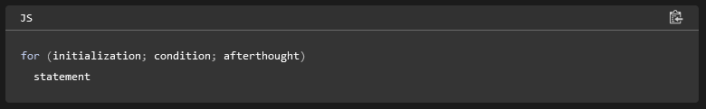

When a for loop executes, the following occurs:

1. The initializing expression initialization, if any, is executed. This expression usually initializes one or more loop counters, but the syntax allows an expression of any degree of complexity. This expression can also declare variables.
2. The condition expression is evaluated. If the value of condition is true, the loop statements execute. Otherwise, the for loop terminates. (If the condition expression is omitted entirely, the condition is assumed to be true.)
3. The statement executes. To execute multiple statements, use a [block statement](https://developer.mozilla.org/en-US/docs/Web/JavaScript/Reference/Statements/block) ({ }) to group those statements.
4. If present, the update expression afterthought is executed.
5. Control returns to Step 2.

### [Example](https://developer.mozilla.org/en-US/docs/Web/JavaScript/Guide/Loops_and_iteration#example)s

In the example below, the function contains a for statement that counts the number of selected options in a scrolling list (a [<select>](https://developer.mozilla.org/en-US/docs/Web/HTML/Element/select) element that allows multiple selections).

#### HTML

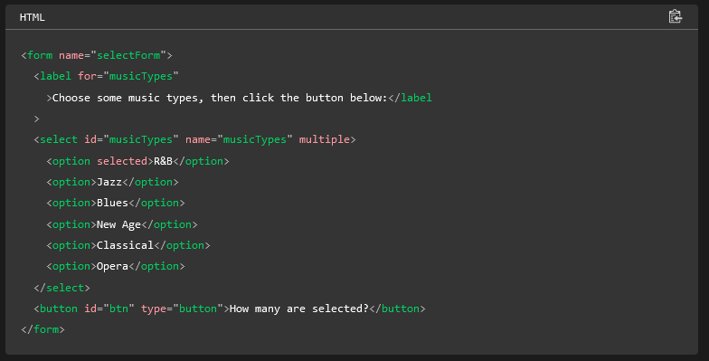

#### JavaScript

Here, the for statement declares the variable i and initializes it to 0. It checks that i is less than the number of options in the <select> element, performs the succeeding if statement, and increments i by 1 after each pass through the loop.

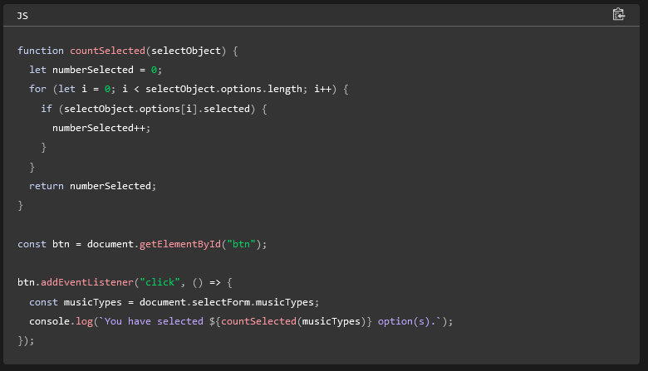

#### [**do...while statement**](https://developer.mozilla.org/en-US/docs/Web/JavaScript/Guide/Loops_and_iteration#do...while_statement)

The [do...while](https://developer.mozilla.org/en-US/docs/Web/JavaScript/Reference/Statements/do...while) statement repeats until a specified condition evaluates to false.

A do...while statement looks as follows:

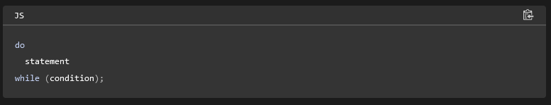

statement is always executed once before the condition is checked. (To execute multiple statements, use a block statement ({ }) to group those statements.)

If condition is true, the statement executes again. At the end of every execution, the condition is checked. When the condition is false, execution stops, and control passes to the statement following do...while.

[**Example**](https://developer.mozilla.org/en-US/docs/Web/JavaScript/Guide/Loops_and_iteration#example_2)

In the following example, the do loop iterates at least once and reiterates until i is no longer less than 5.

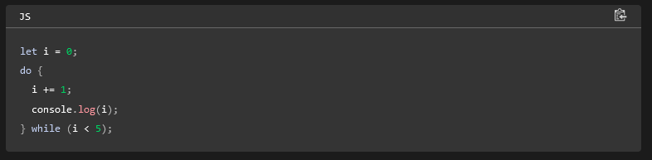

#### [**while statement**](https://developer.mozilla.org/en-US/docs/Web/JavaScript/Guide/Loops_and_iteration#while_statement)

A [while](https://developer.mozilla.org/en-US/docs/Web/JavaScript/Reference/Statements/while) statement executes its statements as long as a specified condition evaluates to true. A while statement looks as follows:

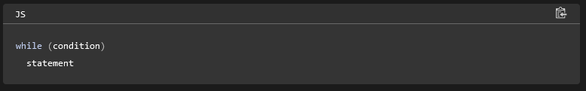

If the condition becomes false, statement within the loop stops executing and control passes to the statement following the loop.

The condition test occurs *before* statement in the loop is executed. If the condition returns true, statement is executed and the condition is tested again. If the condition returns false, execution stops, and control is passed to the statement following while.

To execute multiple statements, use a block statement ({ }) to group those statements.

[**Example 1**](https://developer.mozilla.org/en-US/docs/Web/JavaScript/Guide/Loops_and_iteration#example_1)

The following while loop iterates as long as n is less than 3:

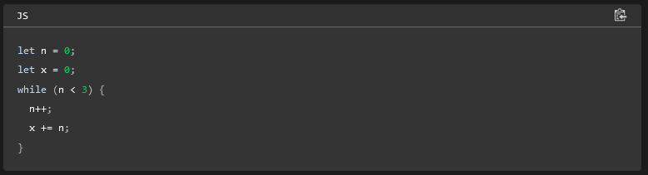

With each iteration, the loop increments n and adds that value to x. Therefore, x and n take on the following values:

* After the first pass: n = 1 and x = 1
* After the second pass: n = 2 and x = 3
* After the third pass: n = 3 and x = 6

After completing the third pass, the condition n < 3 is no longer true, so the loop terminates.

[**Example 2**](https://developer.mozilla.org/en-US/docs/Web/JavaScript/Guide/Loops_and_iteration#example_2_2)

Avoid infinite loops. Make sure the condition in a loop eventually becomes false—otherwise, the loop will never terminate! The statements in the following while loop execute forever because the condition never becomes false:

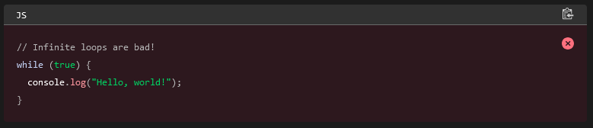

#### [**labeled statement**](https://developer.mozilla.org/en-US/docs/Web/JavaScript/Guide/Loops_and_iteration#labeled_statement)

A [label](https://developer.mozilla.org/en-US/docs/Web/JavaScript/Reference/Statements/label) provides a statement with an identifier that lets you refer to it elsewhere in your program. For example, you can use a label to identify a loop, and then use the break or continue statements to indicate whether a program should interrupt the loop or continue its execution.

The syntax of the labeled statement looks like the following:

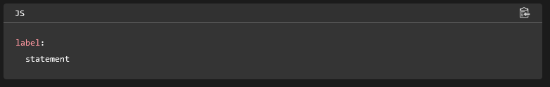

The value of label may be any JavaScript identifier that is not a reserved word. The statement that you identify with a label may be any statement. For examples of using labeled statements, see the examples of break and continue below.

#### [**break statement**](https://developer.mozilla.org/en-US/docs/Web/JavaScript/Guide/Loops_and_iteration#break_statement)

Use the [break](https://developer.mozilla.org/en-US/docs/Web/JavaScript/Reference/Statements/break) statement to terminate a loop, switch, or in conjunction with a labeled statement.

* When you use break without a label, it terminates the innermost enclosing while, do-while, for, or switch immediately and transfers control to the following statement.
* When you use break with a label, it terminates the specified labeled statement.

The syntax of the break statement looks like this:

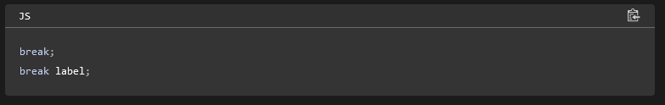

1. The first form of the syntax terminates the innermost enclosing loop or switch.
2. The second form of the syntax terminates the specified enclosing labeled statement.

[**Example 1**](https://developer.mozilla.org/en-US/docs/Web/JavaScript/Guide/Loops_and_iteration#example_1_2)

The following example iterates through the elements in an array until it finds the index of an element whose value is theValue:

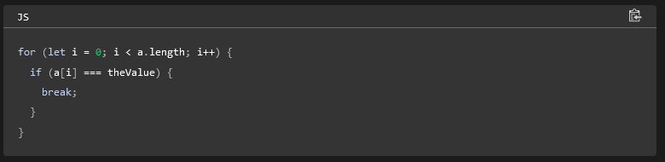

[**Example 2: Breaking to a label**](https://developer.mozilla.org/en-US/docs/Web/JavaScript/Guide/Loops_and_iteration#example_2_breaking_to_a_label)

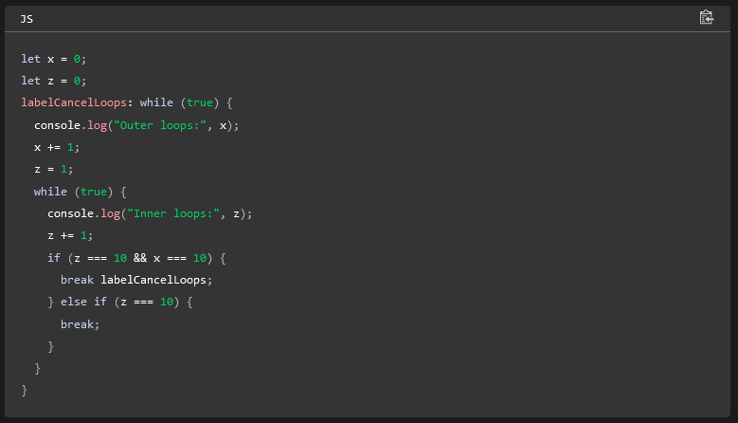

#### [**continue statement**](https://developer.mozilla.org/en-US/docs/Web/JavaScript/Guide/Loops_and_iteration#continue_statement)

The [continue](https://developer.mozilla.org/en-US/docs/Web/JavaScript/Reference/Statements/continue) statement can be used to restart a while, do-while, for, or label statement.

* When you use continue without a label, it terminates the current iteration of the innermost enclosing while, do-while, or for statement and continues execution of the loop with the next iteration. In contrast to the break statement, continue does not terminate the execution of the loop entirely. In a while loop, it jumps back to the condition. In a for loop, it jumps to the increment-expression.
* When you use continue with a label, it applies to the looping statement identified with that label.

The syntax of the continue statement looks like the following:

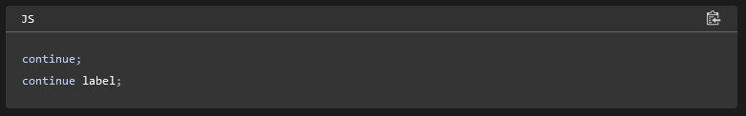

[**Example 1**](https://developer.mozilla.org/en-US/docs/Web/JavaScript/Guide/Loops_and_iteration#example_1_3)

The following example shows a while loop with a continue statement that executes when the value of i is 3. Thus, n takes on the values 1, 3, 7, and 12.

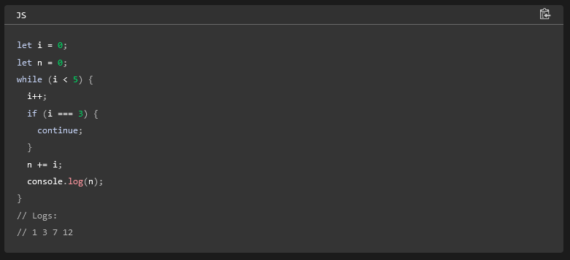

If you comment out the continue;, the loop would run till the end and you would see 1,3,6,10,15.

[**Example 2**](https://developer.mozilla.org/en-US/docs/Web/JavaScript/Guide/Loops_and_iteration#example_2_3)

A statement labeled checkIandJ contains a statement labeled checkJ. If continue is encountered, the program terminates the current iteration of checkJ and begins the next iteration. Each time continue is encountered, checkJ reiterates until its condition returns false. When false is returned, the remainder of the checkIandJ statement is completed, and checkIandJ reiterates until its condition returns false. When false is returned, the program continues at the statement following checkIandJ.

If continue had a label of checkIandJ, the program would continue at the top of the checkIandJ statement.

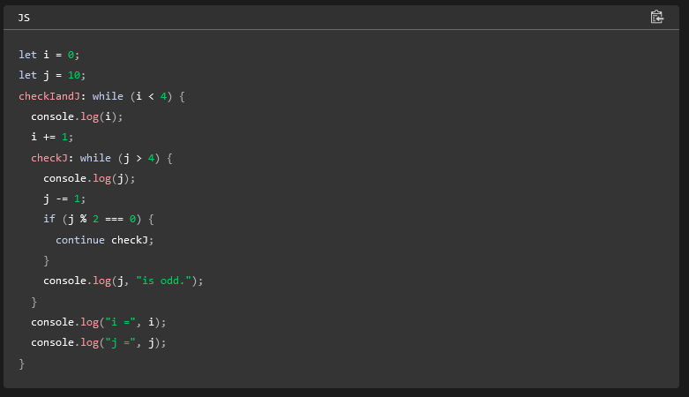

#### [**for...in statement**](https://developer.mozilla.org/en-US/docs/Web/JavaScript/Guide/Loops_and_iteration#for...in_statement)

The [for...in](https://developer.mozilla.org/en-US/docs/Web/JavaScript/Reference/Statements/for...in) statement iterates a specified variable over all the enumerable properties of an object. For each distinct property, JavaScript executes the specified statements. A for...in statement looks as follows:

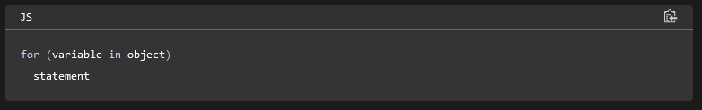

[**Example**](https://developer.mozilla.org/en-US/docs/Web/JavaScript/Guide/Loops_and_iteration#example_3)

The following function takes as its argument an object and the object's name. It then iterates over all the object's properties and returns a string that lists the property names and their values.

js

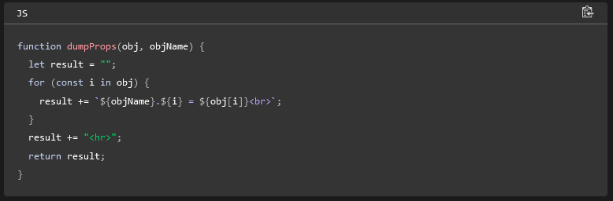

For an object car with properties make and model, result would be:

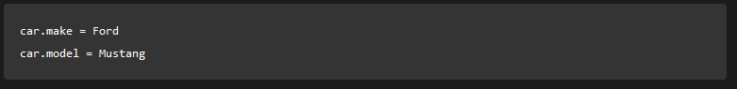

#### [**Arrays**](https://developer.mozilla.org/en-US/docs/Web/JavaScript/Guide/Loops_and_iteration#arrays)

Although it may be tempting to use this as a way to iterate over [Array](https://developer.mozilla.org/en-US/docs/Web/JavaScript/Reference/Global_Objects/Array) elements, the for...in statement will return the name of your user-defined properties in addition to the numeric indexes.

Therefore, it is better to use a traditional [for](https://developer.mozilla.org/en-US/docs/Web/JavaScript/Reference/Statements/for) loop with a numeric index when iterating over arrays, because the for...in statement iterates over user-defined properties in addition to the array elements, if you modify the Array object (such as adding custom properties or methods).

[**for...of statement**](https://developer.mozilla.org/en-US/docs/Web/JavaScript/Guide/Loops_and_iteration#for...of_statement)

The [for...of](https://developer.mozilla.org/en-US/docs/Web/JavaScript/Reference/Statements/for...of) statement creates a loop Iterating over [iterable objects](https://developer.mozilla.org/en-US/docs/Web/JavaScript/Reference/Iteration_protocols) (including [Array](https://developer.mozilla.org/en-US/docs/Web/JavaScript/Reference/Global_Objects/Array), [Map](https://developer.mozilla.org/en-US/docs/Web/JavaScript/Reference/Global_Objects/Map), [Set](https://developer.mozilla.org/en-US/docs/Web/JavaScript/Reference/Global_Objects/Set), [arguments](https://developer.mozilla.org/en-US/docs/Web/JavaScript/Reference/Functions/arguments) object and so on), invoking a custom iteration hook with statements to be executed for the value of each distinct property.

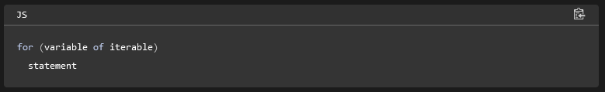

The following example shows the difference between a for...of loop and a [for...in](https://developer.mozilla.org/en-US/docs/Web/JavaScript/Reference/Statements/for...in) loop. While for...in iterates over property names, for...of iterates over property values:

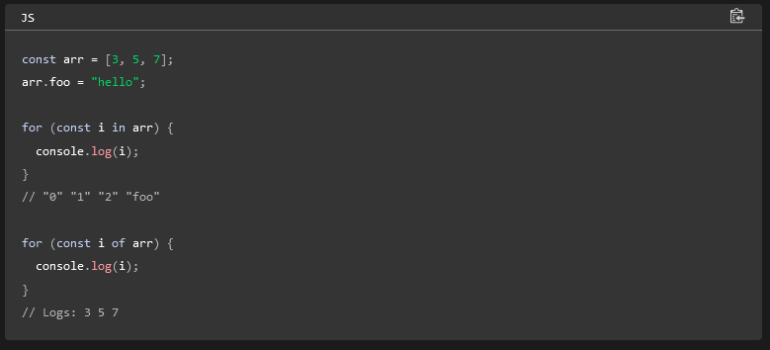

The for...of and for...in statements can also be used with [destructuring](https://developer.mozilla.org/en-US/docs/Web/JavaScript/Reference/Operators/Destructuring_assignment). For example, you can simultaneously loop over the keys and values of an object using [Object.entries()](https://developer.mozilla.org/en-US/docs/Web/JavaScript/Reference/Global_Objects/Object/entries).

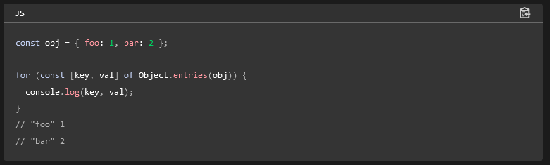

# Looping Activity

**for-of**

Replacement for the for loop. Array.forEach or Array.map are usually better options if you are looping over an array (which you often are).

**for-in**

This allows you to iterate over objects. It returns the key of the item instead of the value like for of. If you find yourself reaching for this often you should probably take a look at how you are storing your data...

**while**

while is great for when you need to do something until a certain state occurs in your program. You know when you want the loop to end...but aren't sure how many loops it will require to get there.

**Activity 1** [**#**](https://byui-cit.github.io/learning-modules/modules/js/loops/ponder1/#activity-1)

The code above will output the elements in an Array to the DOM. The provided solution above showed doing that one list element at a time, but this produces a lot of duplicated code and is tedious even for short lists. Loops would be a much better way to approach that problem. How can we use loops to make this more DRY?

1. Decide which type of loop would be best for this task.

What would be an appropriate loop to use? A basic while loop is useful for when we don't know how many times we need to loop. In this case we do: as many times as we have elements in the array. So a basic for loop is good for when we know how many loops we need to make. But if you remember back to the reading it mentioned that anytime we are looping over an array we should look at .forEach() or .map()

It is worthwhile to take a look at both options.

1. Write a function using a .forEach method to loop over an array and output it's contents in a <ul>
2. Write a function using a .map method to loop over an array and output it's contents in a <ul>
3. Test your functions.

## Activity 2 [#](https://byui-cit.github.io/learning-modules/modules/js/loops/ponder1/#activity-2)

Another way that we could implement the map version of our code above would be with an arrow function. Our code could be written like this:

// with .forEach  
const foodsElement = document.querySelector('#favorite-foods');  
function createandAppendFoodItem(food) {  
 let favoriteFood = document.createElement('li');  
 favoriteFood.textContent = food;  
 foodsElement.appendChild(favoriteFood);  
}  
myInfo.favoriteFoods.forEach(createAndAppendFoodItem);  
}  
  
// with .map  
 const foodsElement = document.querySelector('#favorite-foods');  
 function mapFoodItem(food) {  
 let favoriteFood = document.createElement('li');  
 favoriteFood.textContent = food;  
 return favoriteFood;  
 }  
 // this function could also be written this way using a template literal:  
 function mapFoodItemSmall(food) {  
 return `<li>${food}</li>`;  
 }  
 const foodListElements = myInfo.favoriteFoods.map(mapFoodItem);  
 // we need to flatten the array of strings into one big string. .join does this.  
 foodsElement.innerHTML = foodListElements.join('');

**Activity 2** [**#**](https://byui-cit.github.io/learning-modules/modules/js/loops/ponder1/#activity-2)

Another way that we could implement the map version of our code above would be with an arrow function. Our code could be written like this:

// The map example could be simplified as below:  
const foodsElement = document.querySelector("#favorite-foods");  
const foodListElements = myInfo.favoriteFoods.map((food) => `<li>${food}</li>`);  
// we need to flatten the array of strings into one big string. .join does this.  
foodsElement.innerHTML = foodListElements.join("");

In fact that example could be simplified even further:

// OR we could in fact simplify this down to one line!  
document.querySelector("#favorite-foods").innerHTML = myInfo.favoriteFoods  
 .map((food) => `<li>${food}</li>`)  
 .join("");

As you look at the third one line version of this what do you think? Which do you prefer? How easy is it to figure out what is going on looking at that compared to one of the more verbose examples above? Discuss with a classmate how you feel about the example above.

Simplification is a good thing, but it can be taken too far and make code harder to read and understand. Sometimes it's worth typing a few more characters to have readable code. **Readable code = maintainable code**

**Activity 3** [**#**](https://byui-cit.github.io/learning-modules/modules/js/loops/ponder1/#activity-3)

What if we needed to output the contents of multiple different Arrays? Can you make what we did above more re-usable?

1. Create a function that will take a food string and return that string embedded in some html. (<li>food</li>)
2. Create a function that will take a place string and return that string embedded in some html. The place is a bit more complex. We have the location and the length. You can use the following for the template: <dt>${place.place}</dt><dd>${place.length}</dd>)
3. Create a function that will take a list, and a callback function to produce an HTML template. The function should transform our list by looping over it calling the template function once for each item in the list. The function should return all of the HTML strings flattened into one long string.
4. Call the function above once for the placesLived list and again for the favoriteFoods list. Set the innerHTML of the appropriate HTML element to the results of the function call.
5. // reusable!  
   myInfo = {  
    name: "Brother T",  
    photo: "images/photo.jpg",  
    favoriteFoods: ["Fettucini", "Steak", "Chicken", "Shrimp", "Baked Potato"],  
    hobbies: ["Reading", "Fishing", "Camping"],  
    placesLived: [  
    {  
    place: "Rexburg, ID",  
    length: "5 years",  
    },  
    {  
    place: "Ammon, ID",  
    length: "3 years",  
    },  
    {  
    place: "Sandy, UT",  
    length: "1 year",  
    },  
    ],  
   };  
   const foodsElement = document.querySelector("#favorite-foods");  
   const placesElement = document.querySelector("#places-lived");  
   // requires a list, and a callback that will produce an html string for each item in the list  
   // returns a string of html  
   function generateListMarkup(list, templateCallback) {  
    const htmlList = list.map(templateCallback);  
    return htmlList.join("");  
   }  
   // requires an food string  
   // returns that string embedded in HTML markup  
   function foodsTemplate(food) {  
    return `<li>${food}</li>`;  
   }  
     
   // requires an place string  
   // returns that string embedded in HTML markup  
   function placesTemplate(place) {  
    return `<dt>${place.place}</dt><dd>${place.length}</dd>`;  
   }  
     
   foodsElement.innerHTML = generateListMarkup(  
    myInfo.favoriteFoods,  
    foodsTemplate  
   );  
   placesElement.innerHTML = generateListMarkup(  
    myInfo.placesLived,  
    placesTemplate  
   );

# Event Handling

"Events are things that happen in the system you are programming — the system produces (or "fires") a signal of some kind when an event occurs, and provides a mechanism by which an action can be automatically taken (that is, some code running) when the event occurs. Events are fired inside the browser window, and tend to be attached to a specific item that resides in it. " - [MDN](https://developer.mozilla.org/en-US/docs/Learn/JavaScript/Building_blocks/Events)

The [Event Reference](https://developer.mozilla.org/en-US/docs/Web/Reference/Events) attempts to maintain a list of the standard Events used in modern web browsers.

In general, we can distinguish events of different kinds based on the object emitting the event including:

* the window object, such as due to resizing the browser,
* the window.screen object, such as due to changes in device orientation,
* the document object, including the loading, modification, user interaction, and unloading of the page,
* the objects in the DOM (document object model) tree including user interactions or modifications,
* the XMLHttpRequest objects used for network requests, and
* the media objects such as audio and video, when the media stream players change state.

Some notable events are:

* the global object [window](https://byui-cse.github.io/en-US/docs/Web/API/Window) emits an event called ['load'](https://byui-cse.github.io/en-US/docs/Web/Reference/Events/load_(ProgressEvent)) when the page has finished rendering, meaning that all resources have been downloaded and acted upon, so that the scripts have been run and the images displayed,
* the global object [window](https://byui-cse.github.io/en-US/docs/Web/API/Window) emits an event called ['resize'](https://byui-cse.github.io/en-US/docs/Web/Reference/Events/resize) when the height or the width of the browser window is changed by a user,
* the DOM object [document](https://byui-cse.github.io/en-US/docs/Web/API/Document) representing the HTML document emits an event called ['DOMContentLoaded'](https://byui-cse.github.io/en-US/docs/Web/Reference/Events/DOMContentLoaded) when the document has finished loading,
* the DOM node objects such as [div](https://byui-cse.github.io/en-US/docs/Web/HTML/Element/div) or [button](https://byui-cse.github.io/en-US/docs/Web/HTML/Element/button) emit an event called ['click'](https://byui-cse.github.io/en-US/docs/Web/Reference/Events/click) when the user presses the mouse button while the mouse pointer is on top of the DOM node in the HTML page.

## addEventListener

target.addEventListener(type, listener [, options]);

How do we make something happen when a specific event happens? addEventListener. Let's say we had a button in our HTML. When the user clicks on that button with the mouse, we would like it to read the value of an input, and output it to another element.

**Callbacks**

We have mentioned that in Javascript functions are special objects...but since they are objects we can do anything with functions that we can a normal object. This includes assigning functions to variables, and passing functions into other functions as arguments, as well as returning functions from functions.

When we pass a function into another function we call it a 'callback'. addEventListener is a good example. The second parameter (listener) that it is expecting should be a function. This function will get called when the event we are listening for happens.

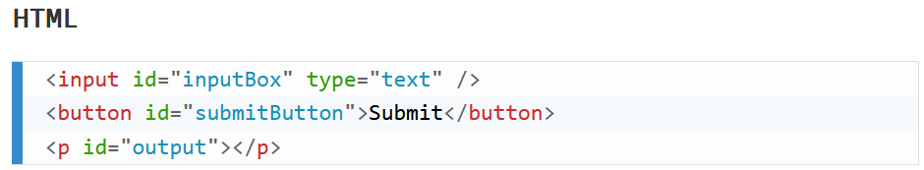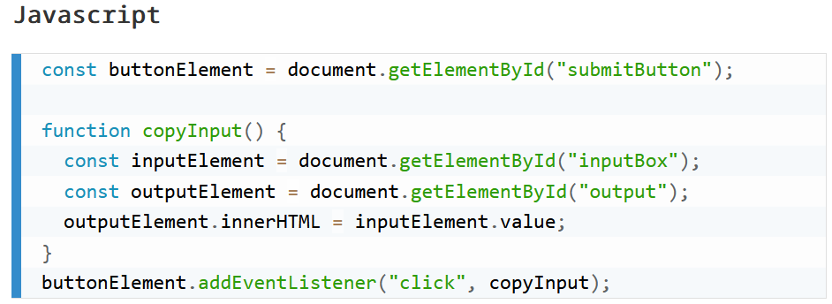

**The Event object**

addEventListener will always pass an object containing information about the event that happened into your callback function. It contains a lot of very useful information. Run the code below and inspect the event that got logged out to the console.

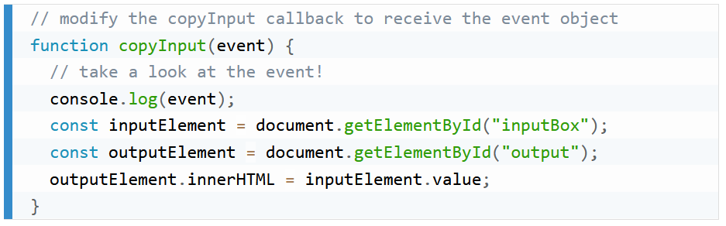

A few properties of particular interest would be event.target, event.currentTarget, and event.type

**Another example** [**#**](https://byui-cit.github.io/learning-modules/modules/js/dom-events/prepare1/#another-example)

We saw how to respond to a 'click' event above. What about a key event? If you refer back to the [Event Reference](https://developer.mozilla.org/en-US/docs/Web/Reference/Events) document from earlier we can find keydown and keyup events. With something like a click, we usually want to know if a specific thing has been clicked. A keyboard event however often is not specific to a particular element, so we will listen at the document level.

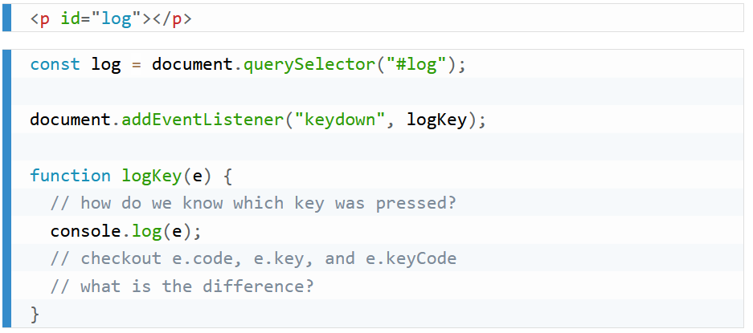

Did you note the difference between e.code and e.key? [Here](https://javascript.info/keyboard-events) is a hint.

[The JavaScript DOM explained in 5 minutes!](https://youtu.be/NO5kUNxGIu0?si=0AV68_oBlm7VnWg3)

Practice: **Some common DOM manipulation concepts/use cases**.

* To **select** an HTML element from the document - using the [querySelector](https://developer.mozilla.org/en-US/docs/Web/API/Document/querySelector) method.  
  This line of code selects the first instance of an article element from the document and assigns the element as a reference to the variable named article.

const article = document.querySelector('article');

* To **change** the innerHTML property of an existing element.  
  This line of code uses an existing variable that has already selected an element and changes its innerHTML property value.

article.innerHTML = 'innerHTML supports <strong>HTML</strong> tags. The textContent property does not.';

* To **change** the inline CSS style of an element.  
  This line of code changes the text-align CSS property of the selected element.

article.style.textAlign = 'right';

* To **change** an attribute of an element.  
  This line of code adds and attribute class to the element and gives it a value.

article.setAttribute('class', 'active');

An alternative way to change an attribute of an element, specifically the class attribute, is by directly manipulating the element's classList.

articleElement.classList.add('active');

This method is often preferred when working with class manipulation because classList provides additional methods like add, remove, toggle, and contains, making it more convenient and expressive for managing classes on an element.

* To **create** an element.  
  This line of code creates a new <p> element and stores it in the variable named paragraph.

const paragraph = document.createElement('p');

* To **append** an element with additional content or elements.  
  These lines of code add content to the end of the article element.
* article.appendChild(paragraph);

article.append(paragraph, 'Hello World Addition!');

The append() method allows you to include multiple arguments to append to the element in the specified order.

* To **remove** an element from the document.  
  These lines of code remove the paragraph from the article and then, the article itself.
* article.removeChild(paragraph);

article.remove();

**Optional Resources**

* [DOM Manipulation](https://youtu.be/y17RuWkWdn8) – by Web Dev Simplified – 14 key techniques in summary demonstration format. Take special note of the concept of **datasets**.
* **Click Event**: Triggered when a user clicks on an element. It's widely used for handling button clicks, link clicks, or any interaction involving a mouse click.
* buttonElement.addEventListener('click', function() {
* // Code to execute when the element is clicked

});

The addEventListener method takes two arguments: the event name and a function to execute when the event is triggered. The function is called an event handler. We will learn more about writing functions later in the course. For now, just know that the function is a block of code that will be executed when the event is triggered. The function is also called a callback function because it is called back when the event is triggered.

* **Keyup Event**: Triggered when a key is released. Useful for handling keyboard input.
* buttonElement.addEventListener('keyup', function() {
* // Code to execute when a key is released

});

* **DOMContentLoaded Event**: Triggered when the HTML document has been completely parsed and all deferred scripts have been executed. It's widely used for initializing JavaScript applications.
* document.addEventListener("DOMContentLoaded", function() {
* // Code to execute when the DOM is parsed

});

# Elements of construction

• **Typography:** Use 2 or 3 fonts at a maximum. If you need variation, use a variation of the font. Remember to use a font that is easy to read and visually appealing. When using Google Fonts, be sure to include only the weights that you need. Here is an example of only including Roboto's regular (400) and bold (700) versions..

<link href="https://fonts.googleapis.com/css2?family=Roboto:wght@400;700&display=swap" rel="stylesheet">

* **Colors:** Use a color scheme that is visually appealing and conveys the desired mood or message. Limit the color palette to five hues or less. Test color contrast to ensure readability for all users.
* **Clarity:** Keep the design clean and uncluttered. Use ample whitespace to guide the user's focus and avoid overwhelming them with too much information at once. Do not be wordy, use visuals to help communicate your message.
* **Consistency:** Maintain a consistent visual language throughout the design. This includes using consistent typography, color schemes, and layout patterns across different pages or sections of your design.
* **Visual Hierarchy:** Establish a clear hierarchy of information to help users understand the relative importance of different elements on the page. Use techniques like size, color, and typography to emphasize important content.
* **Accessibility:** Ensure that your design is accessible to all users, including those with disabilities. This may involve considerations such as providing alternative text for images, using sufficient color contrast, and implementing keyboard navigation. You can test your design for accessibility using tools like a WAVE, Axe, or Lighthouse.
* **Feedback:** Provide clear feedback to users when they interact with elements on the page. This could include visual cues such as button states or animations to indicate that an action has been successfully completed.
* **User-Centric Design:** Design with the needs and preferences of your target audience in mind. Conduct user research to understand their goals, behaviors, and pain points, and tailor your design accordingly.
* **Visual Appeal:** Use visually appealing elements such as high-quality images, engaging animations, and attractive typography to capture the user's attention and create a memorable experience.

As an active learner, leverage the resources of the internet and AI to help you apply these principles in your own design and development.

# Pseudo Elements

Mozilla Main Page for Pseudo Classes

[Pseudo Classes](https://developer.mozilla.org/en-US/docs/Web/CSS/Pseudo-classes)

A pseudo-class is a selector that selects elements that are in a specific state, e.g. they are the first element of their type, or they are being hovered over by the mouse pointer. They tend to act as if you had applied a class to some part of your document, often helping you cut down on excess classes in your markup, and giving you more flexible, maintainable code.

Pseudo classes start with a single colon : .

[Pseudo Elements](https://developer.mozilla.org/en-US/docs/Web/CSS/Pseudo-elements)

Pseudo-elements behave in a similar way. However, they act as if you had added a whole new HTML element into the markup, rather than applying a class to existing elements.

Pseudo-elements start with a double colon :: .

A [CSS](https://developer.mozilla.org/en-US/docs/Web/CSS) ***pseudo-class*** is a keyword added to a selector that lets you style a specific state of the selected element(s). For example, the pseudo-class [:hover](https://developer.mozilla.org/en-US/docs/Web/CSS/:hover) can be used to select a button when a user's pointer hovers over the button and this selected button can then be styled

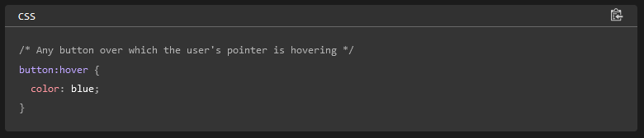

A pseudo-class consists of a colon (:) followed by the pseudo-class name (e.g., :hover). A functional pseudo-class also contains a pair of parentheses to define the arguments (e.g., :dir()). The element that a pseudo-class is attached to is defined as an *anchor element* (e.g., button in case button:hover).

Pseudo-classes let you apply a style to an element not only in relation to the content of the document tree, but also in relation to external factors like the history of the navigator ([:visited](https://developer.mozilla.org/en-US/docs/Web/CSS/:visited), for example), the status of its content (like [:checked](https://developer.mozilla.org/en-US/docs/Web/CSS/:checked) on certain form elements), or the position of the mouse (like [:hover](https://developer.mozilla.org/en-US/docs/Web/CSS/:hover), which lets you know if the mouse is over an element or not).

**Note:** In contrast to pseudo-classes, [pseudo-elements](https://developer.mozilla.org/en-US/docs/Web/CSS/Pseudo-elements) can be used to style a *specific part* of an element.

## [**Element display state pseudo-classes**](https://developer.mozilla.org/en-US/docs/Web/CSS/Pseudo-classes#element_display_state_pseudo-classes)

These pseudo-classes enable the selection of elements based on their display states.

### [:fullscreen](https://developer.mozilla.org/en-US/docs/Web/CSS/:fullscreen)

Matches an element that is currently in fullscreen mode.

### [:modal](https://developer.mozilla.org/en-US/docs/Web/CSS/:modal)

Matches an element that is in a state in which it excludes all interaction with elements outside it until the interaction has been dismissed.

### [:picture-in-picture](https://developer.mozilla.org/en-US/docs/Web/CSS/:picture-in-picture)

Matches an element that is currently in picture-in-picture mode.

## [**Input pseudo-classes**](https://developer.mozilla.org/en-US/docs/Web/CSS/Pseudo-classes#input_pseudo-classes)

These pseudo-classes relate to form elements, and enable selecting elements based on HTML attributes and the state that the field is in before and after interaction.

### [:autofill](https://developer.mozilla.org/en-US/docs/Web/CSS/:autofill)

Matches when an [<input>](https://developer.mozilla.org/en-US/docs/Web/HTML/Element/input) has been autofilled by the browser.

### [:enabled](https://developer.mozilla.org/en-US/docs/Web/CSS/:enabled)

Represents a user interface element that is in an enabled state.

### [:disabled](https://developer.mozilla.org/en-US/docs/Web/CSS/:disabled)

Represents a user interface element that is in a disabled state.

### [:read-only](https://developer.mozilla.org/en-US/docs/Web/CSS/:read-only)

Represents any element that cannot be changed by the user.

### [:read-write](https://developer.mozilla.org/en-US/docs/Web/CSS/:read-write)

Represents any element that is user-editable.

### [:placeholder-shown](https://developer.mozilla.org/en-US/docs/Web/CSS/:placeholder-shown)

Matches an input element that is displaying placeholder text. For example, it will match the placeholder attribute in the [<input>](https://developer.mozilla.org/en-US/docs/Web/HTML/Element/input) and [<textarea>](https://developer.mozilla.org/en-US/docs/Web/HTML/Element/textarea) elements.

### [:default](https://developer.mozilla.org/en-US/docs/Web/CSS/:default)

Matches one or more UI elements that are the default among a set of elements.

### [:checked](https://developer.mozilla.org/en-US/docs/Web/CSS/:checked)

Matches when elements such as checkboxes and radio buttons are toggled on.

### [:indeterminate](https://developer.mozilla.org/en-US/docs/Web/CSS/:indeterminate)

Matches UI elements when they are in an indeterminate state.

### [:blank](https://developer.mozilla.org/en-US/docs/Web/CSS/:blank)

Matches a user-input element which is empty, containing an empty string or other null input.

### [:valid](https://developer.mozilla.org/en-US/docs/Web/CSS/:valid)

Matches an element with valid contents. For example, an input element with the type 'email' that contains a validly formed email address or an empty value if the control is not required.

### [:invalid](https://developer.mozilla.org/en-US/docs/Web/CSS/:invalid)

Matches an element with invalid contents. For example, an input element with type 'email' with a name entered.

### [:in-range](https://developer.mozilla.org/en-US/docs/Web/CSS/:in-range)

Applies to elements with range limitations. For example, a slider control when the selected value is in the allowed range.

### [:out-of-range](https://developer.mozilla.org/en-US/docs/Web/CSS/:out-of-range)

Applies to elements with range limitations. For example, a slider control when the selected value is outside the allowed range.

### [:required](https://developer.mozilla.org/en-US/docs/Web/CSS/:required)

Matches when a form element is required.

### [:optional](https://developer.mozilla.org/en-US/docs/Web/CSS/:optional)

Matches when a form element is optional.

### [:user-valid](https://developer.mozilla.org/en-US/docs/Web/CSS/:user-valid)

Represents an element with correct input, but only when the user has interacted with it.

[:user-invalid](https://developer.mozilla.org/en-US/docs/Web/CSS/:user-invalid)

Represents an element with incorrect input, but only when the user has interacted with it.

## [**Linguistic pseudo-classes**](https://developer.mozilla.org/en-US/docs/Web/CSS/Pseudo-classes#linguistic_pseudo-classes)

These pseudo-classes reflect the document language and enable the selection of elements based on language or script direction.

### [:dir()](https://developer.mozilla.org/en-US/docs/Web/CSS/:dir)

The directionality pseudo-class selects an element based on its directionality as determined by the document language.

### [:lang()](https://developer.mozilla.org/en-US/docs/Web/CSS/:lang)

Select an element based on its content language.

## [:root](https://developer.mozilla.org/en-US/docs/Web/CSS/:root)

The **:root** [CSS](https://developer.mozilla.org/en-US/docs/Web/CSS) [pseudo-class](https://developer.mozilla.org/en-US/docs/Web/CSS/Pseudo-classes) matches the root element of a tree representing the document. In HTML, :root represents the [<html>](https://developer.mozilla.org/en-US/docs/Web/HTML/Element/html) element and is identical to the selector html, except that its [specificity](https://developer.mozilla.org/en-US/docs/Web/CSS/Specificity) is higher.

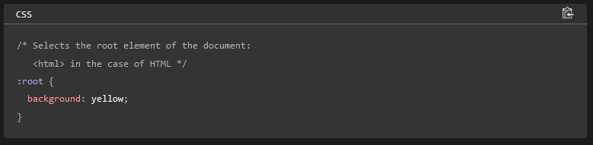

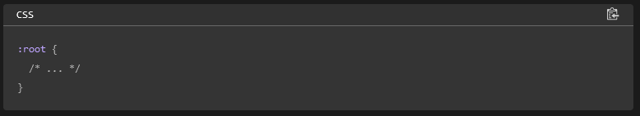

Examples

### [**Declaring global CSS variables**](https://developer.mozilla.org/en-US/docs/Web/CSS/:root#declaring_global_css_variables)

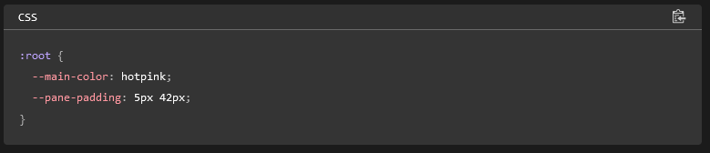

[Using CSS custom properties (variables)](https://developer.mozilla.org/en-US/docs/Web/CSS/Using_CSS_custom_properties)

**Custom properties** (sometimes referred to as **CSS variables** or **cascading variables**) are entities defined by CSS authors that represent specific values to be reused throughout a document. They are set using the [@property](https://developer.mozilla.org/en-US/docs/Web/CSS/@property) at-rule or by [custom property syntax](https://developer.mozilla.org/en-US/docs/Web/CSS/--*) (e.g., **--primary-color: blue;**). Custom properties are accessed using the CSS [var()](https://developer.mozilla.org/en-US/docs/Web/CSS/var) function (e.g., **color: var(--primary-color);**).

Complex websites have very large amounts of CSS, and this often results in a lot of repeated CSS values. For example, it's common to see the same color used in hundreds of different places in stylesheets. Changing a color that's been duplicated in many places requires a search and replace across all rules and CSS files. Custom properties allow a value to be defined in one place, then referenced in multiple other places so that it's easier to work with. Another benefit is readability and semantics. For example, --main-text-color is easier to understand than the hexadecimal color #00ff00, especially if the color is used in different contexts.

Custom properties defined [using two dashes (--)](https://developer.mozilla.org/en-US/docs/Web/CSS/--*) are subject to the [cascade](https://developer.mozilla.org/en-US/docs/Web/CSS/Cascade) and inherit their value from their parent. The [@property](https://developer.mozilla.org/en-US/docs/Web/CSS/@property) at-rule allows more control over the custom property and lets you specify whether it inherits its value from a parent, what the initial value is, and the type constraints that should apply.

**Note:** Variables do not work inside media queries and container queries. You can use the [var()](https://developer.mozilla.org/en-US/docs/Web/CSS/var) function in any part of a value in any property on an element. You cannot use [var()](https://developer.mozilla.org/en-US/docs/Web/CSS/var) for property names, selectors, or anything aside from property values, which means you can't use it in a media query or container query.

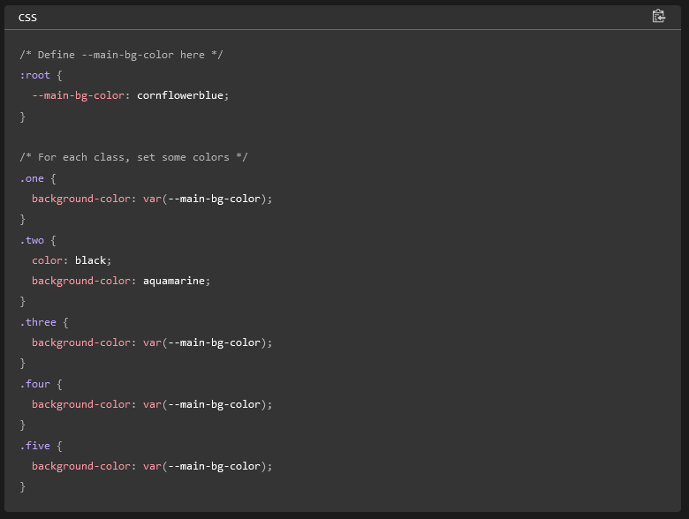

[**Inheritance of custom properties**](https://developer.mozilla.org/en-US/docs/Web/CSS/Using_CSS_custom_properties#inheritance_of_custom_properties)

A custom property defined using two dashes -- instead of @property always inherits the value of its parent. This is demonstrated in the following example:

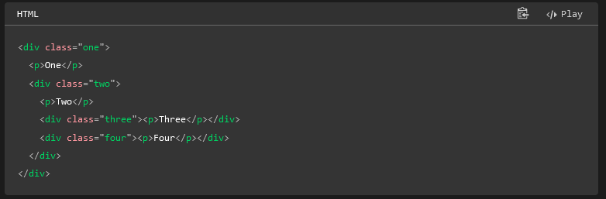

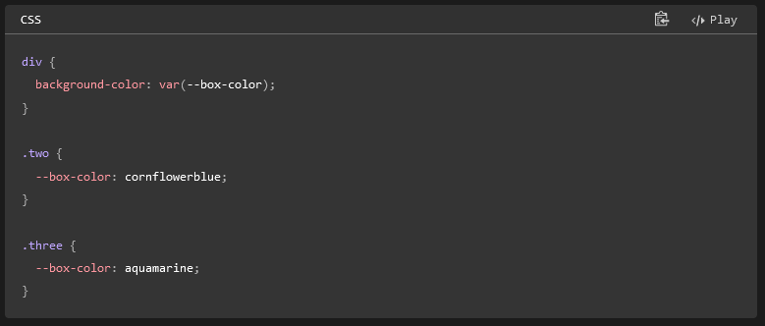

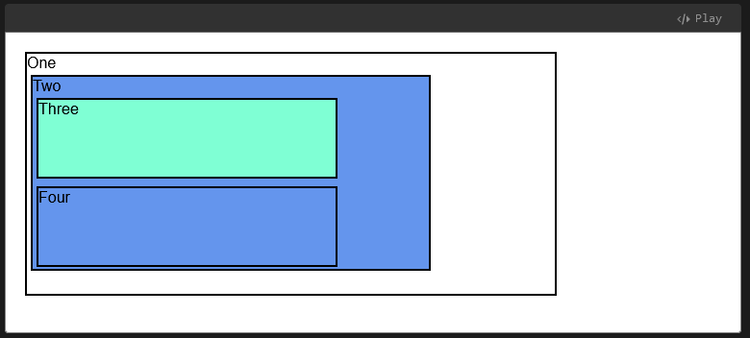

[**Using @property to control inheritance**](https://developer.mozilla.org/en-US/docs/Web/CSS/Using_CSS_custom_properties#using_property_to_control_inheritance)

The @property at-rule lets you explicitly state whether the property inherits or not. The following example creates a custom property using the @property at-rule. Inheritance is disabled, there's a [<color>](https://developer.mozilla.org/en-US/docs/Web/CSS/color_value) data type defined, and an initial value of cornflowerblue.

The parent element sets --box-color to a value of green and uses --box-color as a value for its background color. The child element also uses background-color: var(--box-color), and we would expect it to have the color green if inheritance was enabled (or if it was defined using the double dash syntax).

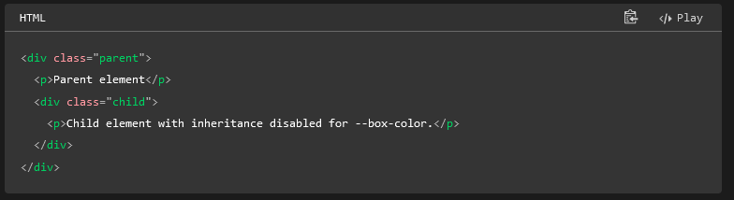

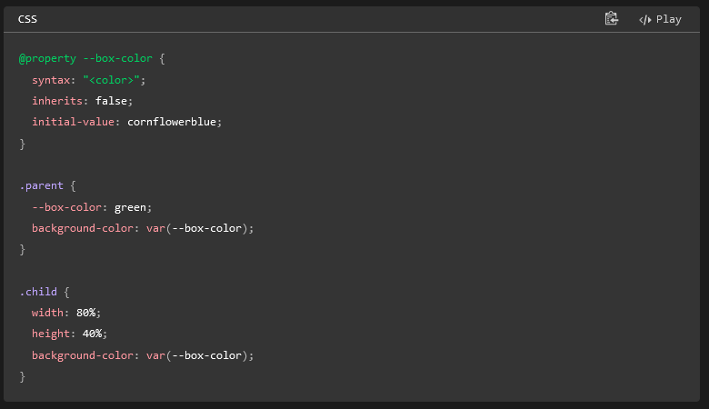

Because inherits: false; is set in the at-rule, and a value for the --box-color property is not declared within the .child scope, the initial value of cornflowerblue is used instead of green that would have been inherited from the parent:

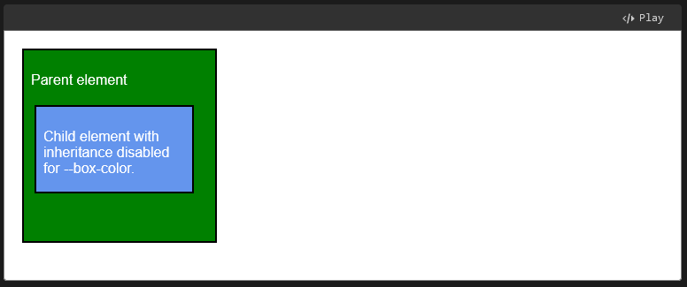

# Image File Formats

## File Formats

The work of responsive image design is to support smaller page weights and to deliver content based upon screen size. This activity explores SVG (Scalar Vector Graphic) and the WebP image format which offers better compression to support faster page loads.

"WebP is a modern image format that provides superior lossless and lossy compression for images on the web. Using WebP, webmasters and web developers can create smaller, richer images that make the web faster." - developers.google.com

The SVG format is a vector image format that is used for two-dimensional graphics with support for interactivity and animation. "As such, it's a text-based, open Web standard for describing images that can be rendered cleanly at any size and are designed specifically to work well with other web standards including CSS, DOM, JavaScript, and SMIL. SVG is, essentially, to graphics what HTML is to text." - [MDN](https://developer.mozilla.org/en-US/docs/Web/SVG)

[Common File Types](https://www.youtube.com/watch?v=Zx0CacsiDZ4)

[Webp](https://developers.google.com/speed/webp)

Don’t Use BMP (bit map) Not good for the web

Some terms that you may not be familiar with include:

* **Lossless Compression** - File compression that maintains the original data using sophisticated, redundancy, replacement algorithms.
* **Lossy Compression** - File compression that uses approximations and partial data to represent the original media source.
* **Transparency** - The image property representing the amount or level of transmission of background color through the image.

[File Types And What to Select](https://developer.mozilla.org/en-US/docs/Web/Media/Formats/Image_types)

* Note the summary of the **SVG** and **WebP** file formats presented in the table.

"The older formats like PNG, JPEG, GIF have poor performance compared to newer formats like WebP and AVIF, but enjoy broader "historical" browser support. The newer image formats are seeing increasing popularity as browsers without support become increasingly irrelevant (meaning have virtually zero market share)." – MDN

## Image Optimization

**Overview**

One of the concerns of frontend web design and development is site performance. A common element affecting performance is image load time. That is where image optimization becomes a factor because images account for most of the downloaded bytes from the web server. The art of optimization is the process of trying to find the balance between design quality needs and file size.

Here are some [Web Almanac](https://almanac.httparchive.org/en/2024) facts:

* 99.9% of pages on the web generate at least one request for an image resource.
* Most images (54%) are presented in landscape aspect ratio versus square or portrait.
* "Images are the poster child for balance between performance-enhancing technologies and asset byte size."

**Basic Steps of Optimization**

Often the original photos that we work with are very large and those photos need to be scaled down to the largest size that is actually needed on the page given the design and layout plan. Software can be used to crop, reduce, and optimize the images. These are the basic steps supported by most photo editing packages:

1. Crop the original image to the critical content keeping in mind design principles, like the [rule of thirds](https://www.slrlounge.com/glossary/rule-of-thirds-definition/), and the site or section purpose.
2. Resize the image to the maximum size that you actually need in the design of your site. That image will then be saved in smaller formats, possibly with slightly different design to match the design and layout in smaller views, meaning, smart phone, tablet.
3. Reduce the quality of the image to an acceptable level, thus reducing its file size.

Image optimization is some of that low-hanging fruit which we can employ without a staggering amount of investment of time. Additional image handling techniques include:   
• Resizing images during the build process using script   
• Creating multiple image sizes and use srcset to let the browser or user agent decide which image to load   
• Use an image CDN (Content Delivery Network)

**Measuring Performance / Page Weight**

Check the size of the page resources by using the Dev Tools **Network** tab. Reload the page using a cache emptying "[hard](https://support.planwithvoyant.com/hc/en-us/articles/360046611171-How-to-do-hard-refresh-in-Chrome-Firefox-Safari-and-Microsoft-Edge)" refresh. The course standard will be outlined in the course development standards checklist and in the assessment rubrics.

**Editing Tools**

The following list of software applications is in no way comprehensive but rather provides some healthy options of tools that will help you manipulate images including the process of optimizing images. You may elect to use any tool you wish.

* **Adobe Photoshop**: Adobe Photoshop is the most popular software application when it comes to actually being named on front-end web designer job descriptions under qualifications or desired experience. It is an industry standard. This course does not require or teach Photoshop even though it certainly ranks high in the skill set for front-end web designers and developers. The tool has a built-in optimization process known as **Save for web**. You can specify some constraints via a setting that should help in finding this balance mentioned above.
* **GIMP** or [GNU Image Manipulation Program](https://www.gimp.org/), is an image manipulation, image authoring, and photo editing software that is freely distributed and has a lot of support online. It may be a step down from Photoshop, but it supports a large percentage of the actual work that is essential in graphical design.
* [TinyJPG / TinyPNG](https://tinyjpg.com/) is a free online application that will reduce JPEG images through encoding.
* [PIXLR x](https://pixlr.com/x/) is a web-based photo-editor that will let you crop, resize, and enhance your photos for free.

There are many other tools and you are free to use any image editing too. Many of these come with excellent support including the following:

* [Squoosh.app](https://squoosh.app/) - online photo editing
* [JPEG Optimizer](https://jpeg-optimizer.com/) - online jpg file editing
* [ImageOptim](https://imageoptim.com/) (Here is [an absolute beginners guide](https://www.youtube.com/watch?v=L0FkL5T4QGQ&feature=youtu.be) for use on Mac computers)
* [File Optimizer](http://nikkhokkho.sourceforge.net/static.php?page=FileOptimizer) (for use on Windows)

# Responsive Images: srcset

## Responsive Images

The work of [responsive image design](https://developer.mozilla.org/en-US/docs/Learn/HTML/Multimedia_and_embedding/Responsive_images) is to support smaller page weights and to deliver content based upon screen size. The objective is to reduce page weight while being conscious of image clarity and functionality in each screen size and subsequent viewports (the visible area of a web page).

"Serving desktop-sized images to mobile devices can use 2-4x more data than needed. Instead of a "one-size-fits-all" approach to images, serve different image sizes to different devices. How many image versions should you create? There is no single 'correct' answer to this question. However, it's common to serve 3-5 different sizes of an image. Serving more image sizes is better for performance, but will take up more space on your servers and require writing a tiny bit more HTML." - Web.dev

The user experience (**UX**) concept is that users expect to scroll web pages vertically with no need to scroll horizontally to view content. Nor should the user should be required to zoom in or out to see the page content. We cannot expect nor rely upon on a particular viewport width in order for the page to render properly.

This activity focuses on applying the [srcset](https://developer.mozilla.org/en-US/docs/Web/HTML/Element/img#Using_the_srcset_and_sizes_attributes) attribute to images using the picture and source elements. The browser parses the responsive image syntax and decides which image is the best match.

The activity content **assumes** the following:

* The [**viewport meta element**](https://byui-cse.github.io/wdd131-ww-course/resources/dev-standards.html) has been properly applied to the document.
* The images to be used have been **optimized** for the web by
  + Limiting the images' **width and height** (dimensions) to no more than is necessary for the page design in any view size.
  + The images are of a valid web **type/format**.
  + The images are **compressed** to reduce their overall file size. In many image editing software packages this is referred to as reducing the 'quality'.
* The developer has designed and saved images for use on different screen sizes.

**Art Direction** is the cropping and dimensional sizing of images to focus the user's attention on a specific part of the image to meet the design objectives of the page in different view sizes.

Read: 📄 [Art Direction](https://developer.mozilla.org/en-US/docs/Learn/HTML/Multimedia_and_embedding/responsive_images#Art_direction) - MDN

Responsive images are images that scale nicely to fit any browser size. The srcset attribute allows the browser to choose the best image to display based on the device's screen size and resolution. The srcset attribute is used with the picture and source elements.

Srcset supports the need to target different browser ranges. A different image can be rendered depending up on the width of the screen. Here is an example:

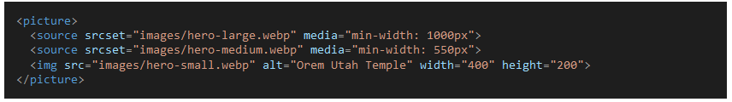

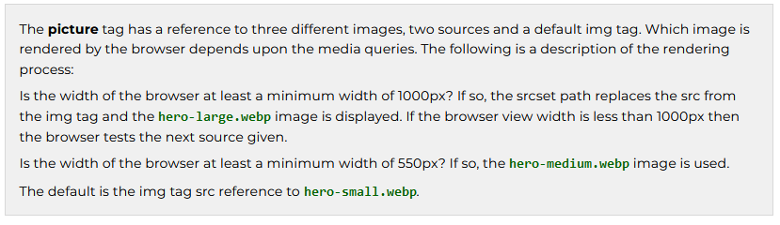

## Why are img width and height necessary?

Some of the most common causes of a **layout shift** or reflow during the rendering of a page are images, ads, embeds, and iframes without dimensions. "Layout shifts can be distracting to users. Imagine you've started reading an article when all of a sudden elements shift around the page, throwing you off and requiring you to find your place again. This is very common on the web, including when reading the news, or trying to click those 'Search' or 'Add to Cart' buttons. Such experiences are visually jarring and frustrating. They are often caused when visible elements are forced to move because another element was suddenly added to the page or resized."

[Optimize Cumulative Layout Shift](https://web.dev/optimize-cls/) - Osmani and Pollard, web.dev

Optional resources

* [Working with Responsive Images](https://www.youtube-nocookie.com/embed/ojZRjhcR3yw?rel=0&showinfo=0) | *(6:49 mins,* [*Responsive Images Transcript*](https://docs.google.com/document/d/e/2PACX-1vTh9y1ppiDLWmG4JJj9B27k5WKvQXBOKJpxVa69hOC7NadANyr2OSUNLlBLjewXmkM_KAi_rn7ZD3cB/pub)*)*
* [Serve Responsive Images](https://web.dev/serve-responsive-images/?utm_source=lighthouse&utm_medium=devtools) - Katie Hempenius - dev.to
* [Aspect-Ratio CSS Property](https://web.dev/aspect-ratio/) - Una Kravets - web.dev

# JavaScript Arrays and Array Methods

## Arrays

An array is a data structure that contains a list of elements which store multiple values in a single variable. Arrays are used to store multiple values in a single variable, instead of declaring separate variables for each value.

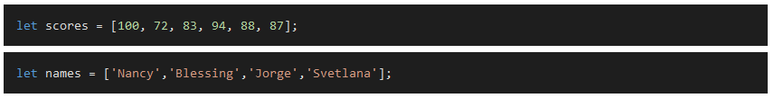Arrays are zero-based indexed, meaning the first element is at index 0, the second element is at index 1, and so on.

Arrays can be accessed by an index reference:

Arrays values can be modified:

Arrays can be iterated over using a classic for loop:

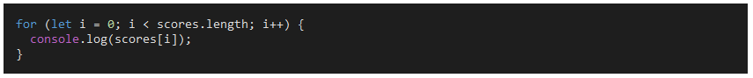**Preferred:** Arrays can be iterated over using other looping structures like forEach:

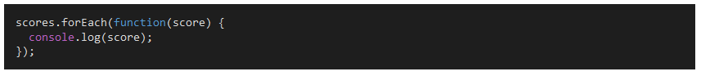Arrays have a length property:

**Array Methods**

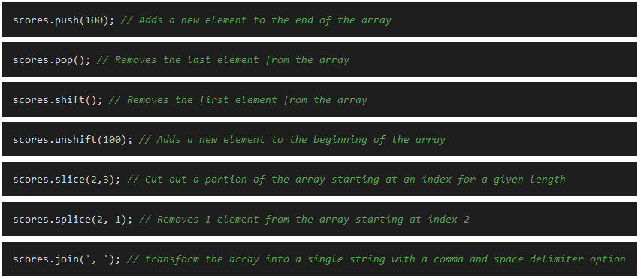

* Reference [JavaScript Arrays Reference](https://developer.mozilla.org/en-US/docs/Web/JavaScript/Reference/Global_Objects/Array) - MDN web docs

This reference provides a complete list of array methods of which some will be used extensively in this course.

**Optional Resources**

* [Master JavaScript Array Methods Like a Pro](https://dev.to/webdev-mohdamir/master-javascript-array-methods-like-a-pro-part-1-1f3j)

## Functions

Functions in JavaScript are common control structures in programming. They are blocks of code that can be called by name to perform a specific task. Functions can be called multiple times throughout a program. Functions can also be passed data to work with, and can return data back to the caller.

"Functions are one of the fundamental building blocks in JavaScript. A function in JavaScript is similar to a procedure—a set of statements that performs a task or calculates a value, but for a procedure to qualify as a function, it should take some input and return an output where there is some obvious relationship between the input and the output. To use a function, you must define it somewhere in the scope from which you wish to call it. - [MDN](https://developer.mozilla.org/en-US/docs/Web/JavaScript/Guide/Functions)"

Read [Functions](https://developer.mozilla.org/en-US/docs/Web/JavaScript/Guide/Functions) - MDN

Focus on how to define functions and how to call functions:

### Function declaration

* + A **function definition** (also called a **function declaration**, or **function statement**) consists of the [function](https://developer.mozilla.org/en-US/docs/Web/JavaScript/Reference/Statements/function) keyword, followed by:
  + The name of the function.
  + A list of parameters to the function, enclosed in parentheses and separated by commas.
  + The JavaScript statements that define the function, enclosed in curly braces, { /* … */ }.
  + For example, the following code defines a function named square:

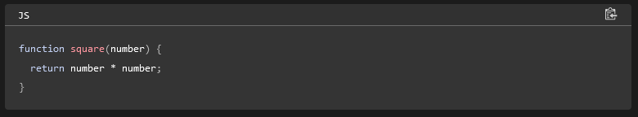

### Function expression

* + While the function declaration above is syntactically a statement, functions can also be created by a [function expression](https://developer.mozilla.org/en-US/docs/Web/JavaScript/Reference/Operators/function).
  + Such a function can be **anonymous**; it does not have to have a name. For example, the function square could have been defined as:

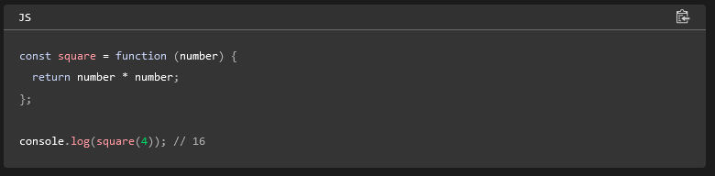

### Arrow function expression

* + An **arrow function expression** is a compact alternative to a traditional [function expression](https://developer.mozilla.org/en-US/docs/Web/JavaScript/Reference/Operators/function), with some semantic differences and deliberate limitations in usage:
  + Arrow functions don't have their own [bindings](https://developer.mozilla.org/en-US/docs/Glossary/Binding) to [this](https://developer.mozilla.org/en-US/docs/Web/JavaScript/Reference/Operators/this), [arguments](https://developer.mozilla.org/en-US/docs/Web/JavaScript/Reference/Functions/arguments), or [super](https://developer.mozilla.org/en-US/docs/Web/JavaScript/Reference/Operators/super), and should not be used as [methods](https://developer.mozilla.org/en-US/docs/Glossary/Method).
  + Arrow functions cannot be used as [constructors](https://developer.mozilla.org/en-US/docs/Glossary/Constructor). Calling them with [new](https://developer.mozilla.org/en-US/docs/Web/JavaScript/Reference/Operators/new) throws a [TypeError](https://developer.mozilla.org/en-US/docs/Web/JavaScript/Reference/Global_Objects/TypeError). They also don't have access to the [new.target](https://developer.mozilla.org/en-US/docs/Web/JavaScript/Reference/Operators/new.target) keyword.
  + Arrow functions cannot use [yield](https://developer.mozilla.org/en-US/docs/Web/JavaScript/Reference/Operators/yield) within their body and cannot be created as generator functions.

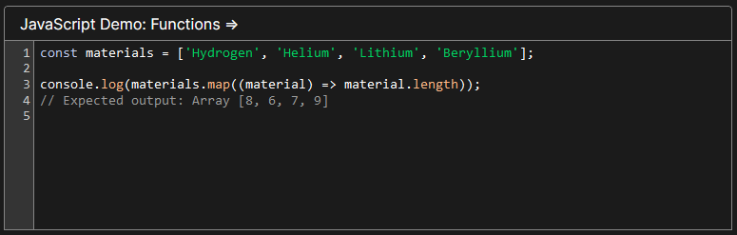

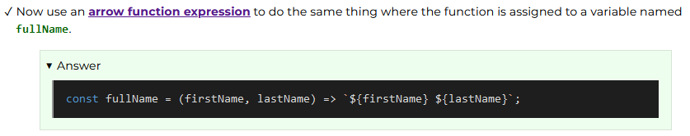

### Calling Functions

* + Defining a function does not execute it. Defining it names the function and specifies what to do when the function is called.
  + **Calling** the function actually performs the specified actions with the indicated parameters. For example, if you define the function square, you could call it as follows:

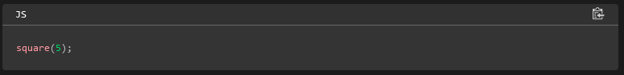

* + The preceding statement calls the function with an argument of 5. The function executes its statements and returns the value 25.
  + Functions must be in scope when they are called, but the function declaration can be [hoisted](https://developer.mozilla.org/en-US/docs/Web/JavaScript/Guide/Functions#function_hoisting) (appear below the call in the code). The scope of a function declaration is the function in which it is declared (or the entire program, if it is declared at the top level).
  + The arguments of a function are not limited to strings and numbers. You can pass whole objects to a function. The showProps() function (defined in [Working with objects](https://developer.mozilla.org/en-US/docs/Web/JavaScript/Guide/Working_with_objects#objects_and_properties)) is an example of a function that takes an object as an argument.
  + A function can call itself. For example, here is a function that computes factorials recursively:

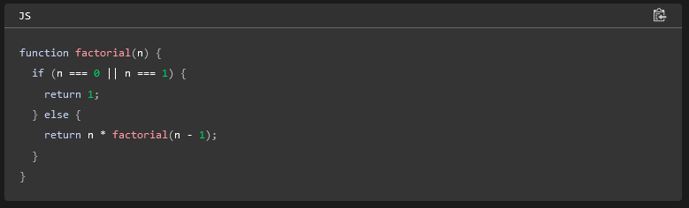

* + You could then compute the factorials of 1 through 5 as follows:

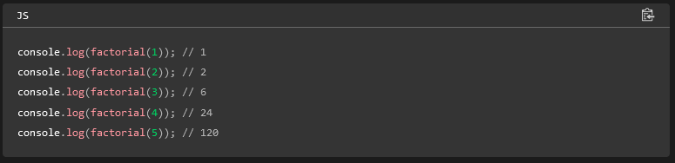

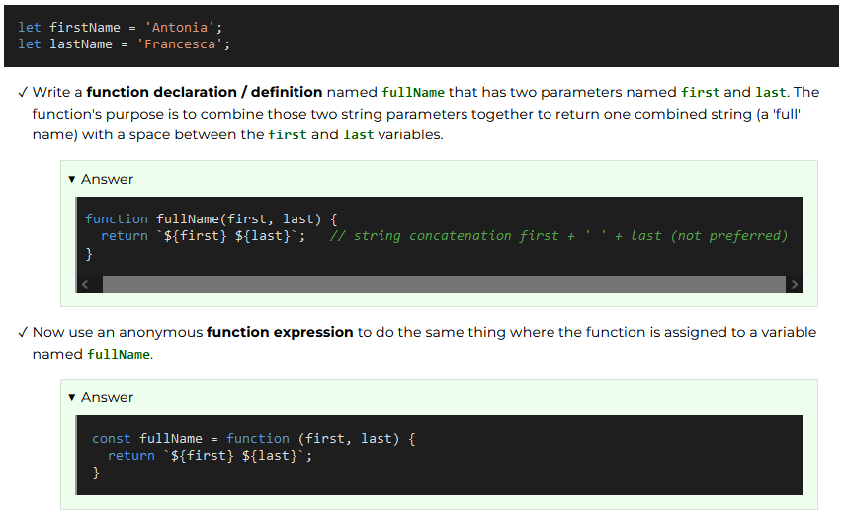

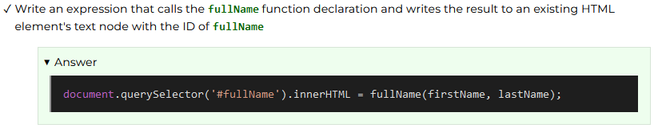

### Optional Resources

* [Functions-reusable blocks of code](https://developer.mozilla.org/en-US/docs/Learn/JavaScript/Building_blocks/Functions) - MDN JavaScript Tutorial
* [Build your own function](https://developer.mozilla.org/en-US/docs/Learn/JavaScript/Building_blocks/Build_your_own_function) - MDN JavaScript Tutorial
* [Test Your Skills: Functions](https://developer.mozilla.org/en-US/docs/Learn/JavaScript/Building_blocks/Test_your_skills:_Functions) - MDN JavaScript Building Blocks

# Tables

## Table Basics

<https://developer.mozilla.org/en-US/docs/Learn_web_development/Core/Structuring_content/HTML_table_basics>

## Table Accessibility

<https://developer.mozilla.org/en-US/docs/Learn_web_development/Core/Structuring_content/Table_accessibility>

## HTML Definitions for tables

### <table></table>

Markup for a table

### <thead><tbody><tfoot>

The <thead> tag is **used to group header content in an HTML table**. The <thead> element is used in conjunction with the <tbody> and <tfoot> elements to specify each part of a table (header, body, footer). Browsers can use these elements to enable scrolling of the table body independently of the header and footer.

### <tr>

The <tr> HTML element **defines a row of cells in a table**. The row's cells can then be established using a mix of <td> (data cell) and <th> (header cell) elements.

### <th>

The <th> tag **defines a header cell in an HTML table**. An HTML table has two kinds of cells: Header cells - contains header information (created with the <th> element)

### <td>

td is **an HTML tag used to define a single cell within a table**. It stands for "table data". The td element is often used within the tr (table row) element to structure and organize tabular data on a webpage.

#### Attritutes

##### Scope

The scope attribute **specifies whether a header cell is a header for a column, row, or group of columns or rows**. The scope attribute has no visual effect in ordinary web browsers, but can be used by screen readers.

Syntax: <th scope="col|row|colgroup|rowgroup">

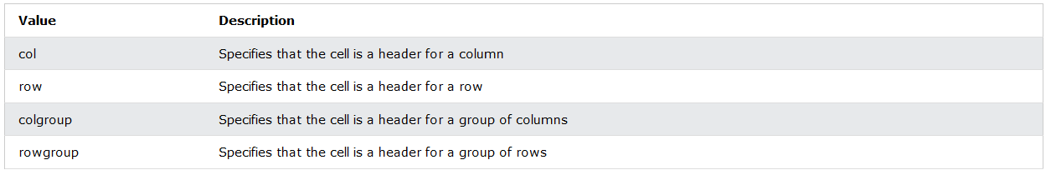

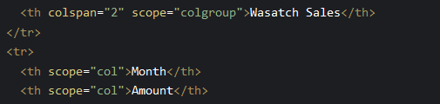

Don’t forget you can also use a class attribute to set some parts as blank

E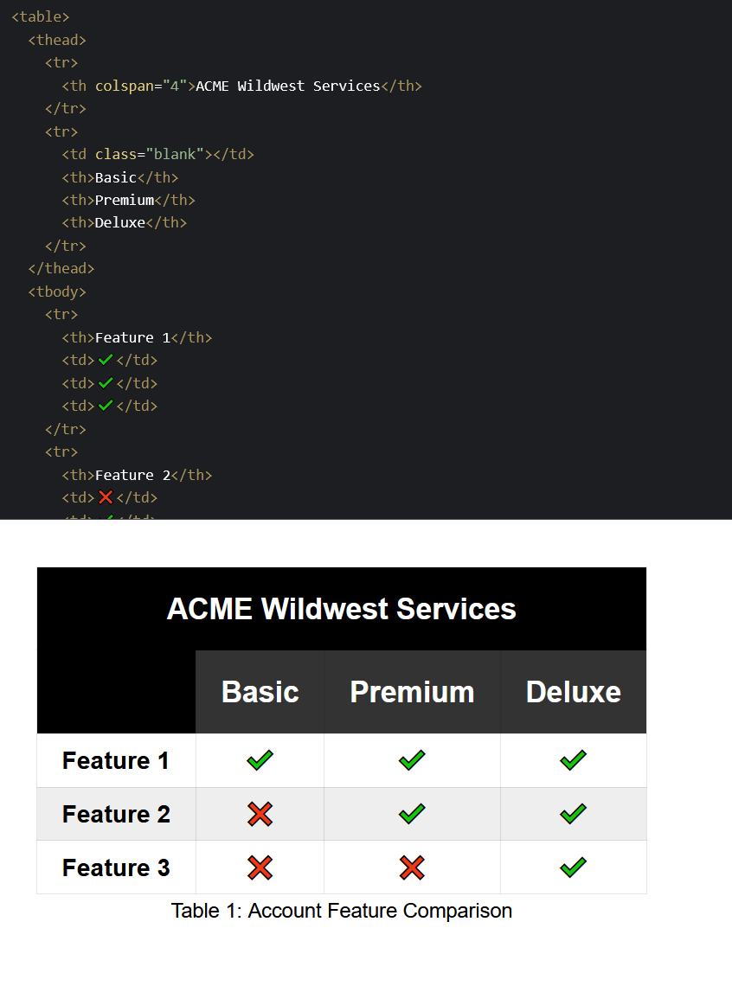

Example of a table:

<https://codepen.io/blazzard-jason/pen/aXGYqL>

<https://codepen.io/blazzard-jason/pen/NNQNrX>

## Zebra Striping

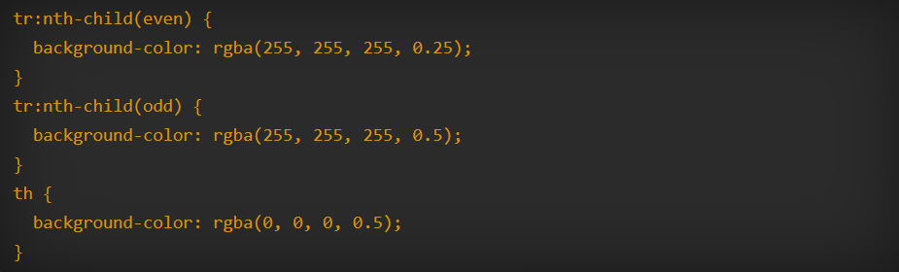

Zebra striping with scrolling table

<https://adrianroselli.com/2017/11/a-responsive-accessible-table.html#GeneralStylesZebra>

# Lazy Loading

**First Meaningful Paint**  
"It's important to deliver something meaningful to the user as soon as possible — the longer they wait for the page to load, the bigger the chance they will leave before waiting for everything to finish. We should be able to show them at least the basic view of the page they want to see, with placeholders in the places more content will eventually be loaded. This could be achieved by progressive loading — also known as [Lazy loading](https://en.wikipedia.org/wiki/Lazy_loading). This is all about deferring loading of as many resources as possible (HTML, CSS, JavaScript), and only loading those immediately that are really needed for the very first experience." - MDN web docs



The loading attribute has only two states, lazy and eager. The eager value instructs the browser to render the resource immediately and is the default. The lazy attribute will defer loading the element, such as an <img> or <iframe>, until the element is called into view by some user action, such as scrolling.

"Lazy loading is a strategy to identify resources as non-blocking (non-critical) and load these only when needed. It's a way to shorten the length of the [critical rendering path](https://developer.mozilla.org/en-US/docs/Web/Performance/Critical_rendering_path), which translates into reduced page load times. Lazy loading can occur on different moments in the application, but it typically happens on some user interactions such as scrolling and navigation." - MDN

* Test the popularity of the loading="lazy" attribute by looking at Google Maps implementation.

[Demonstration of embedding a Google Map](https://video.byui.edu/media/t/1_8mr03zxk) onto an HTML document using an iframe.

See also:

<https://developer.mozilla.org/en-US/docs/Web/Performance/Lazy_loading>

[Demonstration of browser-level lazy loading support.](https://web.dev/articles/browser-level-image-lazy-loading)

# JavaScript Objects

Here's an example of a JavaScript object representing a person:

let person = {

name: "Antonia Francesca",

age: 30,

profession: "Software Engineer",

hobbies: ["reading", "playing guitar", "hiking"],

address: {

street: "123 Camino Real",

city: "Santa Rosa",

country: "Honduras"

},

isEmployed: true,

greet: function() {

console.log(`Hello, my name is ${this.name}.`);

}

};

In this example, the person object has various properties such as name, age, profession, hobbies, address, and isEmployed. It also includes a greet method that logs a greeting message to the console using the person's name.

The address property is an object itself, containing nested properties such as street, city, and country.

You can access and modify the properties and invoke the methods of the person object using dot notation or bracket notation. For example:

# JavaScript Arrays

**array.filter()**

The array.filter() method creates a filtered array from the original array using the condition from the provided function.

* Reference [Array.filter()](https://developer.mozilla.org/en-US/docs/Web/JavaScript/Reference/Global_Objects/Array/filter) - MDN Web Docs

**array.map()**

The array.map() method iterates through each element of the original array using a given function and produces a new array. The original array is not modified. The new array is returned by the map() method. The new array will have the same number of elements as the original array.

* Reference [Array.map()](https://developer.mozilla.org/en-US/docs/Web/JavaScript/Reference/Global_Objects/Array/map) - MDN Web Docs

**array.reduce()**

The array.reduce() method is used to reduce the array to a single value. It executes a reducer function on each element of the array, resulting in a single output value. The reducer function takes four arguments: Accumulator, Current Value, Current Index, Source Array. The reducer function's returned value is assigned to the accumulator, whose value is remembered across each iteration throughout the array and ultimately becomes the final, single resulting value.

* Reference [Array.reduce()](https://developer.mozilla.org/en-US/docs/Web/JavaScript/Reference/Global_Objects/Array/Reduce) - MDN Web Docs

# Forms

[WebForms Part 1 Overview of Web Forms](https://www.youtube.com/watch?v=fbVfFsWMYnw)

[WebForms Part 2 Best Practices](https://www.youtube.com/watch?v=P_-n-28GJWQ)

[WebForms Part 3 Building the Form](https://www.youtube.com/watch?v=ktYYgfcy3-I)

[WebForms Part 4 Styling a Web Form](https://www.youtube.com/watch?v=vCG7tfn9Yw8)

[WebForms Part 5 Checking for Best Practicies](https://www.youtube.com/watch?v=SHc2gAQ7l3c)

[WebForms Part 6 Common Mistakes](https://www.youtube.com/watch?v=nR_64GZtkPg)

# Call Back Functions

[Call Back Functions](https://developer.mozilla.org/en-US/docs/Glossary/Callback_function)

[Array Callback Methods](https://blog.devgenius.io/array-callback-methods-arrow-functions-9ecbd728f63)

This article covers the following list of methods…

1. forEach()
2. map()
3. find()
4. filter()
5. every()
6. some()
7. sort()
8. reduce()

# Web Storage API – localStorage

There are times when non-sensitive data storage would provide a better user experience and offer some site performance improvements. The [Web Storage API](https://developer.mozilla.org/en-US/docs/Web/API/Web_Storage_API) mechanisms provide the ability to store information in a key-value format based on a particular user agent or origin. In this activity, you will discover the purpose and scope of the **localStorage** mechanism available through the [Storage](https://developer.mozilla.org/en-US/docs/Web/API/Storage) interface. You will use this knowledge to drive and display some traffic data from individual clients on a page.

Here are some comparison data between **cookies**, **localStorage**, and **sessionStorage**.

|  |
| --- |
| Table 1: Local Storage Methods Comparison Chart |
|  |

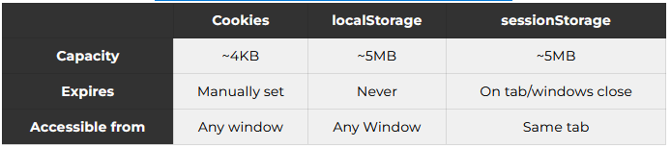

Each of these methods stores data with the actual user agent (browser) client and not on the server.

**localStorage Advantages**

* This method is much more intuitive than using the older method of Cookies.
* Only stores strings in key-value pairs.
* The mechanism's data persists without expiring and is available even when an agent is closed and reopened again.

You can store non-string data in localStorage. One common approach is to use the JSON.stringify() method to convert the data to a string before storing it, and then use the JSON.parse() method to convert it back to its original form when you retrieve it from localStorage. This allows you to store and retrieve more complex data structures, such as objects and arrays, in localStorage.

Watch: [localStorage Demonstration](https://video.byui.edu/media/t/1_z77p3i7c) – Here is the corresponding [CodePen](https://codepen.io/blazzard-jason/pen/RwyePNj) used in demonstration.

**Optional Resources**

1. Video: [JavaScript Cookies vs localStorage vs Session Storage](https://youtu.be/GihQAC1I39Q?si=M_OwWHklCjK3mNfy) - Web Dev Simplified
2. A dynamic structured approach to this activity would be to use [Set object](https://developer.mozilla.org/en-US/docs/Web/JavaScript/Reference/Global_Objects/Set) in JavaScript. **Set** allows us to **add** and **delete** items from the Set object as needed.
3. Reference: [Web Storage API](https://developer.mozilla.org/en-US/docs/Web/API/Web_Storage_API) – MDN
4. The [IndexedDB API](https://developer.mozilla.org/en-US/docs/Web/API/IndexedDB_API) is a more robust method of storing data on the client side and is more like a database.
5. The [Cache API](https://developer.mozilla.org/en-US/docs/Web/API/Cache) is a method of storing data that is specifically used for caching data for offline use.

WDD 231 Web Frontend Development I

# Visual Studio Tools

[Visual Studio Extensions](https://code.visualstudio.com/docs/editor/extension-marketplace)

[Auto Updating Tags](https://code.visualstudio.com/docs/languages/html#_auto-update-tags)

[Building User Defined Snippets](https://code.visualstudio.com/docs/editor/userdefinedsnippets)

[Emmet Short Hand And Snippets](https://code.visualstudio.com/docs/editor/emmet)

# Normalizing

**Historically**

CSS resets have been around for a long time. The first reset CSS file was created by Eric Meyer in 2007. It was a simple file that removed all default browser styling. Since then, many developers have created their own variations of reset CSS files. The most popular of these is **normalize.css**, created by Nicolas Gallagher in 2011. Normalize.css is a modern alternative to CSS resets that preserves useful default styles rather than just removing them.

**Current State**

Browsers have come a long way in adhering to web standards. Default styles are more consistent across modern browsers.

Normalize.css is still relevant as it doesn't completely wipe out default styles, but rather normalizes them across browsers, preserving useful defaults.

Many CSS frameworks like Bootstrap and Tailwind CSS use some form of normalize or reset styles.

**Summary**

The use of CSS normalization and reset is **opinionated**. This means its benefits and shortcomings can be debated among professionals. Depending upon the application, some level of using normalization or reset may be beneficial. You may need to support legacy browsers or you may have highly customized designs that need pixel-perfect control and cross-browser consistency.

Video Demonstration ► [How does newsroom.churchofjesuschrist.org use CSS normalization/reset.](https://video.byui.edu/media/t/1_7cxpg7l9)

**Application of Normalize or Reset CSS**

1. You can create your own copy of a normalize CSS file by first creating a "**normalize.css**" file located in your wdd231 root "**styles**" folder.
2. Use the following code reference and copy the CSS into your file. [Nicolas Gallagher's – normalize.css](https://github.com/necolas/normalize.css/blob/master/normalize.css)
3. Apply the CSS by including the link in the head of a page. For example, this line of code would be included before any other CSS link reference.

<link rel="stylesheet" href="styles/normalize.css">

IMPORTANT CONCEPT: Why should this CSS reference precede all the other CSS references?

If you have more than one rule, all of which have exactly the same weight, then the one that comes last in the CSS will win (**cascade**).   
[CSS Cascade and Inheritance](https://developer.mozilla.org/en-US/docs/Learn/CSS/Building_blocks/Cascade_and_inheritance) – MDN

An **alternative** to hosting your own normalize or reset CSS file is to use a [content delivery network](https://aws.amazon.com/what-is/cdn/) (CDN) reference.  
This particular reference has minimized the "normalize.css" file as indicated by the .min in the file name.

<link rel="stylesheet" href="https://cdnjs.cloudflare.com/ajax/libs/normalize/8.0.1/normalize.min.css">

[Take a look at the file](https://cdnjs.cloudflare.com/ajax/libs/normalize/8.0.1/normalize.min.css) and see how difficult it is to read for humans but completely usable by the browser. What does **minimizing** mean when it comes to web file optimization?

All unnecessary syntax in the CSS is removed from the file including spaces, comments, line returns. More sophisticated minification would optimize the CSS and extract redundancy.

# Testing and Development

The **Web Developer** browser extension provides access to some endorsed validation and page checking tools including:

* [W3C HTML validation](https://validator.w3.org/nu/),
* [W3C CSS validation](https://jigsaw.w3.org/css-validator/),
* [W3C Link Checker](https://validator.w3.org/checklink?check=Check), and
* [WAVE accessibility](https://wave.webaim.org/).

# Favicon

Favicon stands for favorite icon but more relevant than its name is the purpose of the favicon to provide enhancement to your branding of your site/application as the site is bookmarked and referenced. The favicon image will appear with the domain in the address bar, tabs, bookmarks, search results, and other areas depending upon the browser.

You may have encountered a reference to a 404 NOT FOUND favicon error in the browser's DevTools console when other not found errors are present on your [https enabled](https://developer.mozilla.org/en-US/docs/Glossary/https) GitHub Pages site.

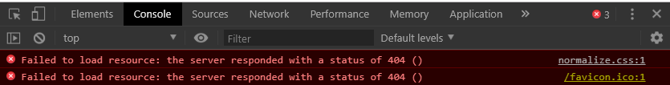

* The Favicon ("Fav-icon") is a small image file that can be 16px X 16px, however [Google development recommends](https://support.google.com/webmasters/answer/9290858) multiples of 48px square.
* Most web image file formats are supported, however, the preferred **.ico** format is what you will use in the course. Statistically, .png is the most commonly used format for favicons.
* Read the **favicon section** in 📃 [What's in the <head>?](https://developer.mozilla.org/en-US/docs/Learn/HTML/Introduction_to_HTML/The_head_metadata_in_HTML#Adding_custom_icons_to_your_site) – MDN.

# Social Media Meta

Open graph meta tags are used to support the Facebook and other social media crawlers with relevant information including a title, description, preview image, and locality.

"Without these Open Graph tags, the [Facebook Crawler](https://developers.facebook.com/docs/sharing/webmasters/crawler) uses internal heuristics to make a best guess about the title, description, and preview image for your content. Designate this info explicitly with Open Graph tags to ensure the highest quality posts on Facebook." - *developers.facebook.com*

* Read: [The Essential Meta Tags for Social Media](https://css-tricks.com/essential-meta-tags-social-media/) - css-tricks.com
* Read: [A Guide to Sharing for Webmasters](https://developers.facebook.com/docs/sharing/webmasters#markup) - developers.facebook.com
* What are Facebook Open Graph properties for the Church's main website at <https://www.churchofjesuschrist.org> for the title and description?

This content can change at any time. If you are not seeing the same content, do not worry as the principle and application are the important part of this exercise.

Click for Answer

You can view these properties by navigating to the site and viewing the source or you can use a [sharing debugger](https://developers.facebook.com/tools/debug) to provide a formatted report.

* + og:title | The Church of Jesus Christ of Latter-day Saints
  + og:description | Official website of The Church of Jesus Christ of Latter-day Saints. Find messages of Christ to uplift your soul and invite the Spirit.
  + og:image | <https://assets.ldscdn.org/0d/7b/0d7bb93794eb11ecb29ceeeeac1ee20345ef0d4f/church_logo.png>  
    or it may be change to something like this <https://brightspot-assets.churchofjesuschrist.org/dims4/default/f1954e9/2147483647/strip/false/crop/1932x1017+0+0/resize/1280x674!/format/jpg/quality/90/?url=https%3A%2F%2Fassets.churchofjesuschrist.org%2F31%2F72%2F3172a0b72dcf43c62af65bf2e514b50b9900b2fe%2Fjesus_christ_healing_people.jpeg>
  + og:url | https://churchofjesuschrist.org



## Facebook/Twiter(X)

<https://css-tricks.com/essential-meta-tags-social-media/>

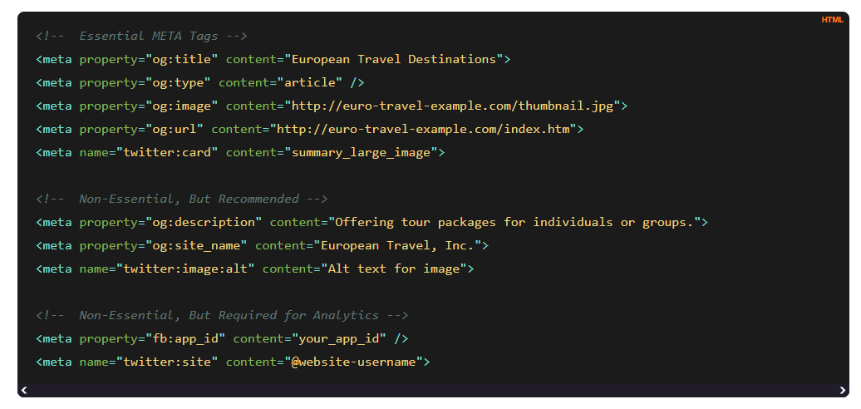

**5+ Must Know HTML Tags That Almost Nobody Knows**

Talks about the use of Social Media Meta Tags

<https://www.youtube.com/watch?v=iX_QyjdctsQ&t=290s>

X Developer platform (Twitter)

<https://developer.x.com/en/docs/x-for-websites/cards/overview/summary>

Guide to sharing for webmasters

<https://developers.facebook.com/docs/sharing/webmasters#markup>

# JSON (JavaScript Object Notation)

JSON is an open standard, simple data interchange format. JSON is often used for transmitting data between a server and a client application and can be used for configuration files and data storage.

"JavaScript Object Notation (JSON) is a standard text-based format for representing structured data based on JavaScript object syntax. It is commonly used for transmitting data in web applications (for example, sending some data from the server to the client, so it can be displayed on a web page, or vice versa) ... Even though it closely resembles JavaScript object literal syntax, it can be used independently from JavaScript, and many programming environments feature the ability to read (parse) and generate JSON."   
– [MDN](https://developer.mozilla.org/en-US/docs/Learn/JavaScript/Objects/JSON)

• JSON is:

* text-based,
* stored in with the extension **.json**,
* closely paired to a literal JavaScript object and is converted to a native JavaScript object.
* **not** dependent on a particular programming language,
* pure property formatted data, there are **no** methods,
* written using basic key/value pairs in this format: key:pair data types of strings, numbers, arrays, Booleans, and other object literals,
* requires double quotes to be used around string and property names and follows strict adherence to comma or colon placement,
* can be accessed using JavaScript object notation,
* can be checked with a linter like [jsonlint.com](https://jsonlint.com/) to validate the structure, and
* does **not** allow comments.

• The JSON object has methods that allow you to convert or parse the string to an native object and you can [stringify()](https://developer.mozilla.org/en-US/docs/Web/JavaScript/Reference/Global_Objects/JSON/stringify) a native object to a string using that same, built-in JSON object.

• Here is an example JSON file. Directly open this file with your browser: [JSON "Hero" Data Example](https://mdn.github.io/learning-area/javascript/oojs/json/superheroes.json) – MDN Can you identify the properties and the data types?

Here are some example property names and corresponding data types from this JSON file.

* **property**: "squadName", **data type**: string
* **property**: "formed", **data type**: number
* **property**: "active", **data type**: Boolean
* **property**: "members", **data type**: holds an **array** of objects (the object has four properties)

[Learn JSON in 10 Minutes](https://www.youtube.com/watch?v=iiADhChRriM)

# Async/Await

"Asynchronous programming is a technique that enables your program to start a potentially long-running task and still be able to be responsive to other events while that task runs, rather than having to wait until that task has finished. Once that task has finished, your program is presented with the result." – [MDN](https://developer.mozilla.org/en-US/docs/Learn/JavaScript/Asynchronous/Introducing)

[Asynchronous Programming](https://eloquentjavascript.net/11_async.html) – Eloquent Javascript

[**Synchronous programming**](https://developer.mozilla.org/en-US/docs/Learn_web_development/Extensions/Async_JS/Introducing#synchronous_programming)

Consider the following code:

js

const name = "Miriam";

const greeting = `Hello, my name is ${name}!`;

console.log(greeting);

// "Hello, my name is Miriam!"

This code:

1. Declares a string called name.
2. Declares another string called greeting, which uses name.
3. Outputs the greeting to the JavaScript console.

We should note here that the browser effectively steps through the program one line at a time, in the order we wrote it. At each point, the browser waits for the line to finish its work before going on to the next line. It has to do this because each line depends on the work done in the preceding lines.

That makes this a **synchronous program**. It would still be synchronous even if we called a separate function, like this:

js

function makeGreeting(name) {

return `Hello, my name is ${name}!`;

}

const name = "Miriam";

const greeting = makeGreeting(name);

console.log(greeting);

// "Hello, my name is Miriam!"

Here, makeGreeting() is a **synchronous function** because the caller has to wait for the function to finish its work and return a value before the caller can continue.

[Bro Code JavaScript ASYNC/AWAIT is easy!](https://www.youtube.com/watch?v=9j1dZwFEJ-c)

* Read: [Asynchronous JavaScript](https://developer.mozilla.org/en-US/docs/Learn/JavaScript/Asynchronous/Introducing) – MDN
* Reference: [async Function](https://developer.mozilla.org/en-US/docs/Web/JavaScript/Reference/Statements/async_function) – MDN
* Reference: [Await](https://developer.mozilla.org/en-US/docs/Web/JavaScript/Reference/Operators/await) – MDN
* Reference: [try...catch block](https://developer.mozilla.org/en-US/docs/Web/JavaScript/Reference/Statements/try...catch) – MDN
* [Asynchronous Programming](https://eloquentjavascript.net/11_async.html) – Eloquent Javascript

# The Fetch API

"The Fetch API provides a JavaScript interface for accessing and manipulating parts of the protocol, such as requests and responses. It also provides a global fetch() method that provides an easy, logical way to fetch resources asynchronously across the network." – [MDN](https://developer.mozilla.org/en-US/docs/Web/API/Fetch_API/Using_Fetch)

* The fetch() method is part of the [Fetch API](https://developer.mozilla.org/en-US/docs/Web/API/Fetch_API/Using_Fetch).
* The fetch() method can be used within an [async function](https://developer.mozilla.org/en-US/docs/Web/JavaScript/Reference/Statements/async_function) which means that you will allow the data retrieval to happen before trying to continue with statements in the program that need to process the data. A promise for data is one thing, but the actual data is what is really needed, so you need a delay. Async/await provide that promised-based asynchronous behavior.
* We need to extract the JSON content from the noise of the full HTTP response by using the json() method. With the string data retrieved, you can run a .json() method on the Response to convert it into a JavaScript object, which is easy to work with.
* The fetch() method has built in error handling.
* Read: 📃 [Fetch Basics](https://byui-cit.github.io/learning-modules/modules/js/fetch-basics/prepare1/)

# Web Accessibility

**Overview**

Web accessibility is the practice of making websites usable by people of all abilities. This learning activity focuses on the basics of web accessibility and the tools that are available to help create accessible websites.

The [Web Content Accessibility Guidelines (WCAG)](https://www.w3.org/WAI/standards-guidelines/wcag/) is the standard for web accessibility. The WCAG guidelines are organized into three levels of conformance: A, AA, and AAA. The WCAG guidelines are also available in a [Quick Reference](https://www.w3.org/WAI/WCAG21/quickref/) format.

**Prepare**

1. Watch this video of some manuel accessibility testing on websites. This will help to gain an overview of the types of things that are considered when talking about web accessibility.   
   ► [How To Do an Accessibility Review](https://web.dev/articles/how-to-review)
2. Consider these basic items that are checked by DevTools Lighthouse – Accessibility category. There are many things on this list that you already have been using in your web development work in this course and previous courses through the audits.
   * Background and foreground colors have a sufficient contrast ratio. This can also be checked in detail using DevTools CSS Overview or via the [Contrast Ratio](https://contrast-ratio.com/?ref=frontendchecklist) online tool.
   * All **images** <img> have alt attribute content that accurately describes the image's purpose.
   * **Heading** elements are in sequentially-descending order. Headings give semantic structure to the document to make it easier to navigate and understand when using assistive technologies.
   * All interactive controls are **keyboard** focusable.
   * The document has a logical **tab** order.
   * Simple [Landmark](https://www.w3.org/WAI/ARIA/apg/patterns/landmarks/examples/HTML5.html), i.e., header, aside, footer, nav, main, etc., elements are used instead of divs. Keep the landmark use basic and consistent.
   * Offscreen content is hidden with display: none or aria-hidden=true. [Hide offscreen content](https://developer.chrome.com/docs/lighthouse/accessibility/offscreen-content-hidden/?utm_source=lighthouse&utm_medium=devtools)
   * Text is resizable.
   * Document has a meaningful and relevant **title**.
   * Page has a language defined in the of the opening html tag.
   * Page has a **favicon**.
   * All forms elements have **labels** that are tied to them.
   * Tables have **headers**.
   * Video and audio have **captions**.

A lot of these items are technical aspects and developers need to remember that they are just tools to aid in the overall accessibility evaluation of a page or site. The Lighthouse accessibility tools will not evaluate the usability of a page with certain disabilities, nor if the content is understood, or what the user's experience is as they navigate and interact with the page and site. These aspects often require manual testing and feedback from users with disabilities to truly understand and improve accessibility.